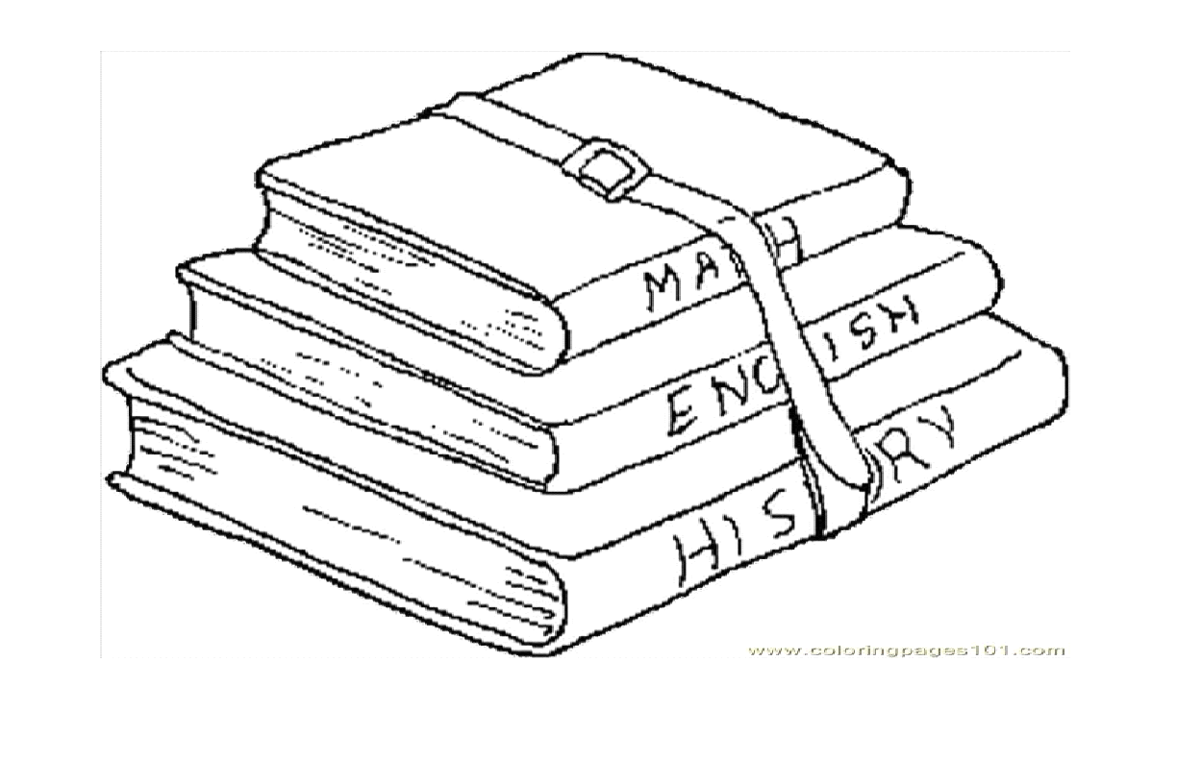
Provision of Education in Ireland
Pre-school, primary, second level, special needs,
3rd level, adult & 2nd chance

Primary Education
- Children generally attend primary school between 4-5 years
- Not compulsory until 6 years
National Schools/Gaelscoileanna | - Make up majority of primary schools.  - Owned by trusteeship of religious communities, boards of governors & individuals  - Managed by the B.O.M.  - Mostly denominational  - Single sex/co-educational.  - Financed by Dept.
Educate Together Primary Schools | - Managed by B.O.M  - Multidenominational  - Co-educational  - Financed by DES
Private | - Managed by B.O.M  - Mostly denominational  - Single sex or Co-educational  - Not eligible to be Financed by DES to help running costs
Primary School Curriculum
- Delivered over 8 years with no formal examination at the end.
- Aims to nurture the spiritual, moral, cognitive, emotional, imaginative, social & physical needs of children so they meet the demands of life now & in the future.
- Provides a broad learning experience by offering languages (Irish & English), maths, social drama, environmental and scientific education, ICT, Arts, Music, P.E. S.P.H.E. and R.E.
- Particular emphasis on literacy & numeracy development
- Teachers are encouraged to include a variety of teaching and learning styles of individual children. Helps create an inclusive learning environment

Educational Supports/resources available in primary schools
- Interactive whiteboards: enable teachers to encourage children to participate more in their learning.
- Laptops & tablets: allows access to educational apps and websites that can assist educational advancement. Allow kids to take control of their own learning.
- Educational psychologists: work in partnership with teachers, parents and children in identifying the educational needs of children.
- The School Book Grant Scheme.
- The Home School Community Liaison Scheme

