Sample Planning Tools for embedding FMS in your PE Plan

The following suite of planning tools are intended for illustrative purposes only. A whole-school approach should be incorporated when planning for Physical Education to ensure that PE provision is broad and balanced, and that all FMS are developed across the school years. Schools should select the number of skills for development in any given year in accordance with pupils' needs and aligned with their School Plan. It is important to teach a balanced range of locomotor, stability and manipulative skills across the strands during the year. Schools could endeavour to provide opportunities to develop the other FMS not covered above during break-times or as part of a programme for active classrooms.
It is not intended that the development of fundamental movement skills replaces the PE lesson – rather, it is intended that this skill development is integrated into the PE lesson in line with the overall school plan. Begin by selecting the strand that you are planning to teach, and then embed the teaching of a FMS into that strand. In this way, you can focus a lens on skill development within a lesson that is based on one of the strands of the PE curriculum. Focus on one skill at a time - this may take four to six weeks depending on the number of teaching points in that skill. It is suggested that teachers introduce one teaching point (maximum two) per lesson.

Creating a whole school PE Plan

- Examine the current PE plan in your school

- Consider the length of time each PE Strand will be taught – 4 or 6 week blocks.

- Choose a PE plan template available in the planning section on www.scoilnet.ie/pdst/physlit www.pdst.ie/Physical_Education_Main or create a suitable planning template

- Initially ensure a broad & balanced PE plan is created where each of the six strands is included each year

- Choose the number of skills that can be realistically taught in a year in accordance with the needs of the pupils in your school

- Will the 15 FMS be taught over a 2-year cycle or 3-year cycle?

- Select the FMS that will be embedded within each Strand (See MWMO Teacher Guide pg. 17)

- Take into account the use of external facilitators, PE hall availability/weather, other activities happening in the school when creating the PE plan

- Consider how the new PE plan will be shared with the whole school

- Discuss the effectiveness of the implementation of the PE plan during staff meetings

- Review the PE plan at the end of the year

- Ensure all staff are aware of the PE plan and the FMS that will be taught in the following year.

- See the planning section on www.scoilnet.ie/pdst/physlit where there is a video showing planning approaches used by two different schools and more information in relation to planning.

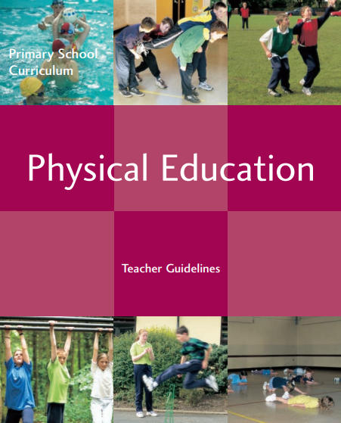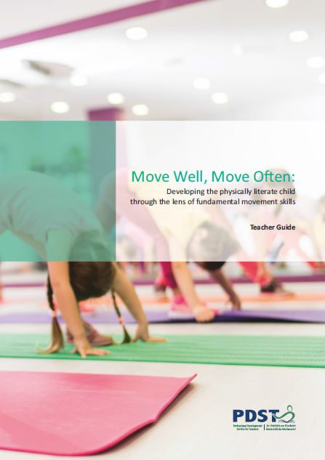

Example Planning Template A – Planning according to months of the year
This plan represents a whole-school approach, where all classes teach the same strand and the same skill at the same time during the year. All 15 skills are taught across a two-year or three – year period. This plan is not intended to be prescriptive, schools are advised to create a plan that best suits their needs. Initially decide when each strand will be taught and then the FMS that will be embedded in each strand each year. Ensure that all 15 FMS are covered over a two/ three year period alternatively, schools could use two copies of this template (as outlined on the following page) to create a two-year/ three - year plan.
Term  1 | September | October |  | November |  | December
 | Walking | Running |  |  |  | Landing
Term  2 | January |  | February |  | March
 | Jumping for Height |  | Skipping |  | Catching
Term  3 | April | May |  | June |  | Subject to pool timetabling per class
 | Kicking |  |  | Throwing

Blank Sample Planning Template A1 – Planning according to months of the year

Whole School PE Plan – 2 year cycle
YEAR 1
Term  1 | Month | September | October |  | November |  | December
 | Strand
 | FMS
Term  2 | Month | January |  | February |  | March
 | Strand
 | FMS
Term  3 | Month | April |  | May |  | June
 | Strand
 | FMS
YEAR 2
Term  1 | Month | September | October |  | November |  | December
 | Strand
 | FMS
Term  2 | Month | January |  | February |  | March
 | Strand
 | FMS
Term  3 | Month | April |  | May |  | June
 | Strand
 | FMS

Blank Sample Planning Template A2 – Planning according to months of the year

Whole School PE Plan – 3 year cycle
YEAR 1
Term  1 | Month | September | October |  | November |  | December
 | Strand
 | FMS
Term  2 | Month | January |  | February |  | March
 | Strand
 | FMS
Term  3 | Month | April |  | May |  | June
 | Strand
 | FMS
YEAR 2
Term  1 | Month | September | October |  | November |  | December
 | Strand
 | FMS
Term  2 | Month | January |  | February |  | March
 | Strand
 | FMS
Term  3 | Month | April |  | May |  | June
 | Strand
 | FMS
YEAR 3
Term  1 | Month | September | October |  | November |  | December
 | Strand
 | FMS
Term  2 | Month | January |  | February |  | March
 | Strand
 | FMS
Term  3 | Month | April |  | May |  | June
 | Strand
 | FMS

Blank Sample Planning Template B – Planning according to months of the year

This plan presents a whole school approach to the planning of PE Strands, where each class grouping teaches the same strand at the same time but a different FMS according to the needs of the pupils. Teachers are reminded to ensure that a variety of skills are taught in each year.

Term  1 | Month | September |  | October |  | November |  | December
 | Strand
 | FMS | J. &S. Infants | 1st & 2nd | J. &S. Infants | 1st & 2nd | J. &S. Infants | 1st & 2nd | J. &S. Infants | 1st & 2nd
 |  | 3rd & 4th | 5th & 6th | 3rd & 4th | 5th & 6th | 3rd & 4th | 5th & 6th | 3rd & 4th | 5th & 6th

Term  2 | Month | January |  | February |  | March
 | Strand
 | FMS | J. &S. Infants | 1st & 2nd | J. &S. Infants | 1st & 2nd | J. &S. Infants | 1st & 2nd
 |  | 3rd & 4th | 5th & 6th | 3rd & 4th | 5th & 6th | 3rd & 4th | 5th & 6th

Term  3 | Month | April |  | May |  | June
 | Strand
 | FMS | J. &S. Infants | 1st & 2nd | J. &S. Infants | 1st & 2nd | J. &S. Infants | 1st & 2nd
 |  | 3rd & 4th | 5th & 6th | 3rd & 4th | 5th & 6th | 3rd & 4th | 5th & 6th

Example Planning Template C – Planning according to 6 x 6 week blocks
This plan represents a whole-school approach, where all classes teach the same strand and the same skill over a 6-week block. Initially decide when each strand will be taught and then the FMS that will be embedded in each strand each year. Ensure that all 15 FMS are covered over a two/ three year period. Teachers should collaborate with each other to ensure a broad and balanced range of FMS are covered in consecutive years. This plan is not intended to be prescriptive, schools are advised to create a plan that best suits their needs. A blank example of a 6-week block whole-school approach is presented on the following page.

6 weeks (specify dates) | 6 weeks (specify dates)
Catching | Landing
6 weeks (specify dates) | 6 weeks (specify dates)
Balancing | Jumping for height
6 weeks (specify dates) | 6 weeks (specify dates)
Kicking | Hopping

Blank Planning Template D – Planning according to 6 x 6 week blocks
This sample plan presents a whole-school approach where all classes focus on the same strand at the same time, but each different class focuses on a different/the same FMS in line with the needs of the pupils. This plan adopts a 6-week block approach. Teachers should collaborate at the beginning of the 2/3 year cycle and select when each strand will be taught and then choose the appropriate FMS that will be embedded in each strand each year. Schools should ensure that a mix of skills are taught each year and all 15 skills should be taught over 2/3 year cycle. Also each child should experience each skill two or three times over eight year period.
6 week block (dates) | Strand | Fundamental Movement Skill
 |  | J. Infants | S. Infants | 1st Class | 2nd Class | 3rd Class | 4th Class | 5th Class | 6th Class

Sample Planning Template D – Planning according to 6 x 6 week blocks

This plan is for illustrative purposes only and is not intended to be prescriptive: schools are advised to create a plan that best suits their needs.

6 week block (dates) | Strand | Fundamental Movement Skill
 |  | J. Infants | S. Infants | 1st Class | 2nd Class | 3rd Class | 4th Class | 5th Class | 6th Class
04.09.18 –  12.10.18 |  | Throwing | Kicking | Striking with the Hand | Kicking | Striking with an implement | Dodging | Kicking | Striking with the hand
15.10.18 –  30.11.18 |  | Walking | Landing | Jumping for height | Side stepping | Balancing | Skipping | Catching | Landing
3.12.18 –  25.01.19 |  | Balancing | Jumping for Height | Skipping | Jumping for distance | Landing | Jumping for Height | Hopping | Side stepping
29.01.19 –  8.3.19 |  | Catching | Dodging | Balancing | Running
12.3.19 –  3.5.19 |  | Running | Striking with an implement | Landing | Striking with an implement | Throwing | Jumping for distance | Running | Throwing
7.5.19 –  21.6.19 |  | Skipping | Side stepping | Hopping | Dodging | Running | Catching | Balancing | Skipping

Blank Planning Template E – Planning according to 6 x 6 week blocks across 3 years
According to this plan, each teacher will teach the same strand and same FMS. Schools should decide when each strand will be taught and then the FMS that will be embedded in each strand each year. A sample of this plan can be found on the video in the planning section on www.scoilnet.ie/pdst/physlit

3 YEAR PE PLAN
DATES  6 WEEK BLOCK | STAND |  | FMS  Year 1 | FMS  Year 2 | FMS  Year 3

Refer to the Move Well, Move Often resource for guidance on how to teach the FMS: | Locomotor Skills | Stability Skills | Manipulative Skills

The Relationship between Physical Education and Physical Literacy

Discussion Activity: Opportunity to focus on FMS across the PE strands
The table enables school staff to identify FMS that could be particularly suitable for teaching within each of the PE strands. This table is for illustrative purposes only and is not intended to be exclusive, as some FMS could be embedded across all strands. It is at the discretion of each individual school to decide which FMS to focus on, what strand to embed it in, and when to focus on it during the school year in line with the school plan for PE. Tick the box(es), which identify which strand would be best suited for embedding the teaching of each particular skill.
 |  | Athletics | Games | Dance | Gymnastics | Outdoor & Adventure | Aquatics
Locomotor Skills | Walking
 | Running
 | Hopping
 | Skipping
 | Jumping (height)
 | Jumping (distance)
 | Dodging
 | Side-stepping
Stability | Balancing
 | Landing
Manipulative | Throwing
 | Catching
 | Kicking
 | Striking with the hand
 | Striking with an implement

Notes:
Discussion Activity: Select a fundamental movement skill to focus on in planning for teaching each of the following strands:

Locomotor Skills | Stability Skills | Manipulative Skills
- Walking  - Running  - Hopping  - Skipping  - Jumping for height  - Jumping for distance  - Dodging  - Side stepping | - Balancing  - Landing | - Catching  - Throwing  - Kicking  - Striking with the hand  - Striking with an implement

