Template cover sheet which must be included at the front of all projects

Title of project:
The Royal Munster Fusiliers: Commemorating Irish Heroes in a Tragic War

Name(s) of class / group of students / individual student submitting the project

Mark O’Leary Troy Vallely (3rd Year)
Oscar Twomey Darragh Walsh

School roll number (this should be provided if possible)

71103k

School address (this must be provided even for projects submitted by a group of pupils or an individual pupil):
Colaiste Choilm, Ballincollig, Co.Cork

Class teacher’s name (this must be provided even for projects submitted by a group of pupils or an individual pupil):
Mr. John Ryan

Contact phone number:
Tel: 021 4873308 Fax: 021 4875626

Contact email address
jrhisteach@outlook.com

The Royal Munster Fusiliers: Commemorating Irish Heroes in a Tragic War

Introduction

Approaching the centenary of WWI, the Great War still lies heavily on Europe's collective memory. Dubbed “the war to end all wars”, it completely revolutionised modern warfare with approximately 37 million casualties. In this essay we aim to commemorate the Irish men who fought and died in this atrocious war who were often overshadowed by revolutionary events back home. In particular this essay’s aim will be to focus on the Royal Munster Fusiliers' duties during WWI, a regiment of the British Army based in Munster and made of Munster men. They fought in many of the war's most significant battles including Gallipoli and The Somme. This essay will try to explain the Munster's significance to the eventual Allied victory. This is illustrated by their important contribution to the ill fated battle at Gallipoli and their fighting in the victory at the Somme. Furthermore we will attempt to portray the individual experience in this terrible war. We will do this through our examination of the battles which took place in Gallipoli, the Somme and through our case study of Victoria Cross winner William Cosgrove. We hope this essay can adequately commemorate the enormous sacrifice that these Irish men made for the cause of democracy and peace in Europe.

"You will be home before the leaves have fallen from the trees." – Kaiser Wilhem II

Gallipoli

The Battle of Gallipoli was the tragic WWI battle that took place between the Allied Powers and the Ottoman Empire on the Gallipoli peninsula in Turkey. Lasting from the 25th of April 1915 to the 9th of January 1916, this battle saw the British suffer one of their greatest losses of the war in which approximately 22,000 died and 198,000 were wounded. Subsequently the battle was a defining event in the formation of Australia, New Zealand and Turkey's national identities.
The reason for the allies' bold move to take the “Dardanelles” is multi faceted. On the 28th of October the Ottoman Empire bombed Russia's Black Sea Port. Subsequently, the Ottoman Empire officially entered the war on the side of The Central Powers on the 31st October. The Allies were faced with a difficult choice, as the Ottomans went on the offensive against Russia, Britain and France were put under pressure from the Tsarist Empire to undermine the Ottoman's military attempts. Furthermore,

capturing the Dardanelles had the potential to greatly change the course of the war. The Dardanelles "gave ready access to the Turkish capital Constantinople and much of the Turkish Empire's industrial powerhouse, but also provided a lane to the Black Sea.” This would give the British and French a direct supply route with their Russian allies. This, coupled with political pressure at home to set up another front and avoid the stalemate on the Western Front led to the launch of an Anglo-French naval attack against the Ottoman Empire lasting over a month. This ended in a resounding defeat for the allies which set the scene for the land invasion. (Gallipoli)
The Royal Munster Fusiliers played an important part in this attempted invasion. They were part of the 10th (Irish) Division of the British Army. There were some British troops in the Division too but "it was found that a considerable number of these English recruits were Irishmen living in Great Britain, or the sons of Irishmen, and, when the Division went to the Front, seventy per cent, of the men, and ninety per cent, of the officers, were Irishmen”. That is to say, the Division was as much entitled to claim to be an Irish Division in its constitution as any Division either in England, Scotland, or Wales is entitled to claim that it is an English, Scottish, or Welsh Division. The Royal Munster Fusiliers landed at Gallipoli at Cape Helles, The landings were planned for five beaches named S, V, W, X, and Y. The Fusiliers landed at V beach on the SS River Clyde. There were four Ottoman machine gunners located on the hills overlooking the beach, who massacred the troops as they came ashore. They were “literally slaughtered like rats in a trap” General Sir Ian Hamilton described the scene in his Gallipoli diary: The Munster Fusiliers along with the Royal Dublin Fusiliers made up a large part of the 30th Brigade of the division.
"Through our glasses we could quite clearly watch the sea being whipped up all along the beach and about the River Clyde by a pelting storm of rifle bullets. We could see also how a number of our dare-devils were up to their necks in this tormented water trying to struggle on to land from the barges linking the River Clyde to the shore. There was a line of men lying flat down under cover of a little sandbank in the centre of the beach. They were so held under by fire they dared not, evidently, stir. Watching these gallant souls from the safety of a battleship gave me a hateful feeling."

The landings were disastrously planned. It was based off maps the British Generals had drawn on boats far out at sea. While these maps accurately showed the basic landscape, they fatally lacked detail of what the troops would face ashore. There were no indications of possible machine gun posts or trenches. Furthermore, the inaccurate description of the terrain led the Fusiliers, like their British counterparts to believe that their pathway would have been relatively easy to capture. (Gallipoli: A Ridge Too Far) The Royal Munster Fusiliers lost 70% of their men during the landing.
Regardless, the battalion pushed further on into the peninsula. They had some success after their initial disaster but this was soon put to a stop by the Ottoman forces. Bryan Cooper makes clear the extent of the battalion's troubles in his book:
"Colonel Bewsher who commanded them had been seriously wounded in the head about 6 a.m., and was resting before making his way down to the beach when a wounded sergeant-major informed him that there appeared to be no officers left unhurt. He, therefore, wounded as he was, returned to the firing line."
This shows how desperate the mission at Gallipoli really was. The Allies were under such pressure they were forced to send injured men back to the front. He goes on further to describe the intolerable conditions on the peninsula in the same chapter:
"Some groaning for water, while others, under the influence of the scorching sunshine, had already begun to give forth the unspeakably foul sweet odour of corruption that in those August days tainted half the hills and valleys of
Gallipoli."
The Royal Munster Fusiliers last great battle came on 21st of August in the Battle of Scimitar Hill. Here they were to suffer heavy casualties once again, as their hunger and thirst continued.
While many deaths came from the enemy, it was not just Ottoman soldiers that the Allied men had to deal with. Disease was also a huge killer. "Of the British casualties on Gallipoli, 145,000 were due to sickness; chief causes being dysentery, diarrhoea, and enteric fever”
On 29th September 1915 the Division withdrew from Gallipoli, but the Munster Fusiliers' duties were not yet over. They would continue to play a part in the war for another three years.

William Cosgrove
Life in the trenches was tough for the Fusiliers, but what was it like for the individual Irishman? William Cosgrove was born on October 1st 1888 at Ballinookera, near the little fishing hamlet of Aghada County Cork. He was one of five sons to farmer Michael Cosgrove and Mary Morrissey. William Cosgrove’s father, leaving behind his wife and children journeyed to Australia later. Mary Cosgrove and her six small children moved to a cottage in nearby Peafield. William attended the local school at Ballinrostig County Cork. Life was hard for people at this time and it was no different for the Cosgrove family having a sister die at the age of 13 from tuberculosis. As soon as William was old enough he left to become an apprentice butcher, working in Whitegate, a neighbouring village on the edge of Cork Harbour. At around this time, William’s father returned from Australia and the reunited family moved to Ballinookera. It was from here that three of William’s brothers, Dan, Ned and David, joined the exodus of young Irishmen to the United States. William and his youngest brother, Joseph, who would later become a farmer, remained. As an apprentice butcher, he regularly delivered meat to Fort Carlisle, an army camp dramatically situated on promontories at opposite sides of the entrance to Cork. The camp must have made quite an impression on young William: “Near the entrance of the fort at the northern end is the Napoleonic fort consisting of one full and two demi bastions with a circular one built to contain the old sea facing battery”. While it is known that William had work at this time, it is not clear the reasons for him joining the army. Without trying to speculate, continuous contact with this magnificent fort may have encouraged William to seek a new life and his thoughts may have increasingly turned towards the army as a career.
In 1910 William enlisted in the 1st battalion Royal Munster Fusiliers and was assigned regimental number 8980. William was regarded as a quiet man, but commanding and he moved up the ranks quickly, being promoted to sergeant after his exploits in Gallipoli. Life in the army was very mundane for William up until the outbreak of war in 1914. He was stationed in Rangoon, Burma until he was shipped back to England to prepare for the attack on Gallipoli. The 1st battalion of Royal Munster Fusiliers, under the command of Lieutenant-Colonel H.E Tizard, landed at V beach in Cape Helles, near Sedd-el-Bahr, Gallipoli on 25th April 1915 at 06.20 am. They were with the 1st battalion Dublin Fusiliers and Hampshire regiment. The Royal Dublin Fusiliers landed first on ships boats that were either rowed or pulled. The ship held two thousand men; the 1st Battalion of the Royal Munster Fusiliers plus two companies of the 2nd Battalion, the Royal Hampshire Regiment (from the 88th

Brigade) and one company of the Royal Dublin Fusiliers. Approximately 100 of the Battalion's finest men died in the early stage of the battle and those who made it to shore were pinned down by heavy gunfire from the enemy. What was meant to be a swift attack on the Ottoman forces was quickly becoming trench warfare. William, like so many of his counterparts was forced to dig into the beach for safety against the Ottoman machine gunners who bombarded the beach with bullets. Not only were the British army unaware of the machine gun nests, but they also did not take into account the vast area of barbed wire that prevented them from gaining ground on “V Beach”. Plans were quickly hatched and on the following day it was decided to destroy these barbed wire entanglements that the naval bombardment failed to destroy. During this attack, Cosgrove earned his Victoria Cross medal. William and his comrades, consisting of 50 men, led by Sergeant Bennet were to run up the beach and destroy the barbed wire entanglement on the beach head:
"Our job was to dash ahead, face the trenches, bristling with rifle and machine guns and destroy the wire entanglements. Fifty men were entailed for the work, poor Sergeant-Major Bennett led us, but was killed, a bullet through the brain."
When they arrived, they found their wire cutters to be useless, and as Cosgrove said himself, "you might as well try and snip Cloyne round tower with a scissors.” Due to this, Cosgrove, heroically, and with great physical strength ran up to the heavy duty barbed wire, amid a hail of bullets, and pulled the stanchions out of the ground clearing a considerable path for the troops.
"I dashed at the first one, heaved and strained and it came into my arms … I believe there was wild cheering when they saw what I was at, but I only heard the screech of bullets and saw dirt rising all round from where they hit. I could not tell you how many I pulled up. I did my best and the boys around me were every bit as good as myself."
He was described by Surgeon P. Burrowes-Kelly, RN.,D.S.O., as an "Irish giant" and by a person from Aghada who remembered him “As a very shy man who hated to be fussed over.” The award of the Victoria Cross was given to Cosgrove on the 23 August 1915. It stated that it was awarded:

“For most conspicuous bravery leading this section with great dash during our attack from the beach to the east of Cape Helles on the Turkish positions on 26 April 1915. Cpl Cosgrove on this occasion pulled down the posts of the enemy’s high wire entanglements single-handed, notwithstanding a terrible fire from both front and flank, thereby greatly contributing to the successful clearing of the heights.”
In this act of bravery, Cosgrove was shot. His Gallipoli wounds caused a drastic muscle shrinkage and regular treatment at Millbank military hospital, London, slowed but could not halt his decline. This would later be a contributing factor to his death. On 14th July 1936, William Cosgrove died at Millbank Hospital, his brother Joseph by his side. During his final months of suffering, his services were recognised by two further awards, the Meritorious Service Medal and the King George V Jubilee Medal. Three days after his death his body was conveyed from London to Fishguard by road en route to Upper Aghada County Cork in Ireland for interment there. About five hundred members of the Royal Munster Fusiliers Association met the vessel at Penrose Quay and formed a guard of honour as the coffin was taken from the boat to the awaiting hearse. The grand salute was also sounded, the guard of honour standing to attention bare-headed. The cortège left Penrose Quay then continued by road to Aghada. Capt. D. D. Sheehan Royal Munster Fusiliers was in charge of the Comrades. When the remains reached Upper Aghada, the coffin was removed from the hearse and members of the R.M.F. Association from Cork and his native place shouldered the coffin to the family burial ground at Upper Aghada. A striking and impressive spectacle was the sounding of the Last Post, while the other ex-army men stood to attention. It was stated that it was an unusual spectacle in those days, and many people were visibly moved. When the interment had taken place a beautiful wreath was laid on the grave on behalf of the Association, and this simple ceremony closed the chapter in the life of a great Irish soldier: "An Irish giant … a shy man who hated to be fussed over". On 16th June 1940, the Royal Munster Fusiliers unveiled a memorial over the grave of William Cosgrove, a true war hero.

The Somme
Gallipoli was not the only battle for which the Fusiliers fought so gallantly. The Battle of the Somme is renowned for being one of the biggest and most horrible wars in all of World War I. It was said that the River Somme actually ran red with the brave soldier’s blood who sacrificed themselves for the safety of their helpless families at home. Among these were the Royal Munster Fusiliers. The battle took place in North-Central Somme and South Eastern Pas-de-Calais. The aim of this battle was to draw German forces away from Battle of Verdun, where the French forces were suffering severe losses. At 7:30 a.m. July 1st 1916, the British launched a massive offensive against German forces in the Somme River region of France. 100,000 British soldiers poured out of their trenches and into no-man's-land expecting to find the way cleared for them. However, scores of heavy German machine guns had survived a previous artillery onslaught by the Allies and their infantry was subsequently massacred. By the end of the day, 20,000 British soldiers were dead and 40,000 wounded. It was the single heaviest day of casualties in British military history. The disastrous Battle of the Somme stretched on for more than four months, with the Allies advancing a total of just five miles. When the whistles blew, they rushed out through the ladders; some of the men in the platoon were shot down just as the climbed up the ladders. It must have been a really horrible sight, seeing so many men die within seconds. As battles like this continued, it started to wear every one down. Throughout the 4 months in the battle, they pushed on forward like this; it made a big number of people really regret joining the army. (Forgotten Voices of the Somme) In the Somme, an officer and 26 men were killed, 127 wounded and 50 gassed from the Royal Munster Fusiliers between the 14th to the 18th of July 1916. After this period, they were put into reserves. They re-entered the lines on the 20th of August but ran into a heavy, inaccurate British bombardment which killed 4 officers and 29 of other ranks. After a month’s break in October they returned to the Somme for maintenance duties and from the 27th of November onwards they worked in the front lines with frostbite and steady raids until the end of December. The Royal Munster Fusiliers went through severe shelling and gas attacks during the Somme campaign. The following diary entry describes vividly one of these horrific gas attacks:

"Today was just another day after the Battle of the Somme; we had a gas attack from the Germans, it started off as a greenish, yellowish cloud coming towards us, blown by the wind. One of the members of the machine gun crew saw it, and started banging an empty shell case with his bayonet; everybody heard it and everybody got into a mad scramble for the gas masks. I luckily got on to one of them as I was near the Tommies, soldiers who always had a bag of gas masks on him,

even when he was sleeping. For some of the others, it was too late, I saw one of the men near me, he clutched his throat, fell down to the ground and twisted around, then he died. We all waited for the gas to disperse for a few hours then we took our masks off, it felt so good to have cold air in your lungs."

Like Gallipoli, the actual enemies weren't the only thing that killed men. The awful conditions in trenches killed off a lot of soldiers too. A diary was found which describes the horrible conditions the soldiers would return to.

"Life was hard, we had to stay in the soil when it rained, we had to keep out heads down; we cannot put our heads up without risk of being sniped. Life was very hard, the toilets were very mess;, we lived in small houses dug out into the soil right behind the trenches called "Dugouts". It was very difficult to keep clean. We were told to change socks when possible, as trench foot was caused by really wet feet, without drying where their foot grows strange poxes or something deforming their foot, eventually killing them" The food that the soldiers did get didn't have much nutritious value and was unpleasant and hard to eat. "Many of my comrades have died on their first day as a result that they have been sniped. Lots of the other soldiers were killed because of disease."

But the soldiers weren't the only ones to occupy their trenches:

“Rats were a problem, lice were also infesting in the soldier's clothes. There was usually blood everywhere in the trenches, sometimes there were corpses of dead men inside the trenches and outside at no-man's land. Despite the food being bad, it always felt so good to have something to eat.
I thought that life was better, where we stayed in barracks rather than in trenches, now I start to regret to join the army..."

Except for its effect of diverting German troops from the Battle of Verdun, the offensive known today as the “Battle of the Somme” was a disaster. It amounted to a total gain of just 125 square miles for

the Allies, with more than 600,000 British and French soldiers killed, wounded, or missing in the action. German casualties were more than 650,000.(The Somme) The willingness to commit massive amounts of men and resources to the stalemate along the Western Front did eventually contribute to the collapse of an exhausted Germany in 1918, but the Allies, and in particular, the Royal Munster Fusiliers lost far too many men.

Conclusion

Nobody thought World War I would have lasted as long as it did, in conditions as terrible as they did. The dreadful scenes which men were exposed to never left survivors minds. Once the war was over, many of the Irish men who came home were received with mixed emotions. Those who fought in the First World War were seen as both heroes and traitors. Many people saw their actions as disloyalty to the 1916 rebels, while others saw the Irishmen's actions as defenders of peace in Europe. The “beat of the sure confusing drum might encourage contemporary Ireland to march to a different tempo”, however this was not the case as the peoples minds were focused on the 1916 rising and the drive for Irish freedom through fervent nationalism which overshadowed the country until recent times. The Royal Munster Fusiliers' exploits' in Gallipoli and the Somme should be looked upon with pride by every Irish person today. They showed unrivalled bravery in horrendous conditions. Having been thrown into treacherously unplanned campaigns against an unknown foe, these men were always destined to face heavy casualties. But those that died fell with honour, and those that lived fought with bravery. Whether they be Unionist or Nationalist, Loyalist or Republican, Protestant or Catholic, these Irishmen fought as comrades against a common enemy, and it is something we should always remember them for.
It was not until 1998 when newly elected president Mary McAleese (an Ulster catholic) and Queen Elizabeth (a powerful public figure around the world) were in attendance of a newly erected monument in Flanders overlooking Messiness Ridge. The monument, ideally shaped like an Irish round tower gave the clear message that the war should be a cause of unity, not division. As the president stated herself, her appearance was for "The memory of the Irish who died in the First World War."

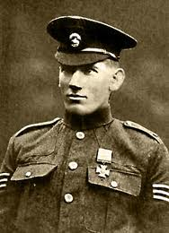

William Cosgrove with his Victoria Cross medal

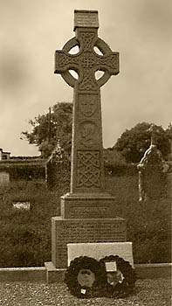

Cosgrove’s grave. The grave features a Celtic cross with the arms of Munster above the effigy of William Cosgrove.

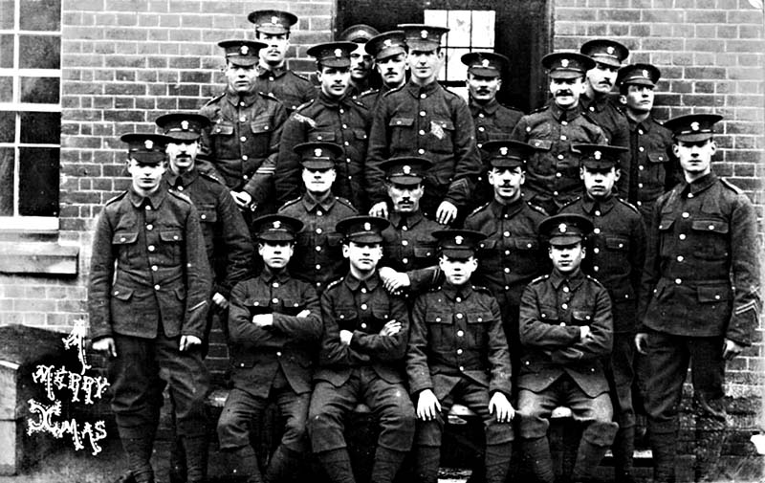

2nd Battalion Royal Munster Fusiliers 1901

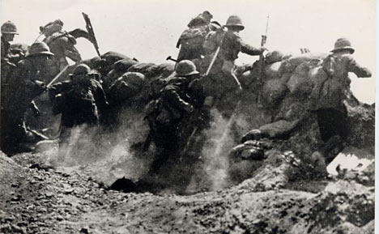

Soldiers of the British Army during the Gallipoli Campaign

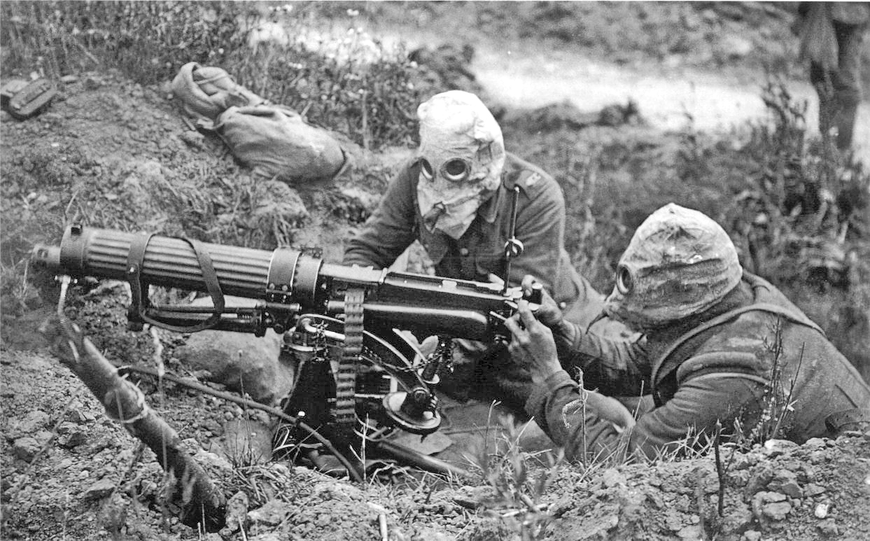

Machine Gunners wearing Gas masks during a chemical attack in the Somme, France 1916

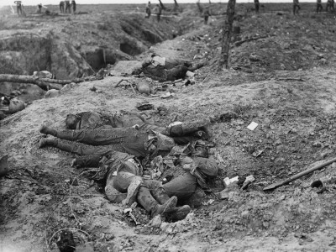

Soldiers killed during the infamous Battle of the Somme

Bibliography

Books

Cooper, Bryan: The Tenth (Irish) Divison At Gallipoli, Published by General Books LLC, 2010

Ekins, Ashley: Gallipoli: A Ridge Too Far, Published by Exisle Publishing, 2013

Gregory, Adrian, Paseta, Senia: Ireland and the Great War: 'A War to Unite Us All'? Published by Manchester University Press, 2002

Hart, Peter: Gallipoli, Published by Profile Books, 2013

Levine, Joshua: Forgotten Voices of the Somme: The Most Devastating Battle of the Great War in the Words of Those Who Survived, Published by Random House, 2008

Prior, Robin, Wilson, Trevor: The Somme, Published by Yale University Press, 2006

Steel, Nigel and Hart, Peter: Defeat at Gallipoli, Published by Pan Macmillan Limited, 2002

Websites
www.history.com
www.historylearningsite.com
http://www.firstworldwar.com/battles/overview_gf.htm
http://www.1914-1918.net/10div.htm
www.victorianforts.co.uk/pdf/datasheets/carlisle.pdf
http://www.1914-1918.net/Gallipoli.htm
www.rmfa.org
www.dublinforum.net

http://www.firstworldwar.com/battles/overview_gf.htm
The Tenth (Irish) Divison At Galipolli pg 6
Defeat at Gallipoli pg 92
Gallipoli Diary by General Sir Ian Hamilton, G.C.B
The Tenth (Irish) Divison At Galipolli p102
The Tenth (Irish) Divison At Galipolli p104
http://www.1914-1918.net/10div.htm
http://www.victorianforts.co.uk/pdf/datasheets/carlisle.pdf
www.rmfa.org
www.rmfa.org
www.dublinforum.net
www.royalfusiliers.com
www.dublinfusiliers.com
www.royalfusiliers.com
http://ww1darryl.blogspot.ie/2008/12/entry-4-gas-attack.html
http://ww1darryl.blogspot.ie/
http://ww1darryl.blogspot.ie/
Ireland and the Great War: 'A War to Unite Us All'? pg 212
Ireland and the Great War: 'A War to Unite Us All'? pg 213

