Readers’ Theatre

This format can be adapted for extracts from any book.
You do not need to have the book Ctrl-Z for this activity.

Ctrl-Z by Andrew Norriss

Devised by Diana Bentley, literacy specialist at Chapter One Bookshop in Woodley, Reading.

On page 2 you will find pages 85-89 from Ctrl-Z by Andrew Norriss. They are typed with a different colour for each character to make it easy for children to follow their parts. Alternatively, you could print in b&w and children could highlight their own parts, which is what Andrew does himself when acting in plays.

Explain to the children that in Readers’ Theatre they will be reading like a writer. Every word is read aloud as Andrew Norriss does when he is writing his books.
The longest part is the narrator who links all the spoken text together. They must try to read with expression and intonation that is appropriate for the characters and the action.

If children have been reading Ctrl-Z, the dialogue starts on page 85 beginning, “The worst argument his parents had… “ and end on page 89 with “…one of the nicest birthdays she could remember.”

Divide the class into groups of 4 and tell the children to take the parts of Narrator, Mum, Dad, Alex.

Tell them to practice reading the parts with expression and intonation. Select a group to present the text to the class.

The introduction which sets the scene could be read either by the narrator or a teacher.

To enhance this activity you could follow up with a discussion about the events that have taken place in the scene.

Points for discussion:
- Mrs Howard’s unusual hobby.
- Mr Howard’s idea for a present.
- How we choose presents for people?
- Does it matter how much a present costs?
- Communication – Why did Alex know better than his father what Mrs Howard would like for a present?
- Why people argue or get into misunderstandings?
- What did you think of the acting?

Readers’ Theatre for Ctrl-Z by Andrew Norriss

4 parts: Narrator Alex Dad Mum

Introduction

Alex has been given a laptop which has a CTRL-Z function that works in his real life. He can go back to an earlier time of the day of his choosing and do it again. Alex’s parents have been going through a difficult time and his Dad wants to get his mum a really good birthday present. Alex’s mum has been working on an old car and has said she would like an engine hoist…

***

The worst argument his parents had, and the one Alex was particularly proud of sorting out, was the one they had on his mother’s birthday. It was the Wednesday of half-term and his father had taken Alex into town to collect the birthday present he had bought for his wife.
Standing in the middle of a brightly lit car showroom, he patted the bonnet of a brand-new silver Toyota and grinned at Alex.
‘There!’ he said. ‘You think she’ll like it?’
‘You’re buying Mum a car for her birthday?’ said Alex. ‘I thought she said she wanted an engine hoist?’
‘I know!’ His father’s smile grew even broader. ‘This is going to be a real surprise! I chose it last week and all I have to do now is pay for it. With this.’ He held out a banker’s draft. ‘It means she won’t break down on the way to important interviews any more. And she won’t have to spend all her spare time repairing that old Triumph, either. She’ll be able to concentrate on getting the sort of job she deserves!’
When Mrs Howard got home at four o’clock that day, swinging her bicycle on to the driveway, Alex and his father were waiting for her, standing either side of the new car. Mr Howard had got a huge piece of pink ribbon and tied it round the middle into a big bow at the top, so that it looked like a real present.
Mrs Howard got off her bike and looked at it.
‘What’s this?’ she said.
‘It’s for you,’ said Mr Howard proudly.
‘Happy birthday!’ said Alex.
Mrs Howard stepped forward to examine the Toyota.
‘I thought I told you I wanted an engine hoist,’ she said.
‘I know,’ said Mr Howard happily, ‘but I got you this.’
‘I’ve already got a car,’ said Mrs Howard.
‘But this one,’ said Mr Howard, ‘is completely reliable! You can go to interviews, drive it to work – it’ll never break down!’
‘And what do I do with that?’ Mrs Howard pointed to the Triumph in the garage.
‘Well . . . you can sell it!’
‘Sell it.’ Mrs Howard looked at her husband. ‘Of course. After I’ve spent two years doing it up, what else would I want to do but sell it?’
‘Look,’ said Mr Howard, beginning to sound rather cross, ‘I think the least you can do after I’ve spent all that money is –’
‘Yes, that’s the other thing,’ interrupted Mrs Howard. ‘You spent all that money without talking to me about it first?’
Mr Howard stared at her. ‘I can’t believe this! You are angry with me for buying you a car?’
‘Yes, I am,’ said Mrs Howard. ‘Very angry.’
‘Oh, for goodness’ sake!’ Mr Howard was beginning to sound quite angry himself. ‘We’ve been working for twelve years so that you can do something a bit more useful with your life than be a garage receptionist, and I thought at least you’d like –’
‘No, you didn’t!’ said Mrs Howard. ‘You didn’t think what I might like at all. All you did was decide what you wanted, and then went ahead and did it!’
After that things followed a familiar pattern. The arguing got worse, the things that were said got more hurtful and the voices got louder and louder until they were both shouting so much that neither of them noticed Alex as he quietly walked back into the house and up to his room.
(Time has been reset with Ctrl-Z)

‘There!’ said his father, patting the bonnet of a silver Toyota. ‘What do you think?’
‘I think it’s fantastic,’ said Alex, ‘but if you’re getting it for Mum’s birthday, I can tell you she won’t like it.’
‘What?’ His father looked rather startled. ‘What do you mean? How can she not like it? It’s brand new. It won’t break down on the way to interviews. It’s –’
‘She’s already got a car,’ said Alex. ‘The Triumph.’
‘Well, she can sell that!’
‘She’s been working on it for two years!’ said Alex. ‘Would you want to sell something you’d been working on for two years and only just finished?’
Mr Howard opened his mouth to speak, then closed it again.
‘You need to trust me on this one, Dad,’ said Alex firmly. ‘Don’t buy the car. Not till you’ve talked to Mum about it. It’d be a mistake. I know it would.’
There was something in the way his son spoke that made Mr Howard hesitate. Things had not been working out too well with Lois recently and he had been hoping that the present would improve things. But if Alex was right . . .
‘Why don’t you call her?’ said Alex. ‘Just to check it’s what she’d really want.’
‘If I call her,’ said his father, ‘it won’t be a surprise.’
‘If it is a surprise,’ said Alex, ‘it’ll be a disaster. Honestly.’
Mr Howard said nothing for several seconds, then slowly took out his mobile and dialled his wife’s number. The conversation he had was short, but left him in no doubt what he should do.
‘Right.’ He turned to Alex. ‘Let’s go and buy that engine hoist.’

Mrs Howard was delighted with her birthday present. It would mean, she pointed out, that she could get at the driveshaft housing without all the trouble of taking her car down to the garage. She gave her husband a huge hug and an embarrassingly soppy kiss, then sat down and opened her cards and her other presents. Later, she ate the supper Dad had cooked, and the cake he had bought and said at the end that it had been one of the nicest birthdays she could remember.

The End
Andrew Norriss

Significant Author & Winner of the Whitbread Children’s Award

Aquila, Bernard’s Watch, Ctrl-Z, The Portal, The Unluckiest Boy in the World and Matt’s Million by Andrew Norriss are all used in many schools for class and group work.

They are perfect for reluctant readers as well as keen readers and as well as being great stories their themes give rise to all sorts of cross-curricular activities and discussions.

More information and resources for Aquila and Andrew Norriss’s other books can be found on
TES Teaching Resources, www.andrewnorriss.co.uk & http://anorrissbooks.wordpress.com/

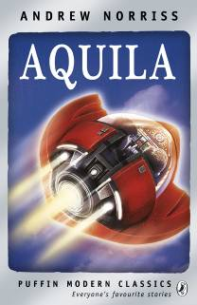
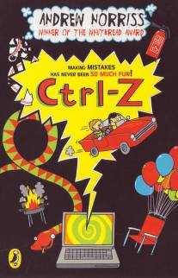


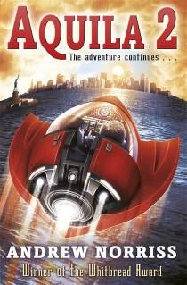

New for 2012 from David Fickling Books (Random House)

I Don’t Believe It, Archie! & Archie’s Unbelievably Freaky Week

Funny stories delightfully illustrated.

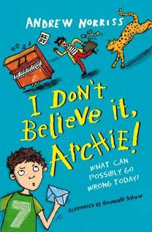
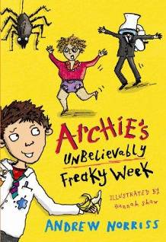

“Read it to Yr 2/3; Yr 3/4/5 can read it alone; and it’ll be great to encourage struggling yr 5/6.” B.R. Hampshire SLS

