30 Essential German Films You Need To Watch
07 June 2014 Features, Film Lists, test by Alex Nasaudean
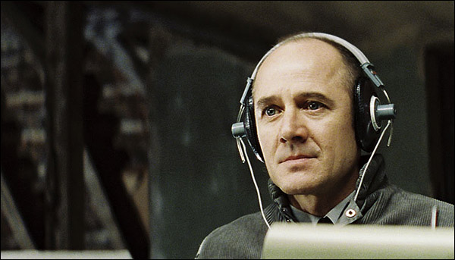
Germany has been a vital contributor to the history of cinema right from the beginning, hitting the ground running when the first cinema for a paying audience in the world was opened in 1895 in Berlin. It was, however, during the interwar period that the social atmosphere relaxed and inspired film-makers created the Golden Age of German film-making.
‘The Cabinet of Dr Caligari’ and ‘Nosferatu’ almost single-handedly established horror as an independent genre. Fritz Lang’s Metropolis still stands tall as the godfather of all science-fiction movies. ‘The Blue Angel’ made Marlene Dietrich an international star, and she still ranks high on any essential female stars of all time list. Everything came to an abrupt halt with World War II, most directors fled to Hollywood with few returning after the war. Germany never recovered its top position in film-making, but the dramatic shifts in its history have produced some of the most remarkable movies in history.
The first signs of true recovery came with what is now known as New German Cinema, one of the many “new waves” which occur constantly in national cinemas around the world. One of the eclectic movement’s starting points was Alexander Kluge’s 1966 ‘Yesterday Girl’.
The movement’s ‘big four’ – R.W.Fassbinder, W. Herzog, Wim Wenders and Volker Schlöndorff are the architects of the relaunch of German cinema, together with important female directors such as Margarethe von Trotta or Helma Sanders Brahms. Their movies are avant-garde, overtly political, literary, poetic and raw. There is daring confrontation with current social realities and with Germany’s complicated past. Many are true wake-up calls. They have contributed vitally to Germany’s evolution and intellectual renaissance.
Most movie-goers, however, are familiar with German movies of the last decade or so. Slightly over-shadowed by the French or the Italians, current German cinema needs to be scrutinized more closely in order to be better appreciated. The influence of Hollywood has been immense. The best example would be any movie involving very successful actor/director Til Schweiger whose feel-good dramas and light-hearted comedies are great popcorn movies. In the area of social dramas and art-house films is where contemporary German cinema’s true strengths lie.
The so-called ‘Berlin school’ who is best represented by Christian Petzold offers mysterious tales reminding one of Lynch or Wenders is carving a respectable niche in the festival circuit. In the social drama category, Matthias Glasner’s aptly titled ‘The Free Will’ about a rapist trying to overcome his urges is highly recommended.
All in all, it is safe to recommend for adventurous viewers not afraid of subtitles to move beyond the old and new classics in this list and into the realm of German auteur cinema, East German science-fiction, German horror movies both old and new, Eurosleaze and many other underrated and undiscovered gems.

30. Trace of Stones (Frank Beyer, 1966)
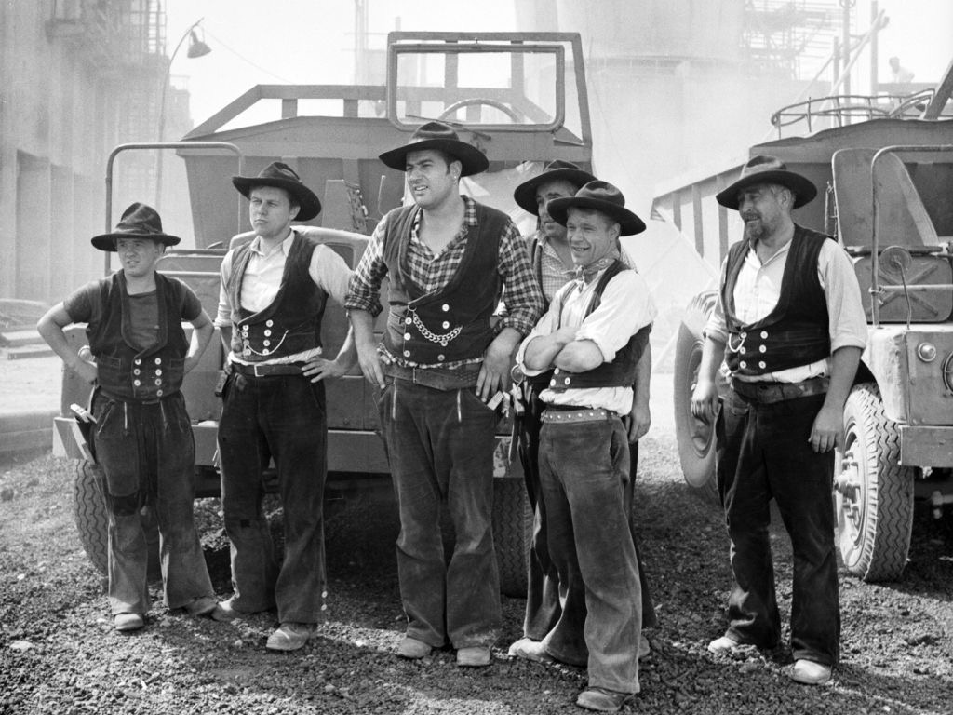
The sole entry from the former East Germany might be criticized for being much too soft on communism, of whitewashing its horrors. One must know that director Frank Beyer was prevented from making movies for ten years after its release, reflecting the bureaucratic nightmare which stifled any perceived side-step. The fight to produce any meaningful artistic artifact was tremendously exhausting and fraught with expected and unexpected perils. The film was shown again in November 1989, after the fall of the Berlin Wall.
The plot is centered on the triangle of Hannes Balla (Manfred Krug) a drunken, rebellious construction foreman, not adverse to skinnydipping in the local pond and pilfering of construction materials, Party Secretary Werner Horrath (Eberhard Esche) who is sent to tone him down and unfazed technician Kati Klee (Krystyna Stypułkowska) who is supposed to offer practical advice. Half romance and half social drama, the film suffers a little from being too long, but its historical value and is uncontested.

29. Tattoo (Robert Schwentke, 2002)

This taut, high-concept, atmospheric thriller in the vein of ‘Se7en’ with some refreshing plot ideas is given a solid boost by the quirky chemistry between slacker, hard-partying rookie cop Schrader (August Diehl) and his veteran partner Chief Inspector Minks (Christian Redl). The Inspector casually blackmails Schrader to work for the homicide department after he busts him for possession of soft drugs at an improvised nightclub.
The case they proceed to work on involves people being literally skinned for their intricate tattoos. Soon they discover that a mysterious group hunts for 12 tattoos made by the same Japanese artists. Everything races for a surprising climax when a heretofore unknown 13th tattoo complicates things even more. Director Robert Schwentke went on to direct the suspenseful but far-fetched ‘Flightplan’ and the witty ‘Red’.

28. Eight Miles High (Achim Bornhak, 2007)
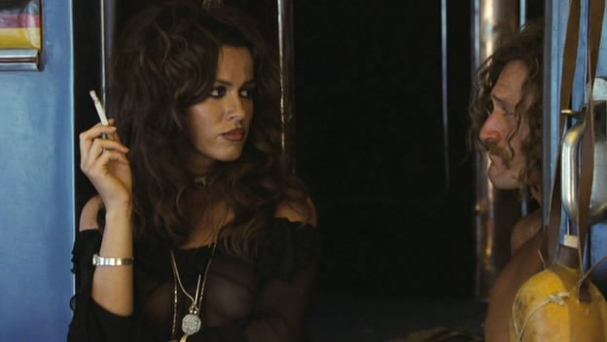
When gorgeous German teen Uschi Obermaier (Natalia Avelon) leaped from the dubious environs of the infamous ‘Kommune 1’ in Berlin right on the cover of ‘Playboy’, even the ‘Rolling Stones’ started paying attention. They invite her to party with them, but astoundingly are no match for a rowdy small-time hoodlum turned globetrotter Dieter Bockhorn.
Their raunchy affair takes to Pakistan and India and even prevents Uschi from becoming an international movie star when she turns down famed Italian producer Carlo Ponti. A lighthearted homage to the swinging sixties, the movie’s over-the-top charms are best personified by the antics of Keith Richards, played with hilarious effects by Alexander Scheer. Hippie nymphs can carry any movie!

27. A Coffee in Berlin (Jan Ole Gerster, 2012)
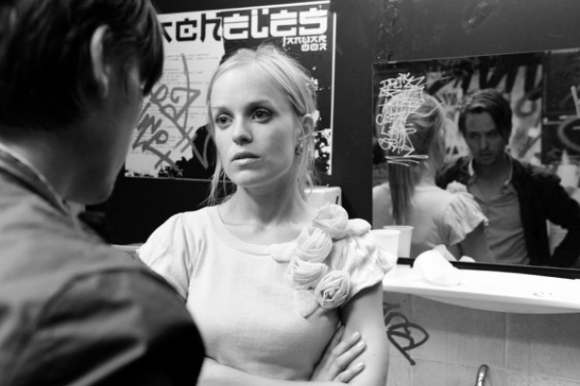
Gorgeously shot in black&white, a film to be enjoyed especially by fans of Jim Jarmusch’s first movies, Woody Allen’s ‘Manhattan’ or the more recent ‘Frances Ha’, Jan Ole Gerster’s debut manages to single-handedly revive German comedy mired in saccharine productions usually involving Til Schweiger or childish slapstick a la Otto Waalkes or Michael Herbig a.k.a. Bully.
A suitable companion piece to the delightfully anarchic Berlin comedy Black Sheep (2006) directed by Oliver Rihs, it is a more introspective and existential film, following the aimless, awkward entanglements of a college drop-out played with admirable restraint by Tom Schilling. To add weight, there’s also some confrontation with the guilt of Germany’s dark past which plays out like a sobering coda to the previous charming light-heartedness.

26. Head-On (Fatih Akin, 2004)
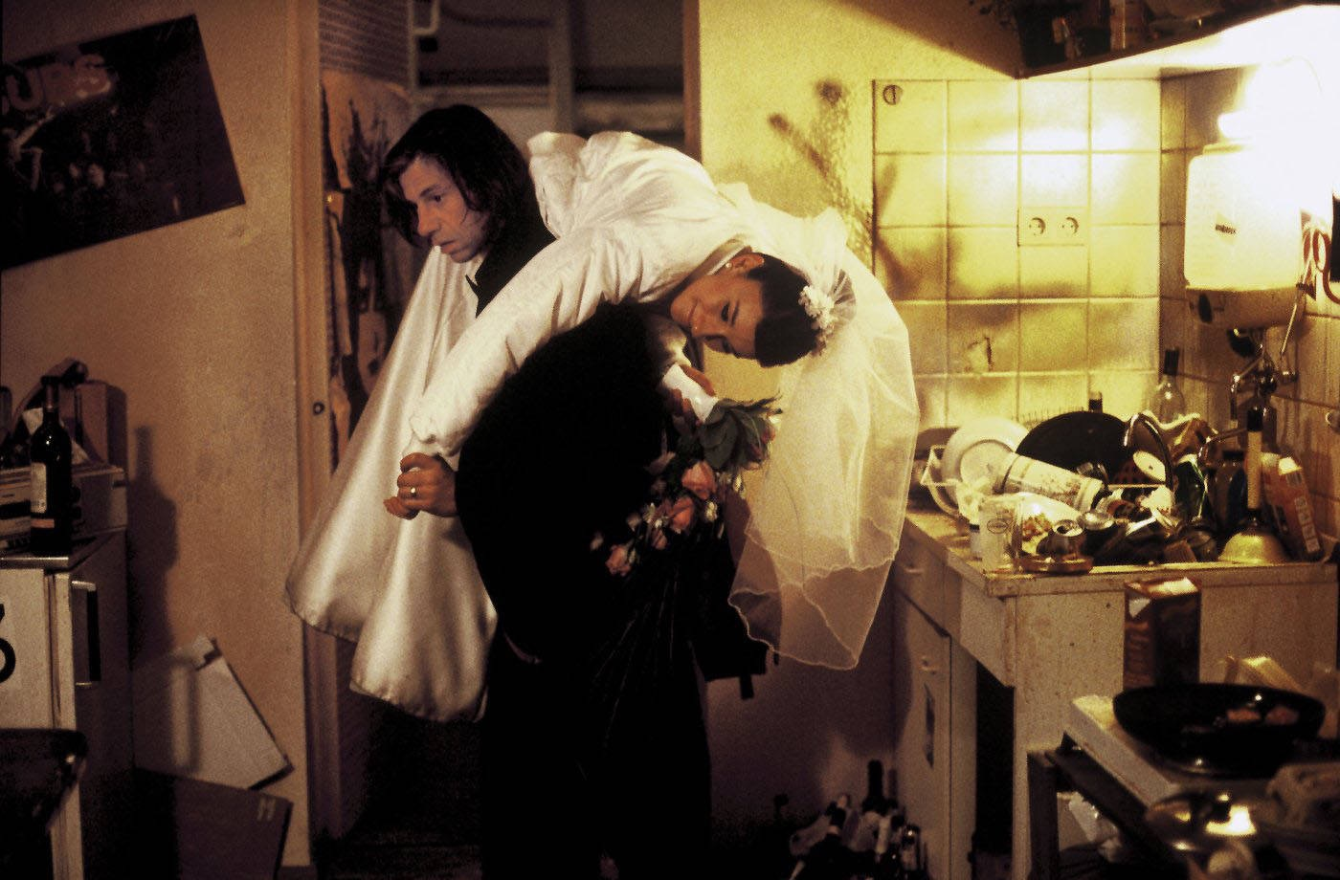
This is a raw and gritty love story between two German Turkish immigrants from Hamburg who slowly fall desperately in love after meeting in a psychiatric institution: Cahit (Birol Unel), a dour, 40-year-old alcoholic and equally self-destructive Sibel (Sibel Kekilli) who is trying to escape her family’s patriarchal possessiveness by proposing a sham marriage to Cahit. Loneliness, jealousy, lust slowly add up and the characters fall in love, thus triggering a series of mishaps which spell doom for the couple. It all plays out bittersweetly in Istanbul.
The authentic feel and the sensitive acting are some of the strong points of the movie, with believable secondary characters and inspiring locations adding up to Fatih Akin’s confident directing and tasteful use of music throughout the movie. The film won the top prize at the 2004 Berlin Film Festival.

25. The Deathmaker (Romuald Karmakar, 1995)
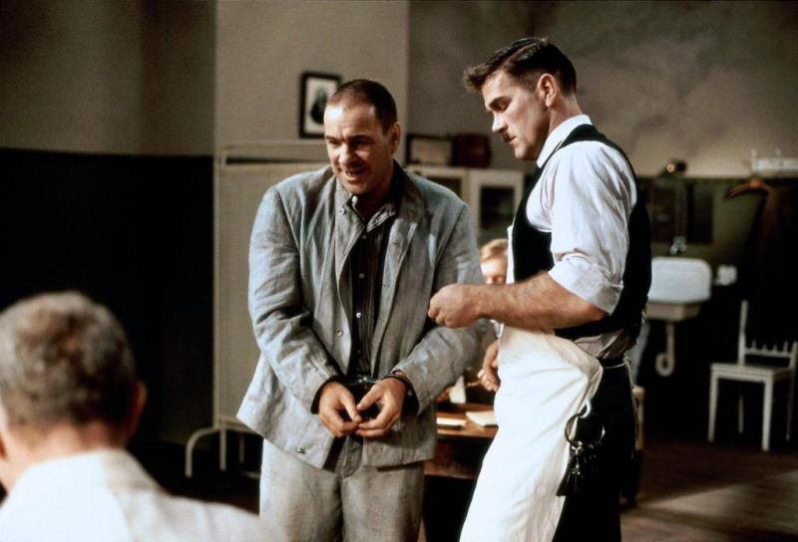
In the venerable tradition of the German Kammerspiel, the whole movie takes place in the interrogation room of a high security prison. The story is based on the transcripts of the interviews conducted by the prison psychiatrist (Jürgen Hentsch) with the notorious German serial killer Fritz Haarmann (Goetz George) who has killed dozens of young boys.
The movie rests almost entirely on the shoulders of Goetz George’s stunning performance who delivers some of the most graphic descriptions of atrocities in any serial killer movie. Fritz is a wily, manipulative and treacherous character, possessing an uncanny ability to enmesh both his interrogator and the viewer into his world of heinous decadence. Together with the gruesome Austrian movie ‘Angst’ (1983) directed by Gerald Kargl, it is one of the best European additions to the serial killer sub-genre.

24. The Baader Meinhof Complex (Uli Edel, 2008)
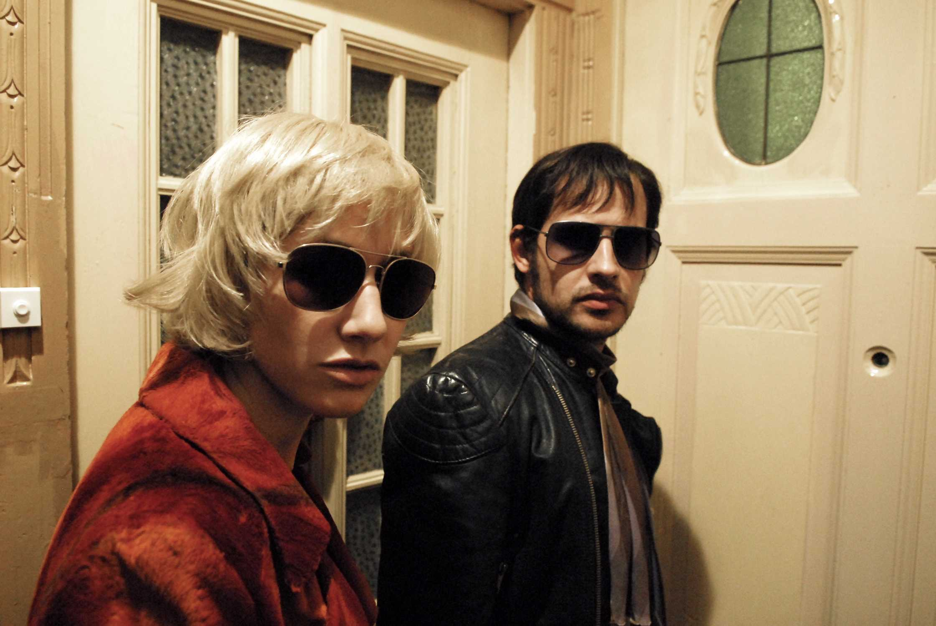
The most entertaining and fluid of the 1970’s German terrorism subgenre (which includes Margarette von Trotta’s ‘Marianne and Juliane’, ‘The Legend of Rita’ and ‘The Lost Honor of Katharina Blum’, both directed by Volker Schlöndorff) is also the most recent one, featuring solid performances from Moritz Bleibtreu who is one of the most recognizable German actors working today, together with Til Schweiger and Daniel Brühl, Martina Gedeck and Johanna Wokalek. They personify a trio of radicalized activists who turn deadly: Andreas Baader, Ulrike Meinhof and Gudrun Esslin.
The film functions as both thriller and social drama, it offers insight into the troublesome 1970’s in Germany and it manages to keep its distance from the controversial and flawed characters in their battle against an even more reprehensible social system. This is required viewing for anyone interested in recent German history and sweeping docudramas with an attention to detail.
Ad Injection:bottom

23. The Experiment (Oliver Hirschbiegel, 2001)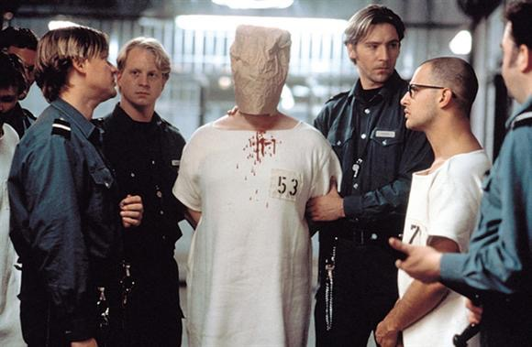
Tarek Fahd (Moritz Bleibtreu), a journalist, takes part in a scientific study in order to write an article about it and have some fun. It is a social experiment supposed to last two weeks inspired by the infamous real-life Stanford prison experiment from 1971, structured like a role-play: half the selected subjects are prisoners while the other half play the guards.
Human nature being what we know it to be, everything soon turns drastically violent, involving gradual mind games and a mysterious black box. Connecting everything with Germany’s dark past, the perfect casting and the actor’s sure-shot delivery makes it an eerie and timeless viewing experience, devoid of stylistic bombast.

22. Good Bye, Lenin (Wolfgang Becker, 2003)
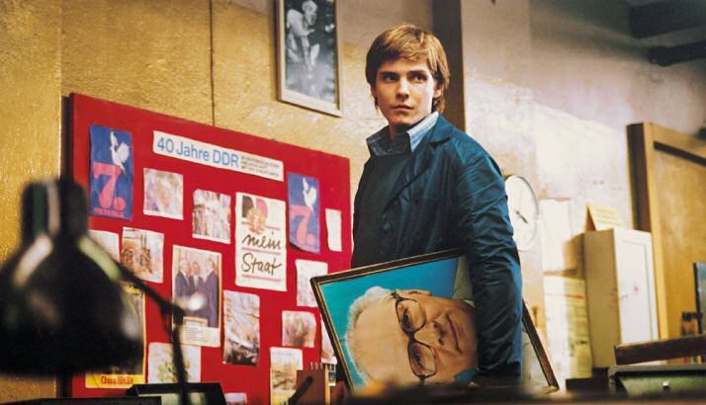
The year is 1989 and Christiane (Kathrin Sass) is the East German mother of two grown children, Alex (Daniel Brühl) and Ariane (Maria Simon). The three have grown especially close since Dad left them in 1978, apparently because he found a new love in the West. Their life behind the Iron Curtain pleases Christiane well enough, but Alex is restless. The last thing his mother sees before she collapses into a coma is Alex being beaten by riot police.
When she awakens eight months later, the Wall is down, Germany is reunified, and the Iron Curtain is now an enormous Coca-Cola banner. Ariane works at Burger King, and Alex has a job installing cable TV. Commercialism, capitalism and cross border freedom are things she’s assumed not be able to cope with, so her children weave an increasingly outrageous and far-fetched web of deceit, which includes fake news bulletins, procurement of food from the old days etc.
An allegorical family drama, Wolfgang Becker’s movie is a heart-warming viewing experience imbued with nostalgia and centered on one of the most momentous events in recent European history.

21. Run Lola Run (Tom Tykwer, 1998)
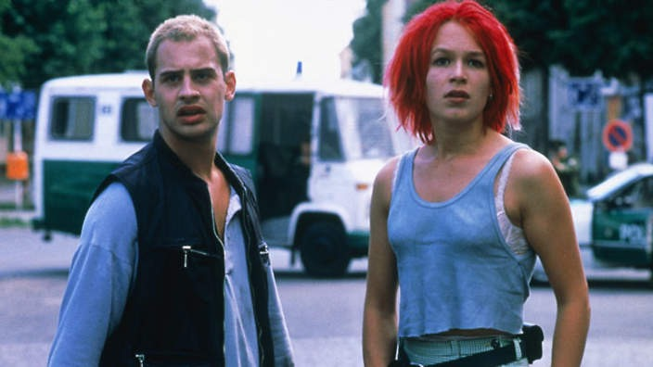
A teenager movie more than anything else, it offers all the cheap visual thrills one might imagine (kinetic animation, black and white flashbacks, fast forwards etc) while being the perfect homage to the MTV-generation of the 90’s. The story involves doomed patsy Manni (Moritz Bleibtreu) who manages to misplace a bag of money in the subway and his vermilion-haired lover and would-be savior Lola (Franka Potente), who has to help him get the money back to avoid retribution.
The movie plays out in three alternate versions of the same story (think Groundhog Day on steroids), all dependant on split-second decisions which crucially alter the characters’ destiny. Peppered by philosophical interludes disguised as flashbacks and held together by Lola’s constant running through the streets of Berlin, the movie manages to pack a wallop of sensory stimuli in its brief 81 minutes of running time.

20. Downfall (Oliver Hirschbiegel, 2004)
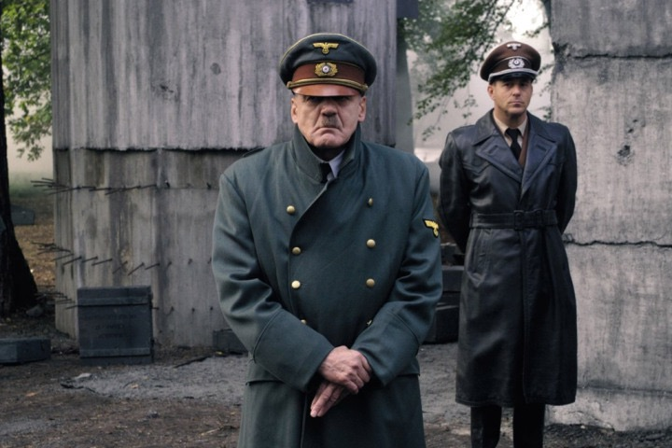
The last 10 days of Adolf Hitler (Bruno Ganz) are viewed through the eyes of his naïve last secretary Traudl Junge (Alexandra Maria Lara), thus bringing the viewer uncomfortably close to the most despicable and pathetic human in history. It’s a bold piece of film-making which necessitates repeated viewing. A suitable companion piece would be the 1984 German TV-movie ‘The Final Solution:
The Wannsee Conference’ a real-time reenactment of the starting point of the Holocaust which offers unprecedented insight into the bureaucratic workings of evil as opposed to the purely psychopathic, personal evil of Hitler. After unwillingly getting to know Hitler better, what is truly astounding and perfectly reflected in the movie, is the contempt Hitler felt for his own people. This is probably true for dictators and so-called strongmen everywhere.

19. The Blue Angel (Josef von Sternberg, 1930)
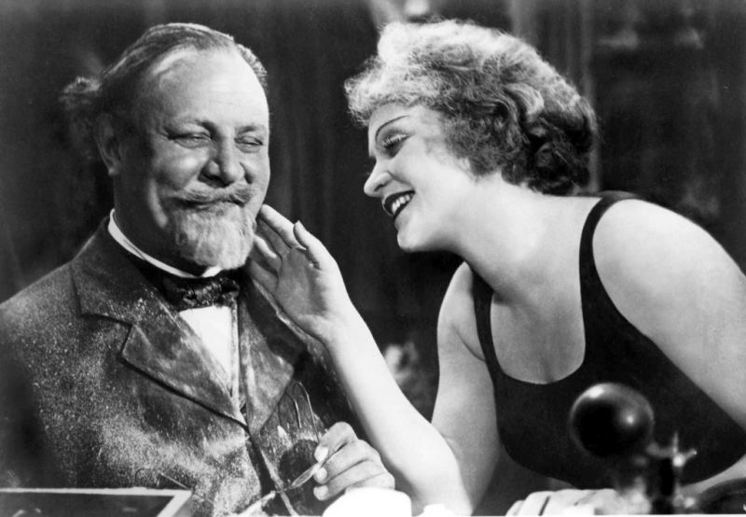
The film that made Marlene Dietrich a shooting star, this is a classic tale of obsessive lust and desperate love which catapults the central character, professor Immanuel Rath into disaster. A strict disciplinarian, he is constantly taunted by his students. When he discovers that they like to spend time at the local cabaret, he decides to pay a visit and have a word with the sleazy manager. There, he is immediately awestruck by the sensual, gorgeous Lola (Marlene Dietrich) and manages to relax in the convivial atmosphere.
A torrid affair ensues, social disapproval reaches a breaking point and the professor is eventually fired. A familiar theme is turned into a complex morality play, still relevant today, not just for the unforgettable Marlene Dietrich.

18. My Fuhrer (Dani Levy, 2007)
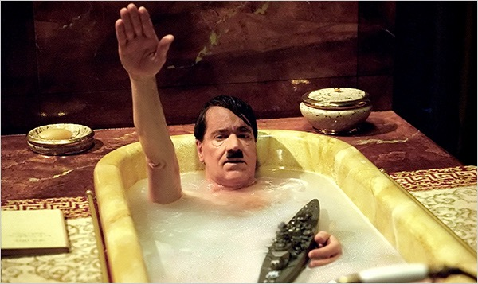
An underrated satirical masterpiece, this little gem sets off to depict Adolf Hitler like never before. It is a more intelligent piece of alternative history than Tarantino’s ‘Inglorious Bastards’ ever hoped to be, executed with less bombast and more panache. The story unfolds in December 1944, when the German army was suffering defeat after defeat, thus leading Minister of Propaganda Dr Joseph Goebbels (Sylvester Groth) to hatch a desperate plan.
The Fuhrer (Helge Schneider) is to give a mobilizing speech to reignite the energy of the miserable masses. Hitler is an emotional basket case, suffering from various phobias and unwilling to appear in public. As a last resort Hitler’s infamous entourage enlists Adolf Grünbaum (Ulrich Mühe), a Jew who has long since been deported to a concentration camp despite having served as Hitler’s acting coach at the start of the Fuhrer’s political career. Grünbaum agrees to help on the condition that his wife (Adriana Altaras) and four children are kept alive.
What follows is a truly memorable viewing experience, full of hilarious moments and biting satire, a paean to Jewish humour, brilliantly conceived by writer-director Dani Levy. This time Hitler truly gets it on his chin!

17. The Marriage of Maria Braun (R.W. Fassbinder, 1979)
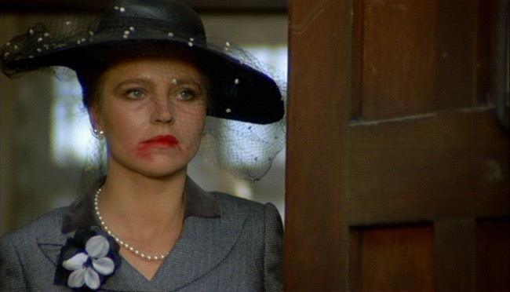
The first film in Fassbinder’s trilogy about women in post-WWII Germany (the other two are ‘Veronika Voss’ and ‘Lola’) helped bolster his international reputation, gave star Hanna Schygulla the role of her career and paid his dues to one of his favorite directors, Hollywood émigré of German origin Douglas Sirk (director of such melodramas as ‘Written on the Wind’ or ‘Imitation of Life’).
During the allied bombing of Germany, Maria decides to get married to her fiancé Hermann Braun. He is shipped off to the Russian front, she hovers desperately around the train station to catch any news about the situation on the front and, after hearing about his supposed death, gets involved with Bill (George Byrd) a black American soldier. Everything takes place against the bleak and chaotic background of post-war Germany trying to rise from the ashes. It’s a highly stylized film, laden with irony, but raw and intense at the same time, centered on Schygulla’s performance as an ice queen with a heart of gold.

16. Das Boot (Wolfgang Petersen, 1981)
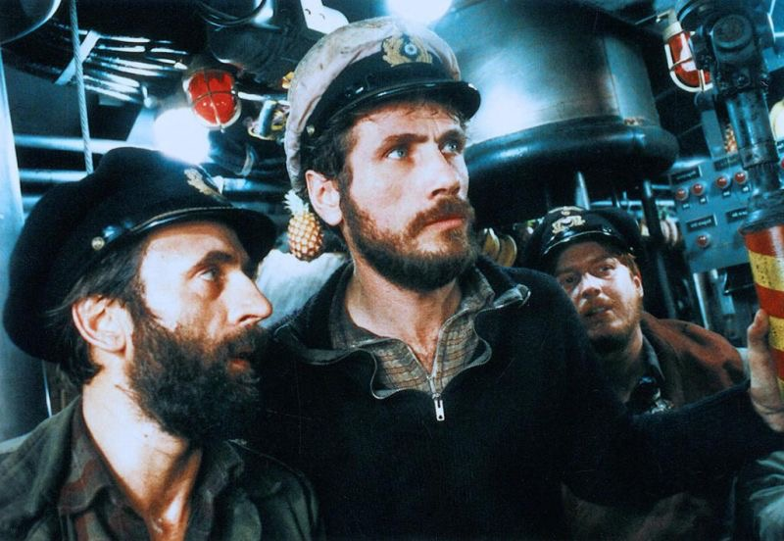
What sets ‘The Boat’ apart from other war movies is its capacity to pull the viewer down the hatch and give him enough sensory perception of the inside of the U-Boat and understanding of the inner workings of the minds of this crew. Tedium, claustrophobia and fear are constant, palpable companions. The battle scenes interrupt the monotony, the conversations reflect lack of trust in the possibility of winning the war and the capacities of the Fuhrer.
They quickly switch from being hunter and prey while patrolling the Atlantic. The towering central performance by Jürgen Prochnow as the fearless commander and the phenomenal camerawork by Jost Vacano are truly mesmerizing. The best way to enjoy the movie in full splendor is to seek out the 1997 restored version. For aficionados there is also a six-hour German miniseries.

15. Fitzcarraldo (Werner Herzog, 1982)
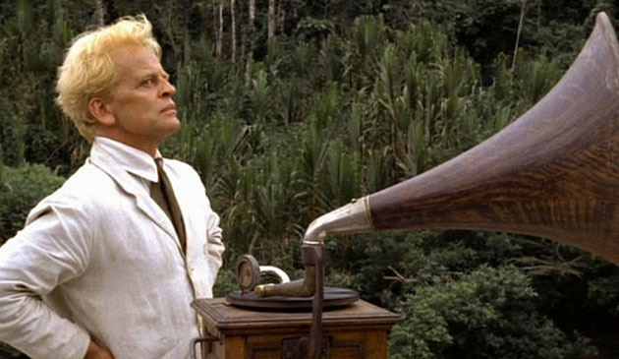
Stories about slightly mad, hopeless dreamers have rarely received a better treatment than in this operatic drama about Brian Sweeney Fitzgerald, known as Fitzcarraldo, an Irish impresario who dreams about building an opera house in the middle of wild jungle in Peru and then have Enrico Caruso perform on its stage.
To achieve that, he tries to move a large steamboat over a mountain. 10 years after the epic adventures of filming ‘Aguirre’, Kinski and Herzog have managed to create another colossal monument of cinematic insanity. Les Blank has chronicled the filming in his documentary ‘Burden of Dreams’.

14. Christiane F. (Uli Edel, 1981)
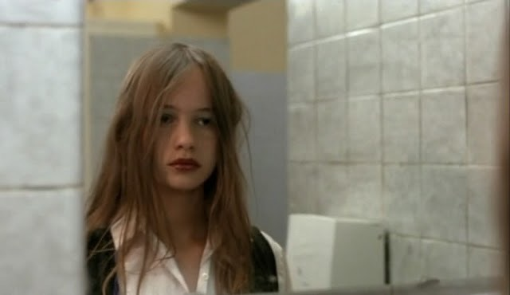
The underworld of drugs and prostitution of ‘70’s Berlin gets a grim portrayal in this bleak coming-of-age drama which boasts a David Bowie soundtrack and vivid acting by an amateur cast. 13-year-old Christiane (Natja Brunkhorst), out of touch with her life and neglected by her recently divorced mother, tries to find solace by partying the weekend nights away in ‘Sound’, the hippest disco in West Berlin.
There she meets Detlev a shy, sweet boy who is a heroin addict. After the initial exhilaration offered by puppy love and mild juvenile delinquency, Christiane succumbs to addiction herself. They are both forced into prostitution. Eventually they decide to go cold turkey together in the most harrowing scene of the movie. It is one of the most effective, unrelenting anti-drug movies ever made, a bone-chilling cautionary that hasn’t lost any of its power over time.

13. Nosferatu (F.W. Murnau, 1922)
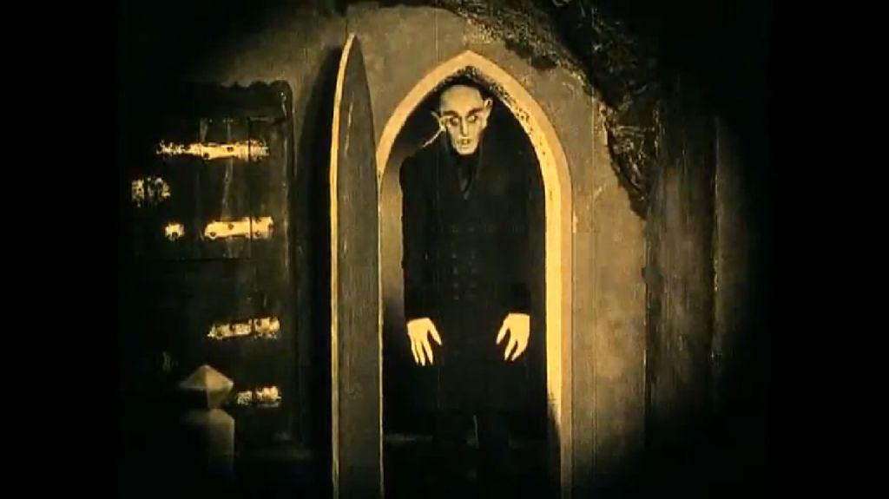
With the plot almost literally lifted out of ‘Dracula’, just some names and locations changed, the foremost reason this film continues to fascinate is the performance of Max Schreck as Graf Orlok Nosferatu, wearing some of the most iconic facial make-up ever seen in a movie. The scare tactics of this first of vampire movies rely more on dread that brute fear.
Being under the influence of German Expressionism, with its credo of dramatic interplay between light and dark, the vampire in this movie even casts a shadow! From the many movies that trace back their influence to this film, perhaps the most intriguing standout is “Dracula: Pages From a Virgin’s Diary” by Canadian director Guy Maddin.

12. Berlin Alexanderplatz (R.W. Fassbinder, 1980)
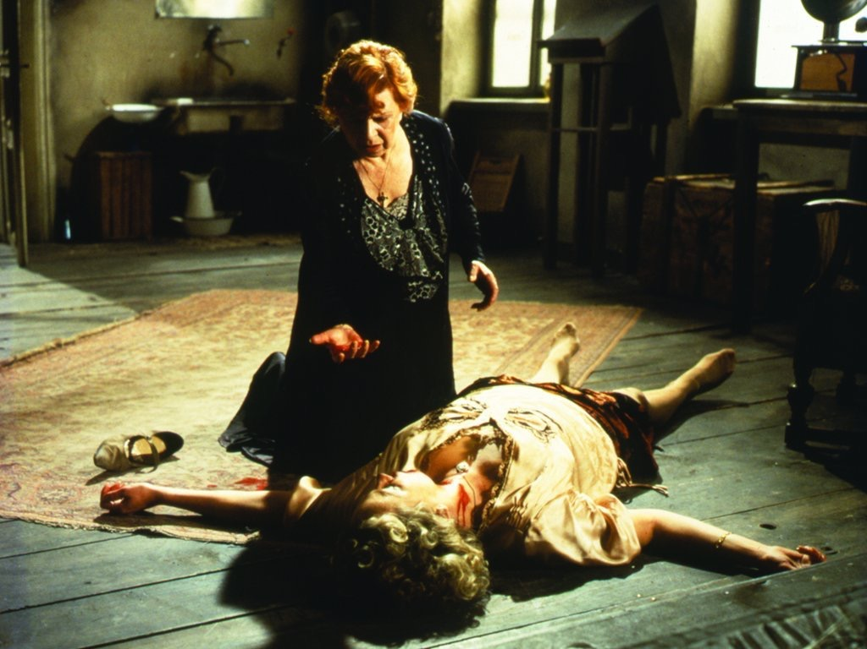
Rainer Werner Fassbinder’s magnum opus stretches out for 15 and a half hours, claiming to be the longest narrative film in history mostly shown as a miniseries on TV. It is the heartfelt culmination of the mostly avant-garde work of one of Europe’s most appreciated auteurs, an adaptation of Alfred Döblin’s classic modernist novel from the 1930’s.It is a lavish, occasionally overblown melodrama about one man, Franz Biberkopf (played by the unjustly forgotten Günter Lamprecht), trying to come to terms with himself and his many weaknesses, the most consuming of which is his almost sexual involvement with out-of-control pimp Reinhold.
This is doubled by Fassbinder’s own involvement with the movie’s central character to which he gives voice in the two-hour epilogue of the movie. This is recommended only for serious film fanatics with a penchant for artsy melodramas able to sit through the gargantuan length of the movie.

11. Pappa Ante Portas (Loriot & Renate Westphal-Lorenz, 1991)
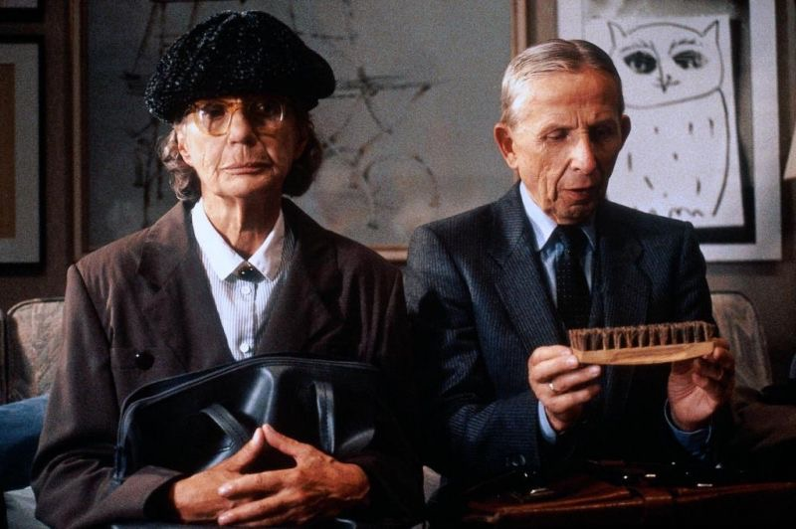
This is probably the best German art-house comedy of all time, starring national treasure Loriot (real name Vicco von Bülow) as Heinrich Lohse, a seemingly respectable head of department at a pipe factory. He promptly loses his job after ordering 40 years worth of typing paper for his office in order to save a few lousy bucks.
What follows is a subtly acted, perfectly timed comed of errors, with a perfect balance between Loriot and Evelyn Hamann as his stoic wife Renate. Every single word is in the right place, every innuendo refreshingly funny, a reflection of Loriot’s prodigious writing talents.

10. The Lives of Others (Florian Henckel von Donnersmarck, 2007)
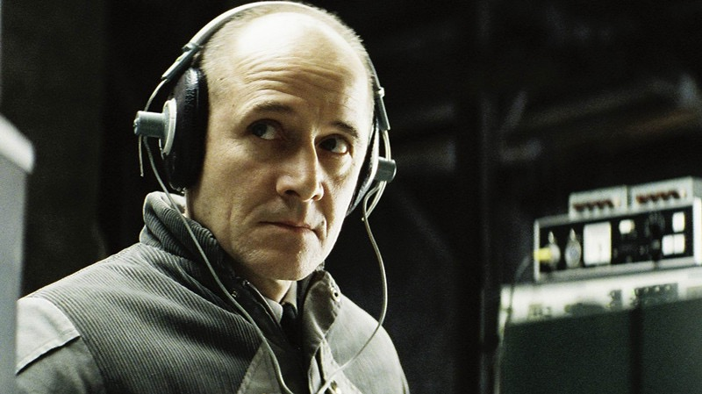
This tale of quiet deception is one of the most unforgettable Cold War spy-thrillers, seemingly coming out of nowhere to become one of the most talked about German movies of the last decade, and one of the most remarkable film debuts in history. Gerd Wiesler (Ulrich Mühe), an agent of the notorious East German secret police, the Stasi, slowly becomes emotionally involved with and then eventually deeply entangled in the lives of the people he has to spy on.
A touching movie about loneliness and redemption, it has been compared to Francis Ford Coppola’s masterpiece ‘The Conversation’.

9. Aguirre, The Wrath of God (Werner Herzog, 1972)
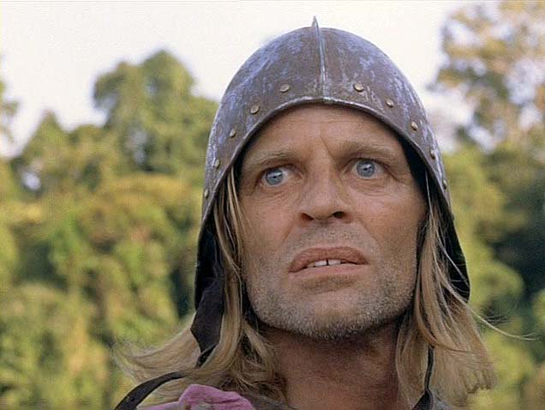
Based on the journals of a priest who accompanied Spanish conquistador Gonzalo Pizarro, younger half-brother of Francisco Pizarro, the conqueror of the Inca Empire, the movie follows a troupe of ragtag conquistadors led by the manic Lope de Aguirre (Klaus Kinski) as they plunge into the Peruvian jungle looking for the elusive riches of El Dorado.
At the crux of the movie lie the horrendously demanding location shots and the obsessive performance by larger-than-life Klaus Kinski. Kinski and Herzog went on to form one of the most legendary actor-director partnerships in film history, second only to that between de Niro and Scorsese. The swashbuckling credentials of this movie have been surpassed only by Coppola while filming ‘Apocalypse Now’.

8. Ali: Fear Eats the Soul (R.W. Fassbinder, 1974)
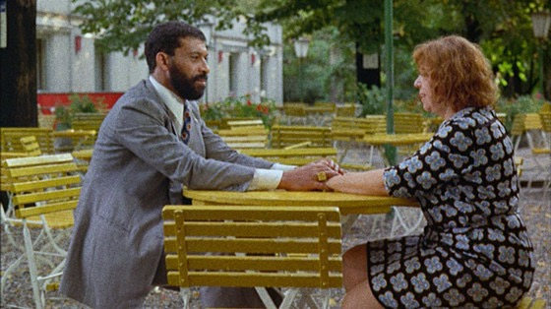
One of the best films of the New German Cinema period, this most personal of Fassbinder’s projects (he produced, scripted and directed) tells the deceptively simple and familiar love story between elderly cleaning lady Emmi (Brigitte Mira) and the young Moroccan immigrant worker Ali (El Hedi Ben Salem). They meet in a bar, awkwardly fall in love and face due societal opprobrium.
Something so familiar and pedestrian is turned from lurid soap opera material into an agonizing meditation on human hypocrisy and cruelty by Fassbinder’s uncanny ability to inject his own personal tragedies and disillusions into his characters. He was able to do this in most of his more than 40 movies before his untimely death at 36 from a cocaine overdose.

7. Wings of Desire (Wim Wenders, 1987)
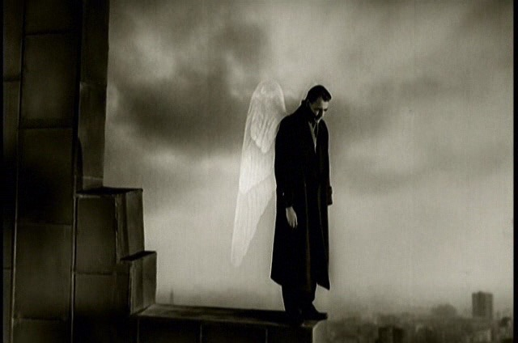
A unique, enriching and literate movie, it tells the story of two angels, Damiel (Bruno Ganz) and Cassiel (Otto Sander) whose duty is to watch over the people of Berlin. Eventually Damiel grows too attached to the plight of the people he seeks to help and sheds his immortality in order to experience life and love as a human. This familiar literary motif taken straight out of the Romantic movement’s cookbook is given a poetic, languid and ponderous treatment by this most philosophical of German filmmakers.

6. The Cabinet of Dr Caligari (Robert Wiene, 1920)
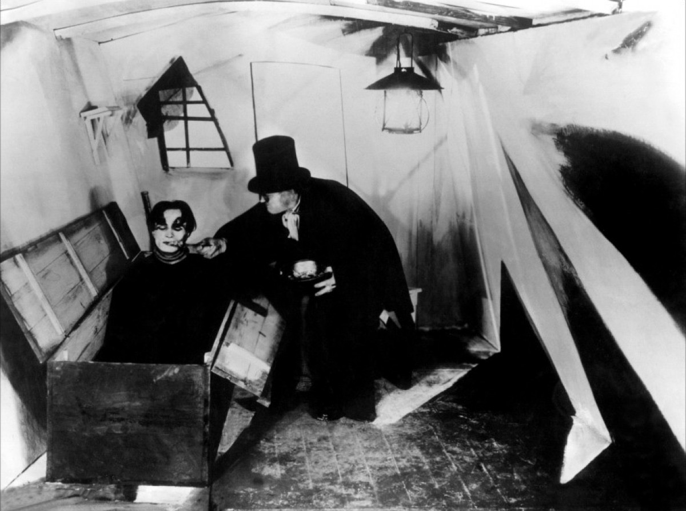
A product of huge shifts in artistic imagination in the wake of the brutal, mechanized and profoundly dehumanizing World War I, this most influential of silent films is seen by many as one of the first horror movies. The simplistic plot involves mysterious hypnotist Dr Caligari (Werner Krauss) who has sleepwalker Cesare under his spell and together the walk the carnival circuit. Following the murder of his friend, Francis (Friedrich Feher) begins to suspect the doctor.
The undisputable star of the movie is the Expressionist set design, stark, angular and creepy, which went on to become a strong influence on the film noirs of the 1940’s when German directors like Billy Wilder or Fritz Lang escaped to America from the Nazis, bringing the legacy of German Expressionism with them.

5. Stroszek (Werner Herzog, 1977)
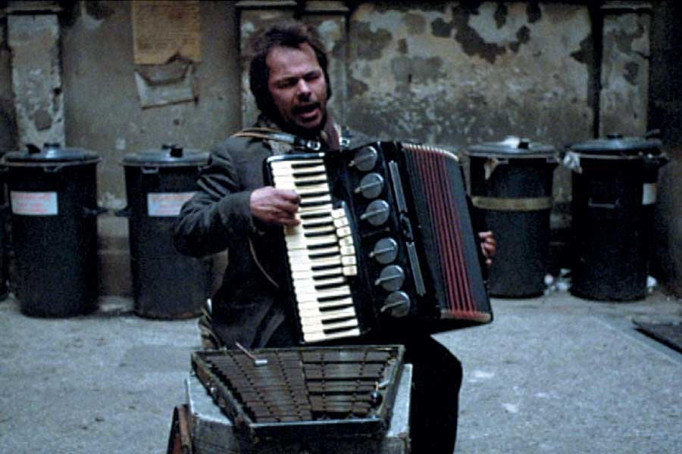
Boasting one of the most heart-wrenching closing credits ever, this movie is perhaps most famous for being the last movie Ian Curtis, the singer of legendary British band ‘Joy Division’ watched before hanging himself. Other tidbits about the movie: Bruno S, the central performer, had spent 23 years in a mental institution after being almost beaten to death by his prostitute mother and had become almost autistic; the script was written by Herzog in a few days after visiting Plainfield, Wisconsin, the birthplace and stomping ground of infamous serial killer Ed Gein (alleged inspiration for ‘Psycho’, ‘Silence of the Lambs’, ‘Manhunter’)
This highly poetic docudrama follows the always surprising meanderings of three misfits who try to escape from their dreary lives in a Berlin suburb to the vast meaninglessness of Wisconsin. It is truly one of the most moving films ever made.

4. Metropolis (Fritz Lang, 1927)
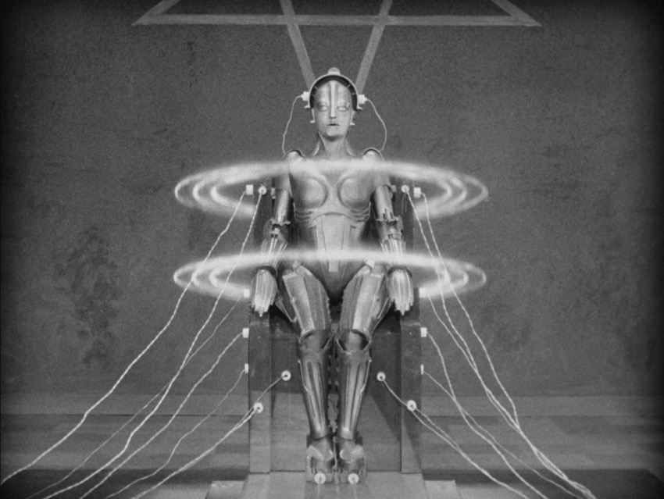
Considered by many to be the most influential science-fiction movie ever made, it opened up the floodgates of imagination and its influence has trickled down into modern classics like ‘Blade Runner’,’ The Matrix’ or ‘Star Wars’. The culmination of Germany’s ‘Golden Age’ of cinema, it nearly bankrupted the UFA studios, but managed to leave an indelible mark on the movie canon, with its story about pointless industrial drudgery and class warfare set against the background of some of the most gigantic movie sets ever constructed.
The newly restored 2008 version accompanied by Gottfried Huppertz’s original score is the preferred version, although one can find a 1984 shortened version, which features Billy Idol on the soundtrack.

3. The White Ribbon (Michael Haneke, 2009)
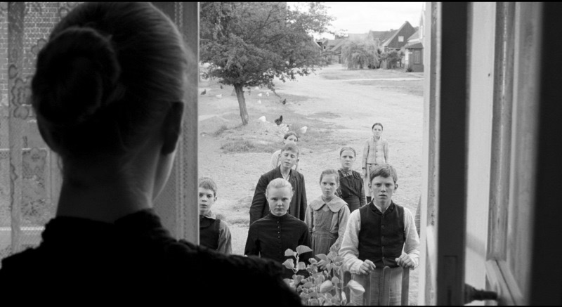
A tour de force of somber and melancholic cinema, the last German film to win the Palme d’Or, ‘The White Ribbon’ is Michael Haneke’s masterpiece. The film’s hypnotic and magical effect is akin to a crystal-clear and ice-cold mountain lake which lures any casual passer-by to take the plunge. People accusing it of unnecessary pretentiousness, lack of cathartic denouement or slow pace should stick to re-runs of Sex and the City. It is unquestionably the best German movie of the past decade.

2. The Tin Drum (Volker Schlöndorff, 1979)
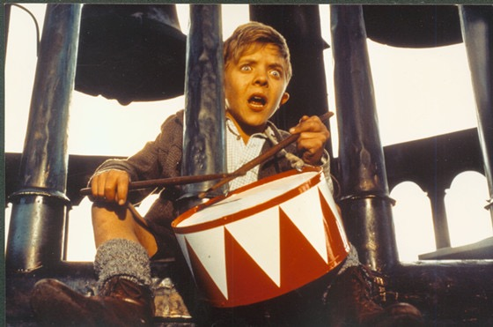
An allegory about the rise and fall of National Socialism in Germany, it’s based on the classic novel of the same name written by Nobel prize winner Günter Grass.
The movie is accompanied by the narration of its central character Oskar Matzerath, played to perfection by young David Bennent. In Danzig, a city with a complicated history located in East Prussia (now in Poland), Oskar’s mother Agnes (Angela Winkler) loves two men, the German Alfred Matzerath (Mario Adorf) and her Polish cousin Jan Bronski (Daniel Olbrychski). Oskar’s biological father is Bronksi, but Matzerath goes on the record. We can hear Oskar’s disdain for the fickleness of the outside world right inside his mother’s womb.
Fed up with his mother’s constant philandering and the hypocrisy of the adults around at age 3 Oskar decides to have an accident and stop growing. His only consolation in life is a red-and-white tin drum which he bangs often to protect himself from anything unpleasant. When that doesn’t work, he emits an ungodly, glass-shattering shriek. Oskar works as an embodiment of the social complacency in face of evil (he witnesses the rise of the Nazis), the politics of burying one’s head in the sand in front of anything unpleasant around and avoiding any responsibility. The perpetual timeliness of this theme and the way it is expressed here, make this film one of the most enduring masterpieces of German cinema.

1. M (Fritz Lang, 1931)
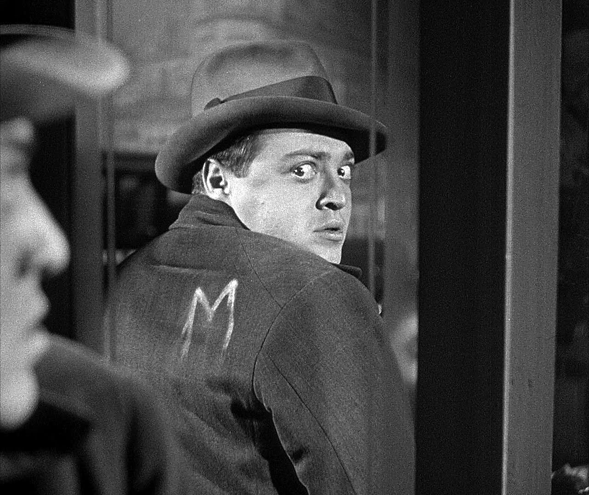
Making a movie that tries to sympathize with a monster even in the remotest possible and getting away with it is a hard task for any director. Imagine accomplishing that more than 8 decades ago with an actor previously known for his comedic roles, Peter Lorre who transforms himself into Hans Beckert, an ogre who is kidnapping and killing small children on the streets of Berlin in 1931.
Possibly conceived as a cautionary tale to urge parents to take better care of their children, the movie has lost absolutely none of its artistry and emotional impact, and remains one of the most haunting serial-killer movies ever made, with mysterious whistling and chalk marks playing important roles in the ingeniously unfolding plot. One might say that this movie opened the stylistic doors for film noir and its counterpart in eeriness, Charles Laughton’s ‘The Night of the Hunter’ closed them in 1955. Timeless classic of the highest order.
Author Bio: Alex Nasaudean is an English teacher from Romania, currently working in China. A long-time movie addict, his favorite directors include David Lynch, Martin Scorsese, Michael Haneke, Takeshi Kitano etc.

Read more: http://www.tasteofcinema.com/2014/30-essential-german-films-you-need-to-watch/#ixzz3gW1MQTuk

