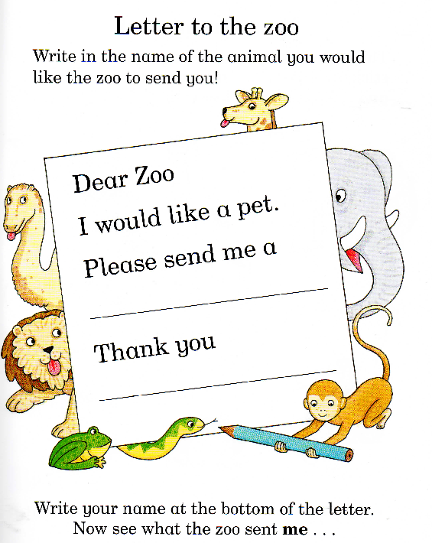
Write your own letter to the Zoo, Use as many words as you can to describe the animal you would like them to send you.

