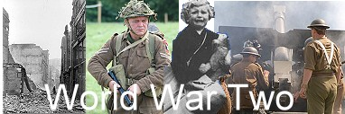
http://www.woodlands-junior.kent.sch.uk/Homework/war/campaigns.htm

World War 2 and Britain

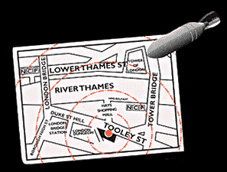
http://www.britainatwar.co.uk/page1.html

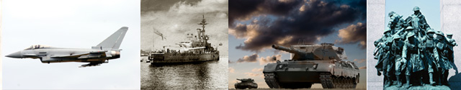
http://www.britainatwar.com/WW2.html
Introduction to World War II

- In 1918, Germany lost World War 1. It had to give up land and was banned from having armed forces.
- In 1938, Adolf Hitler was appointed as their new leader. He vowed to make his country great again, planning to seize land from other countries and with visions of world domination.
- On September 1st, 1939, Hitler staged a Polish attack on a German radio station in order to justify an attack back on Poland.
- France and Britain had a defensive pact with Poland and therefore were forced to declare war on Germany after Hitler refused to withdraw from Poland – Britain then joined the war on the 3rd of Sept 1939 – Neville Chamberlain was Prime Minister at that time.
- There were two sides in World War II – the axis and the allies. The axis included Germany, Italy and Japan. The allies involved many countries e.g.: Britain, Canada, United States and Australia.
- WWII ended with the unconditional surrender of the axis powers.
- In May 1945 the allies accepted Germany’s surrender – about a week later Hitler committed suicide.
- VE Day marked the end of the Second World War – 8th May 1945.
- Street parties were held all over Britain to mark the end of the war.

- World War II lasted for almost six years and took place between the years 1939-1945.
- It involved 61 countries and three quarters of the world’s population.
- Fifty million people lost their lives and hundreds of millions of people were injured.

Rationing, ID Cards

During World War 2 Germany tried to cut off supplies entering Britain. Many ships bringing food and other goods to Britain were attacked by German submarines. As a result there was a huge shortage of some of the essential foodstuffs; therefore, rationing was introduced by the government to ensure everyone got their fair share. They were afraid that as foods got scarcer that prices would go up and the poorer people would not be able to afford to feed themselves.

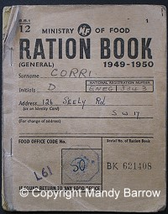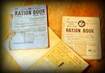
http://www.britainatwar.co.uk/page1.html

Every person had to register to get their ration book. When they wanted to buy some food, that item would either be crossed off in their ration book or the token be taken.

National Identity cards were also issued by the government to each individual, man, woman and child. This card had to be carried with you at all times enclosing your name and address. Id was necessary in the event of getting separated from your family or in case of injury or even death that the body could be recognized.

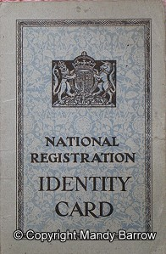

Quote from a schoolgirl during the war:
I remember my uncle fetching back some bananas when he came home on leave. He gave me one and I took it to school. Everyone crowded around me and my teacher showed it to the whole class. It seemed like a priceless treasure. I was a very popular girl that day. Everyone wanted me to open it and eat it, but I wouldn't. I took it back home with me and left it till it went black, but it still smelled so good. Even now I can't smell ripe bananas without evoking that memory. (http://www.bbc.co.uk/dna/h2g2/A533918)
The Blitz

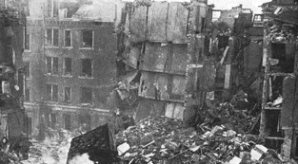
The Blitz got its name from the heavy and frequent bombing attacks on London and other cities in Britain. From September 1940 until May 1941, German bombers attacked British cities, ports and industrial areas – London was bombed every day and night for eleven weeks – destroying over one third of the city. During the Blitz 32,000 civilians were killed and 87,000 were seriously injured.
The museum has a whole section dedicated to the Blitz, visitors can see depictions of bomb site remnants.
Air Raid Warning
Sirens were placed throughout the towns to warn people of a likely air raid. The sirens made a very loud and long signal or warning sound. Replica siren sounds can be heard in the Anderson Shelter in the museum.
Blackout
During the war, everyone had to cover their windows and doors at night (before sunset) with heavy blackout curtains, cardboard or paint. This was so the planes flying above could not see where the cities were located at night – therefore not being able to locate where they intended on bombing.
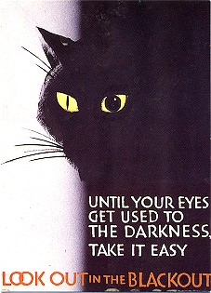
http://www.woodlands-junior.kent.sch.uk/Homework/war/blackout.htm
Air Raid Shelter
Anderson Shelters half buried in the ground were used during the raids to protect themselves and take shelter from the bombs beings dropped by the Germans.
By Sept 1939 over one and a half million shelters were built.
When bombing got harsher people sought further safety in the underground stations. On the busiest night 177,000 people slept on the platform.
An Anderson Shelter is on show in the museum; visitors can go in and listen to the air raid sirens.

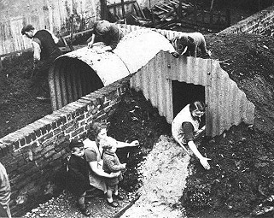

Evacuation
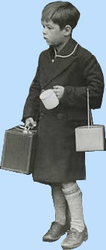
Evacuation means to temporarily leave. During the war, nearly 2 million children had to temporarily leave their parents and their city homes to seek refuge and safety in the countryside.

They did not have to go but warnings from the government advised parents to ensure it took place for the safety of the children due to the frequent German bombings.

World War Two ended in September 1945, however evacuation did not officially end until March 1946 when it was felt that Britain was no longer under threat from invasion.

Children accounted for one in ten of the deaths during the blitz in 1940 and 1941

Gas Masks

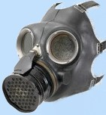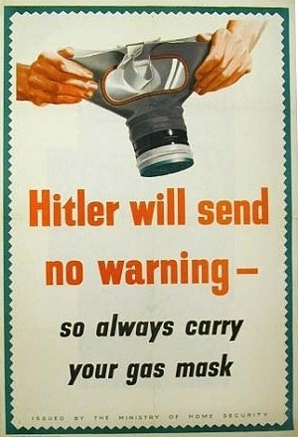

Everyone in Britain was given a gas mask in a cardboard box, to protect them from gas bombs, which could be dropped during air raids. By September 1939 some 38 million gas masks had been given out, house to house, to families. They were never to be needed. The museum has original gas masks on display and visitors are allowed to try the different war time outfits on. (http://www.woodlands-junior.kent.sch.uk/Homework/war/blackout.htm - Pics)
Women’s Land Army

Prior to the war women were typically seen as the housewives and to do typical women’s jobs.
Once the war started women were needed to take the place of the men who had gone off to fight in the army; they found themselves working in very male orientated roles such as mechanics, building ships, driving fire brigades and plumbers.

As the prospect of war became increasingly likely, the government wanted to increase the amount of food grown within Britain. In order to grow more food, more help was needed on the farms and so the government started the Women's Land Army.

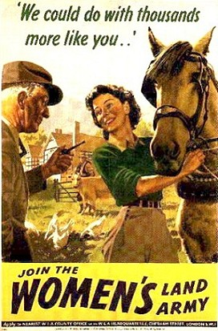

The girls of the land army worked for around 50 hours each week. They looked after animals, ploughed the fields, and harvested the crops along with all the other duties that came with farm life.

Home Guard
The Home Guard were volunteers who defended the five thousand miles of Britain coastline in the event of an invasion by Germany. They were originally called the Local Defence Volunteers.

The Home Guard defended places like factories, explosive stores, beaches and sea fronts. No one expected them to be able to beat the German soldiers - their job was to just slow them down until the army arrived.

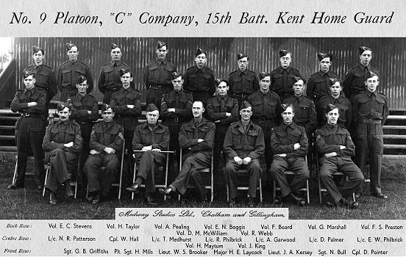
(http://www.woodlands-junior.kent.sch.uk/Homework/war/htm - Pics)
Campaigns & Posters

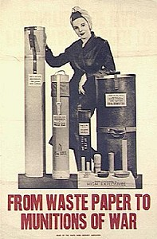
The war resulted in a lot of items being difficult to get, therefore, posters advertised the need to reduce unnecessary consumption and waste.

People in some areas collected waste to feed the animals.

People were also urged to use their gardens and every spare piece of land to grow veg.
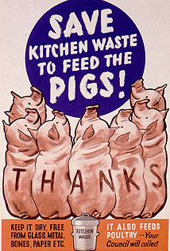

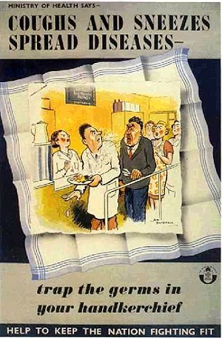
It was important for people to remain healthy in times of war. Disease spreads extremely easy especially with so many wounded.

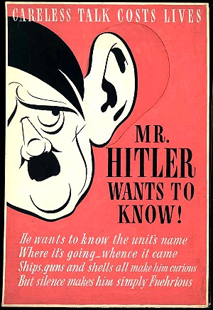(http://www.woodlands-junior.kent.sch.uk/Homework/war/blackout.htm - Pics)
'Careless talk costs lives' was the slogan of a nationwide campaign to prevent people from gossiping and letting useful information get into the hands of the enemy.

