We look at the person we are talking to

We listen to the other person when they are talking

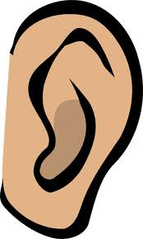

Our Conversation Rules

Let’s talk about......

