Hypothesis
Learning Intention:
- Use observations as the basis for formulating a hypothesis
- Apply their knowledge & understanding of agricultural science to develop arguments or draw conclusions related to both familiar & unfamiliar situations
- Compile & interpret data or other information gathered from print, laboratory & electronic sources (including websites), to research a topic or solve a problem
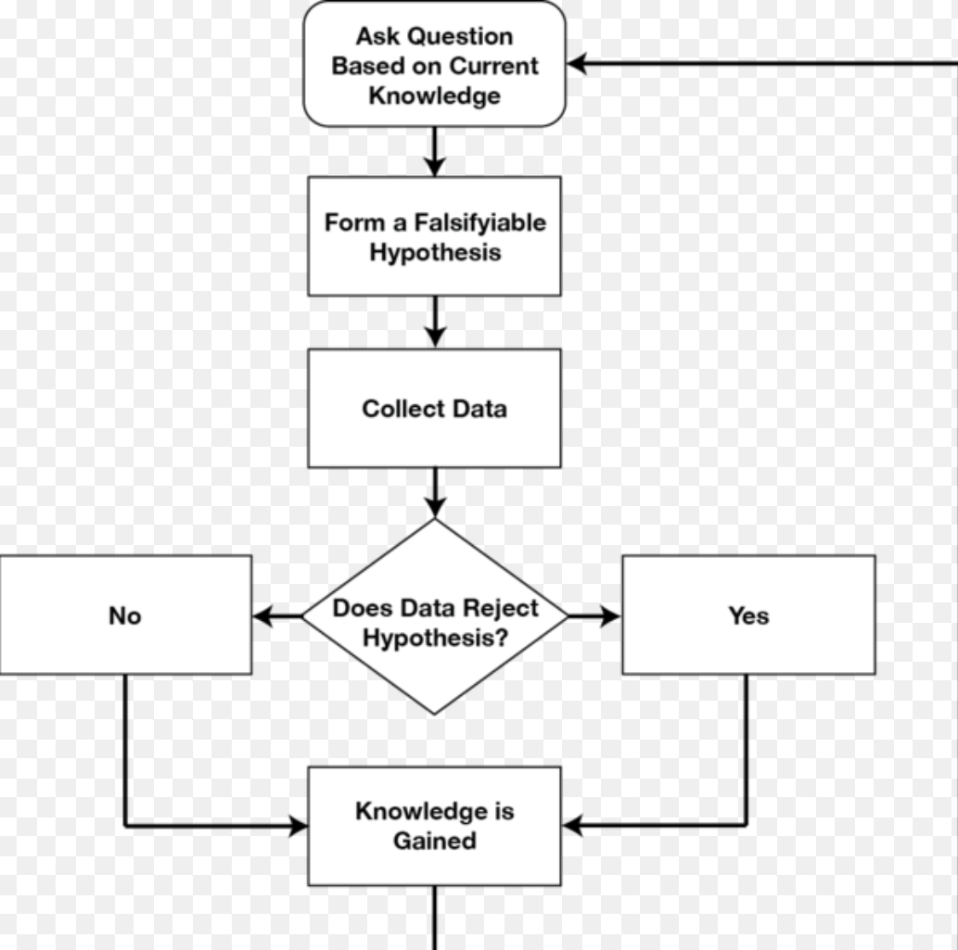
- Make a prediction based on the hypothesis

What is a hypothesis:
Proposed explanation made, on the basis of limited evidence as a starting point for further investigation.

There are 2 types of hypothesis:
- Null Hypothesis (H₀) is a hypothesis which the researcher tried to disprove, reject or nullify. The ‘null’ often refers to the common view of something
- Alternative hypothesis is what the researcher really thinks is the cause of a phenomenon

Question:
- State the null & alternative hypothesis for the following:
- A new organic fertiliser which is environmentally safe has come on the market claims to have no effect on average yield of 70 vegetables per plant
- Department of agriculture wants to test the claim again as they suspect that the new fertiliser has an effect on the average yield of 70 vegetables per plant

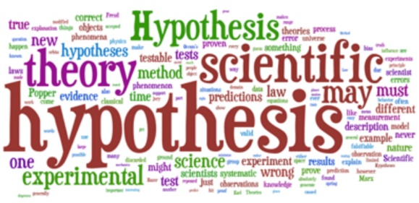
A hypothesis should always:
- Be clear & easy to understand
- Explain what you think will happen
- Be testable
- Be measurable
- Contain an independent & dependent variable

(independent variable – variable that is being tested & dependent variable is what you will see as a result)

Example of a hypothesis in agriculture:
Read the following examples & state if you think they are good hypothesis & give a reason for your answer
- When fertiliser is added to plants then it will make it grow
- If you add the correct amount of fertiliser to a crop, based on soil test analysis then the crop will reach its peak yield because it has the correct amount of nutrients required for the plant to grow.
In the hypothesis that yout think is a good hypothesis, can you:
- Carryout research relating to the hypothesis (research 3 relaible sources of data) & record 3 pieces of data from each source
- Name a control that could be used in the experiment
- What is the independent variable?
- What is the dependent variable?
- What do you predict will happen in this experiment?

3 reliable sources of data

Source: _________________
Information:
- _________________
_________________
- _________________
_________________
- _________________
_________________
Source: _________________
Information:
- _________________
_________________
- _________________
_________________
- _________________
_________________
Source: _________________
Information:
- _________________
_________________
- _________________
_________________
- _________________
_________________

CV
Scientific Method
Dependent variable
_______________________________________________________________________________________
Prediction
_______________________________________________________________________________________
Independent variable
_______________________________________________________________________________________________________________
Source: _________________
Information:
- _________________
_________________
- _________________
_________________
- _________________
_________________
Control
_______________________________________________________________________________________

