Learning Outcome:
Discuss the importance of good soil management in relation to soil sampling & testing & analysis of results, fertiliser or slurry / manure application.

Keywords:
Auger, potassium, random, sampling, analysis, application, manure, slope, organic matter, soil index

Numeracy:
Min 25 samples, %OM, pH, length time after fertiliser / lime application, soil index

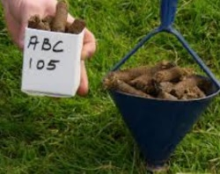
How to take a soil sample:
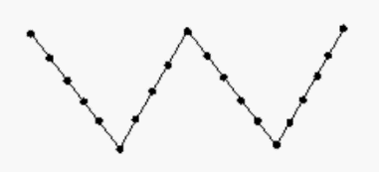
- Taken using a soil auger
- Min 25 samples
- Taken at random
- Avoid water troughs & gateways
- Take from areas that have different soil types, crop history, slope, drainage, different yield
- Don’t sample for 3 – 6 months after P & K & slurry application
- Don’t sample for 2 years after lime application

Task:
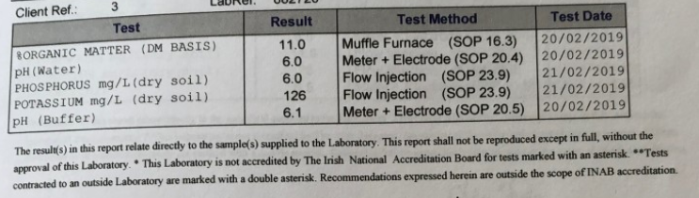
Look at the following secondary data from soil test results & answer the questions that follow:

- What is the % Organic Matter (OM) of the soil sample?
- How does this relate to the average soil composition?
- Based on the % OM result – what does this tell you about the slurry / FYM application on the farm?
- What is the pH of the soil? Is this the correct pH? What would you recommend farmers to do to adjust the pH of the soil?
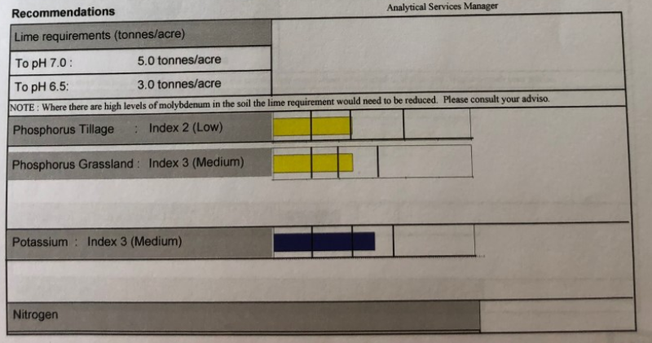

- Above are the recommendations from the soil test –
  - What does the terms index 2 for phosphorus tillage & index 3 for phosphorus grassland mean? Why is there a difference between the P requirement in tillage & grassland?
  - What is meant by index 3 for Potassium?
  - What is the recommended lime requirement for the soil?
- This is another soil test result from the same farm:
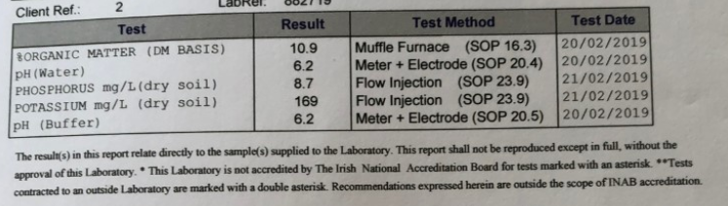
  - Compare the %OM in both soil samples
  - Compare the pH in both samples.
- This is the recommendations from the lab for the results given in Q6:

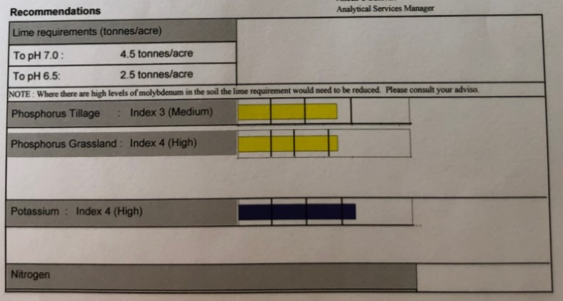

  - What is the lime requirement of the soil?
  - What is meant by the index 3 for tillage P & index 4 for grassland P? Why is there a difference in the figures?
  - What is meant by the index 4 for K?
  - What would your recommendations be to the farmer with this soil sample?
- The above 2 soil samples are taken from the same farm, from neighbouring paddocks. Can you explain the difference in soil results?

