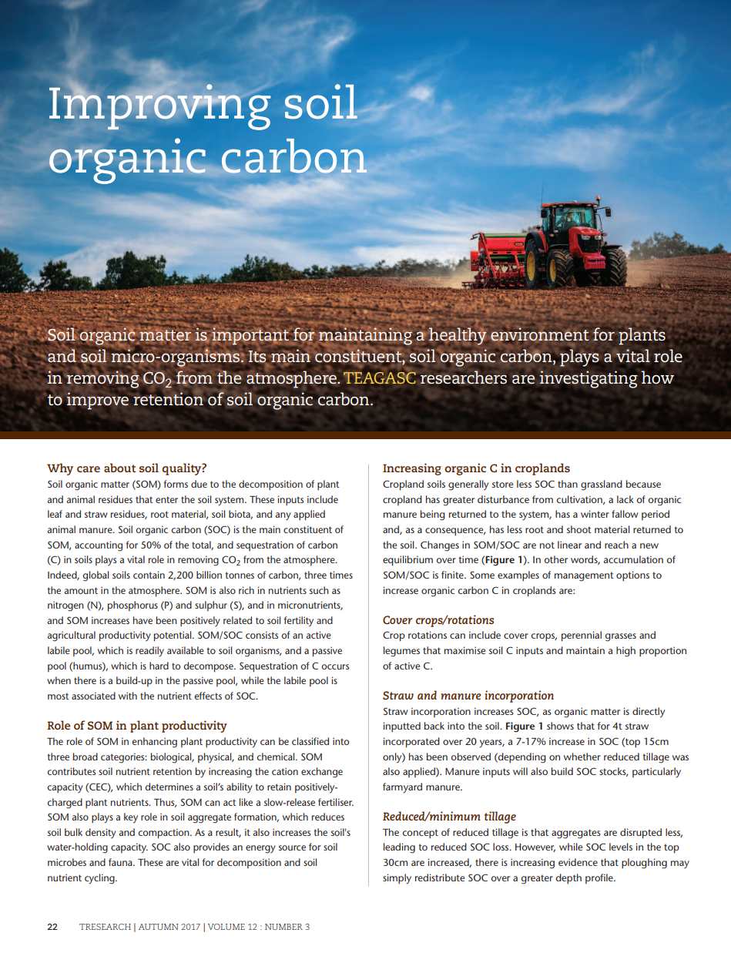
Soil Organic Carbon
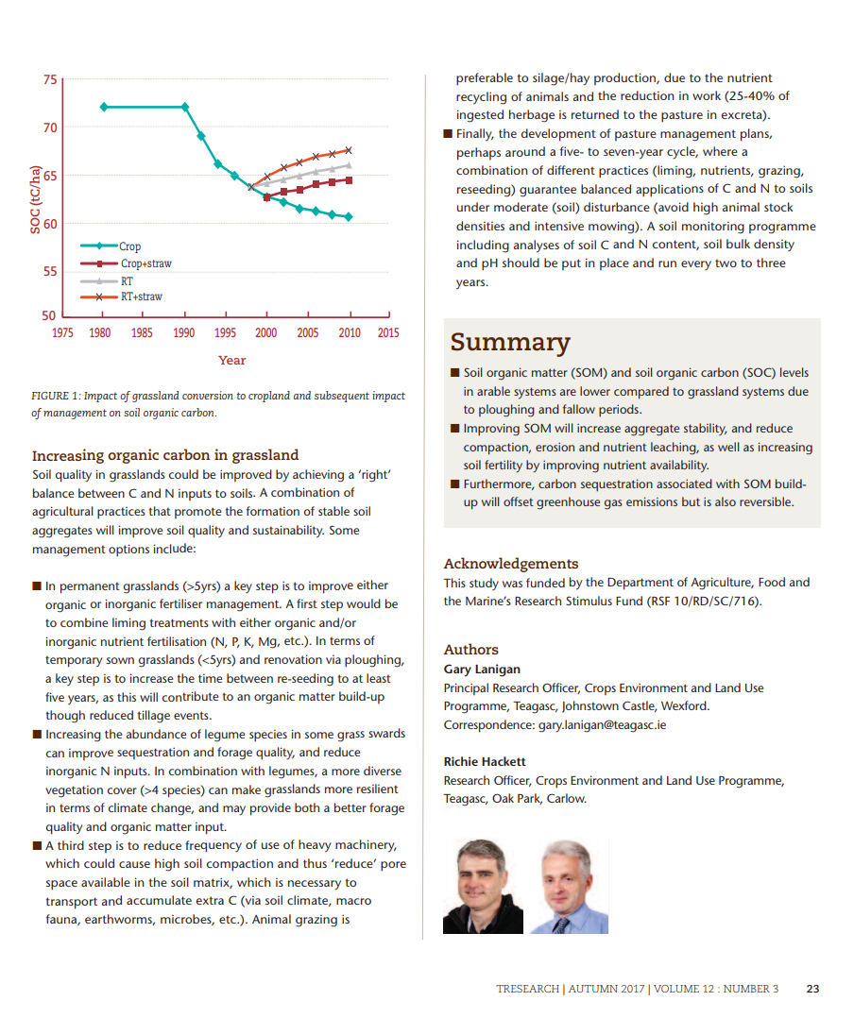

Task:
Read the above article by Lanigan & Hackett, Teagasc (2017) on how to improve the soil’s organic carbon component.
- How is soil organic matter (SOM) formed?
- What is meant by the sequestration of carbon? What is its role in the soil?
- How much carbon do global soils contain?
- Why has SOM been positively related to soil fertility?
- Explain the role of SOM in plant productivity (biological, chemical & physical)
- Explain 3 ways of increasing organic C in croplands.
- Describe 4 ways to increase organic carbon in grassland using good agricultural practices.
- After reading the article, in your opinion, does improving soil organic carbon maintain a healthy environment for plants & soil micro – organisms? Explain your answer.

Curriculum link:
- Soils & reducing greenhouse gas emissions - Geography

