Your mission is to create Function Art

Here are some ideas of how art can be made with functions

Spirals
Move forward the first number and turn left, move forward the second number and turn left, etc
Below are examples of 90 degree turn spirals.
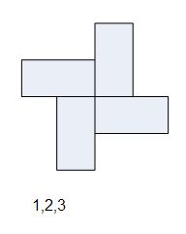
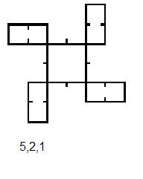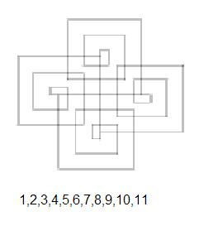
Area spirals
These are constructed from a series of regular polygons. For example with triangle, square, hexagon, use the second side of the triangle as the first side of the square; use the third side of the square as the first side of a regular hexagon and then draw five sides and so on…..
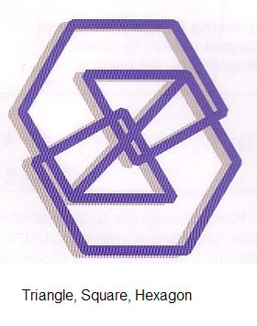
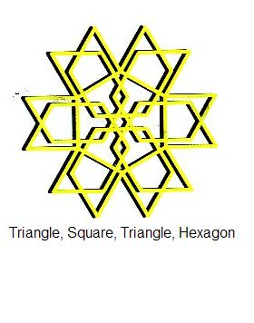
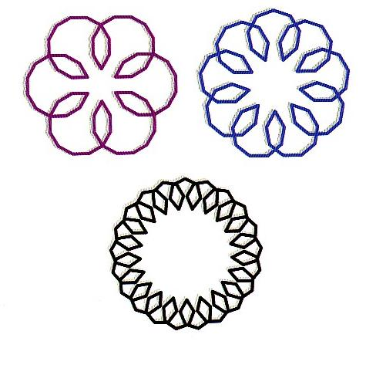

Your mission is to create Maze Art

Here are some ideas of how art can be made with mazes

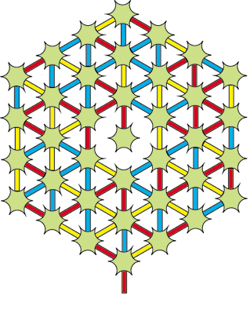
Giant Snowflake Maze
Move from star to star, following paths in the repeated colour sequence red - blue - yellow, to reach the central star.

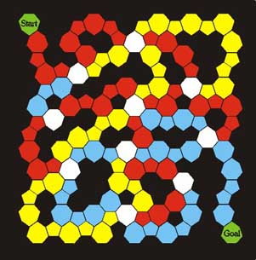

Serpent Maze
Find your way from "Start" to "Goal", keep to the same path colour until you reach a white cell; when you must change path colour.

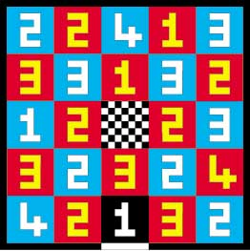
Jumping Maze
Start at the black square with the "1" on it in the centre of the bottom row, and jump forward, sideways, or backwards, but never diagonally, the number of squares indicated by the number on the square. The objective is to find your way to the central square.

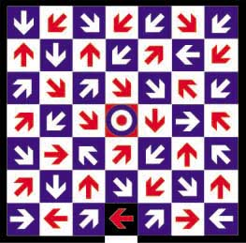

Archery Maze
Starting at the arrow in the black square, find your way to the central target. Move any distance in the direction indicated. Whenever you stop, chance direction as indicated by the arrow on which you land

Your mission is to create Random Art

Here are some ideas of how art can be made more random.

Test for the level of randomness in a pattern. For example with three colours red (R), green (G) and blue (B) you can count how many times red was followed by red, green or blue, and similarly for the other colours. Looking at 18 colour sequence, each colour should occur 6 times.

Looking at what happens next an average of 18/9 = 2 is expected and you get the following table.
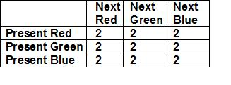

A pattern RGBRGBRGBRGBRGBRGBR … Deviation from expected is
gives
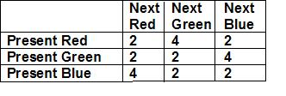
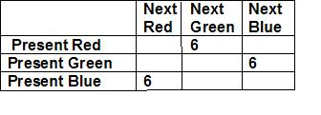
Total of deviations 2+4+2+2+2+4+4+2+2=24

A pattern RBBGRBBGRBBGRBBGRBB.…
gives Deviations from expected is
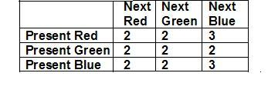
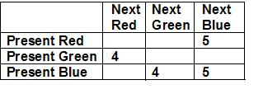

Total of deviations 2+2+3+2+2+2+2+2+3=20

A pattern RBBGRBBGRGRGRBGRBBB....
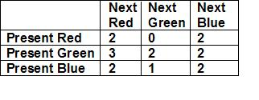
gives Deviations from expected is
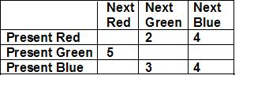
Total of deviations 2+0+2+3+2+2+2+1+2=16

Note smaller the result the more randomness in the pattern.

Where to find out more……
Sam Loyd Faces
http://library.thinkquest.org/28049/new_page_18.htm

Adrian Fisher’s http://www.mazepuzzle.com/
Adrian Fisher, The Mazing Book of Mazes, Thames & Hudson

John Haigh, Taking Chances, Oxford University Press
More on Random art http://www.maths2art.co.uk/

Steve Humble, The Experimenter’s A-Z of Mathematics, David Fulton Publishers
aka Dr Maths email drmaths@hotmail.co.uk
More information on Dr Maths
http://www.ima.org.uk/Education/DrMaths/DrMaths.htm

Martin Gardner, Mathematics, Magic and Mystery, Dover
Solomon Golomb, Polyominoes, Princeton University Press

More information on Spirals
http://www.mi.sanu.ac.yu/vismath/krawczyk/spdesc00.htm

The only seventeen possible patterns….
http://en.wikipedia.org/wiki/Wallpaper_group
