**Coordinate Geometry OL**

**2019 Paper 2**

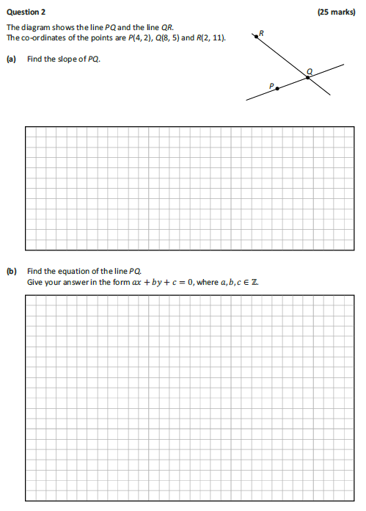

**2015 Paper 2**

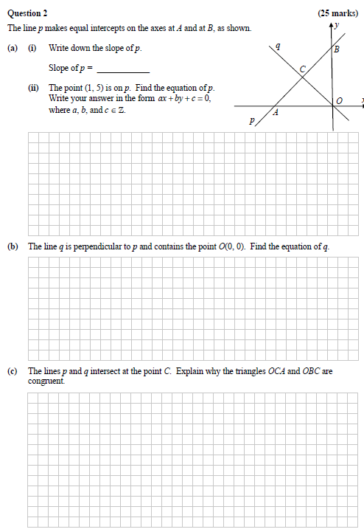

**2013 Paper 2**

