Code-makers & Code-breakers



Substitution ciphers and frequency analysis

Author:

Will Mitchell
william.mitchell@ic.ac.uk

Introduction to Substitution Ciphers

A substitution cipher replaces each letter with another one using a ‘mixed up’ alphabet as follows:

A | B | C | D | E | F | G | H | I | J | K | L | M | N | O | P | Q | R | S | T | U | V | W | X | Y | Z
Q | A | Z | W | S | X | E | D | C | R | F | V | T | G | B | Y | H | N | U | J | M | I | K | O | L | P

So ‘attack at dawn’ would be enciphered as ‘QJJQZF QJ WQKG’

Alternatively a keyword would used, so that all the receiver needed to know was the keyword. In the example below, notice how the rest of the alphabet is enciphered after the keyword.

- Using a keyword of ‘spy’, decipher the following message:

“S GLTOKBX LC S RELTQSKA JFIBQ PBDFKQ VFRE S QFKDIB QRBM” (Lao Tze)

A | B | C | D | E | F | G | H | I | J | K | L | M | N | O | P | Q | R | S | T | U | V | W | X | Y | Z
s | p | y | a | b | c | d | e | f | g | h | i | j | k | l | m | n | o | q | r | t | u | v | w | x | z

- Choose a keyword of your own (if there are multiple letters ignore all except the first occurrence, ie. LONDON would be LOND and ATTACK would be ATCK). Encipher this message:

"Never doubt that a small group of thoughtful committed people can change the world. Indeed, it is the only thing that ever has." —Margaret Mead

- What happens if you use BAD as a keyword? Why is this and how can it be prevented?

Imagine receiving a coded message from a mystery sender. You know that each letter of the message has been replaced by another letter in the alphabet BUT you don’t know which one. How could you crack the code?

- About 1000 years ago an Arabic scholar called Al-Kindi realised that letters have their own personalities! What do you think this means?

Al-Kindi thought that he could look for these tell-tale ‘fingerprints’ of each letter in the code, and by doing this discover the original message.

Deciphering- Frequency Analysis

On ‘The Code-Book’ CD-Rom, go to the index page and click on ‘Cracking the Substitution Cipher’. From there, follow the pages through until the ‘Frequency Analysis Tool’ page by clicking on the icon that is lit up in red.

You will need to read carefully, your code-breaking skills will soon be put to the test!

Once you feel confident you have understood the idea behind frequency analysis, you are ready to test your skills against an unknown message. You now stand in the same position as many code-breakers have stood throughout history. On their success or failure has rested life or death, war or peace. As you try to break a cipher, think of those at GCHQ (the Government Communications HQ) who are at this very moment using secret techniques to decode intercepted messages!

Have a go at deciphering by clicking on the ‘Frequency Analysis Puzzle’ circle on the ‘Frequency Analysis Tool’ page. As you proceed, note down your mathematical (or logical) reasons for deducing the identity of each letter. For instance:

Deduction: Q represents E
Reason: It occurs 13% of the time in the ciphertext

If you get stuck, refer to the handout for some reminders of the main strategies.

If you have successfully managed to crack at least 2 of the puzzles, go back to the index on the CD and type ‘Mary’ into the search. Click on ‘The Tragedy of Mary Queen of Scots’ to learn how Mary was executed after her enciphered plot to assassinate Queen Elizabeth was intercepted and deciphered.

The challenge of withstanding frequency analysis

Throughout history, cryptography has been a tale of code-breakers and code-makers. A new code would be invented, it would be secure for a while until it was cracked and then another new code would replace it and so on.

By the end of the Sixteenth Century, after Queen Mary’s execution, the code-breakers were clearly on top. It was a matter of extreme urgency to devise a code that could withstand frequency analysis. BUT, this is not so easy!

It turns out that two ways were invented to foil frequency analysis. One was by trying to use more than one substitute alphabet; the poly-alphabetic cipher.

Can you devise a method for a poly-alphabetic cipher to work?

Would this foil frequency analysis? How?

Is it a practical code to use? Why / Why not?

On the CD, go to the index and click on ‘The Uncrackable Code’ and follow through this section to find out more.

In your own words, explain why the Vigenère cipher is so strong.

Hints for using Frequency Analysis

Repeated letters. In English, the most common repeated letters are ‘ss’, ‘ee’, ‘tt’, ‘ff’, ‘ll’, ‘mm’ and ‘oo’, in that order.

If the ciphertext contains spaces between words, then try and identify words containing just one, two or three letters. The only one letter words in English are: ‘a’ and ‘I’. The commonest two letter words are: ‘of’, ‘to’, ‘in’, ‘it’, ‘is’, ‘be’, ‘as’, ‘at’, ‘so’, ‘we’, ‘he’, ‘by’, ‘or’, ‘on’ and ‘do’. The most common three letter words are: ‘the’ and ‘and’.

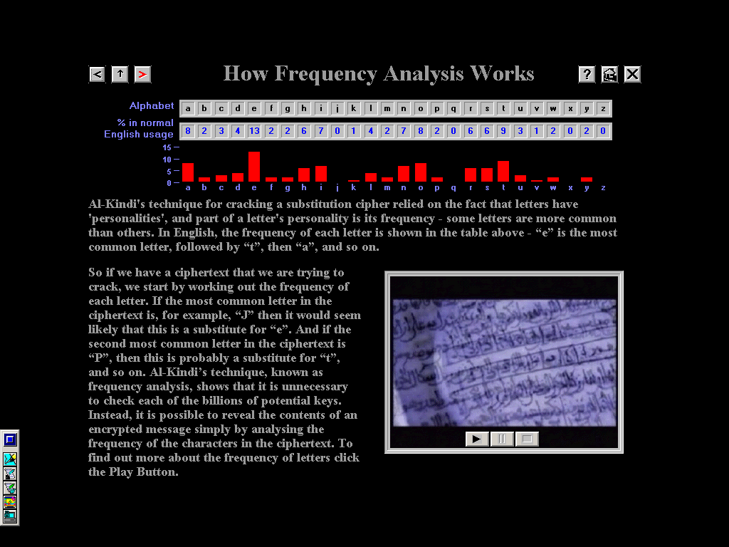
If we know ‘e’ then ‘h’ frequently goes before ‘e’ (as in ‘the’, ‘then’ or ‘they’) but rarely after ‘e’. No other pair of letters has such a highly asymmetrical relationship. Find a ciphertext letter that has a highly asymmetric relationship with the letter you think represents ‘e’, and this is probably ‘h’.

Substitution ciphers & frequency Analysis

Teachers’ Notes

Target age: Y9 (13 / 14 year olds)
Curriculum: Problem-solving, Communicating & Reasoning. Interpreting data, solving unfamiliar problems using ICT.

Overview

This activity introduces students to substitution ciphers and how to crack them using frequency analysis. It is a great way to build students’ abilities to interpret information from bar-charts, use percentages, and to use logical clues. It is suggested that you read through the substitution cipher pages on the CD (see below). They can be found by typing ‘subsitution’ into the search on the index page (click on the [?] at the top of any page).

This activity is designed to accompany the CD ‘The Code-Book’, by Simon Singh. If you don’t have the CD, you can order it at http://www.simonsingh.net. It only costs £5, or £2 for educational establishments.

It is best done in a computer room, since the sheets refer students to certain parts of the CD. However, sheet 1 (Introduction to Substitution Ciphers) does not require use of a computer. If you do not have access to a computer room, then you could print out some of the frequency analysis puzzles (to find them type ‘frequency analysis puzzles’ in the index search) in advance and teach frequency analysis using the ‘Hints for frequency analysis sheet’.

Introduction to Substitution Ciphers (Answers)

The message reads:
‘A journey of a thousand miles begins with a single step’ (Lao Tze)

If you use a keyword of ‘BAD’ then all letters are encoded as themselves except ABCD. Obviously this is ‘bad’ and occurs since D is the ‘furthest along’ letter in the keyword. A good keyword will have at least some letters from near the end of the alphabet.

Deciphering – Frequency Anaylsis

After students have had a chance to work through the suggested pages on the CD, you may wish to go through the finer points (on the hints sheet) and how these can be applied to deciphering. It would also be possible to discuss and compare what the results would be like if we did frequency analysis for other languages- this would be particularly interesting if you have a lot of students with language skills. You could, as an extension, get them to encrypt messages using alphabets from other languages.

These sheets point to parts of the CD where there are several fantastic video clips. It may be more practical to run these through a data projector, or show them to small groups around several computers. They are worth seeing, as they add a lot of context and atmosphere.

