The secrets of the Romans...

So you want to be a spy??

The Caesar Wheel

Sheet 1

- Make a Caesar Wheel! You will need 2 templates. Cut around the red circle on one, and the green circle on the other. Fasten the two wheels together by putting a clip through their centres, which are indicated by a dot. Write the letters of the alphabet in the spaces around the wheels and you are ready to go!

- Turn the wheel to line up A with D. Working with a partner, encode the name of the school. Check you both have the same result.

- Move the wheel to a new position that your partner doesn’t see. Now encode your name.

- Ask your partner to work out how you positioned the wheel.

- Choose a new position of the wheel. Encode a short secret message for your partner. See if they can crack it!
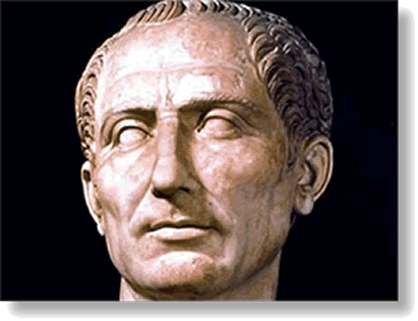
Did you break my code?
Sheet 2

Decoding messages

- Using the Caesar Wheel, try to decode the following message:

ZKHQ BRX KDYH GHFRGHG WKLV ZRUN RXW WZHQWB VHYHQ WLPHV QLQH DQG WHOO BRXU WHDFKHU
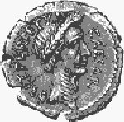
You could try
- Trial and error
- Focusing on just one word
- Another way

- Try this one

HSLE OZ JZF NLWW L OTYZDLFC HTES ZYP PJP
L OZJZFESTYVSPDLHFD

- Do you think the Caesar Wheel was a good method for encoding messages? Give reasons!
The Caesar Wheel – teachers’ notes

Curriculum: pre-functions
Suggested prior experience: none

Equipment Needed:
There is a template for the Caesar wheel provided in this section. Two templates are required for each Caesar wheel. You can also find the Caesar wheel on the CD: Go to index from the main menu and type in ‘Caesar Wheel’. It can be printed out in advance of the lesson. In addition the activity will need scissors & a butterfly clip for each wheel. Finally, each student should have a copy of the worksheets.

Overview:
This activity introduces the notion of a key to a cipher. The cipher is the Caesar Wheel and the key is the number of displacements. It is an interesting code to decipher in that if you try the wrong key you get rubbish, but when you try the right one the message suddenly makes sense.

Caesar used many types of substitution ciphers (where each letter is substituted with another), especially in his many battles, for instance the Gallic Wars. For more information, go to the index on the CD and type ‘Caesar’.

Answers to sheet 2:
- The first message says:
‘When you have decoded this work out twenty seven
times nine and tell your teacher.’
- The second message says:
What do you call a dinosaur with one eye
A doyouthinkhesawus

So you want to be a spy??

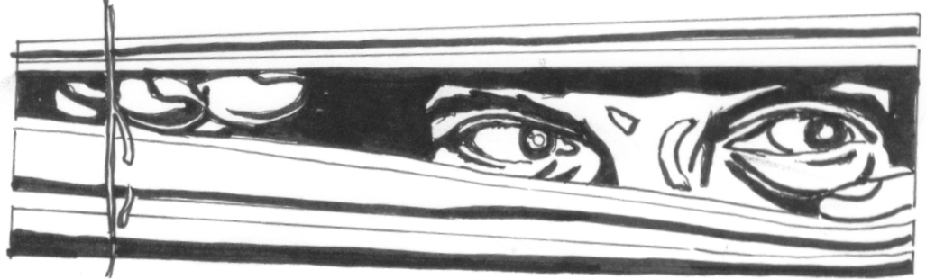

dot, dot, dot…

dash,
dash,
dash…

Morse Code – It’s all in the timing…

Sheet 1

Have a look at the International Morse Code sheet.

If you have a buzzer, try sending HELLO to a partner. Discuss the following questions.

- What problems did you have?

- How did you tell the difference between a dot and a dash?

- How did the person receiving the message know when the next letter began?

- What would happen if you made a mistake?

- How could you tell the message had ended?

When operators were using Morse Code, they had a standard timing known as a 1:3:7 spacing and weighting.
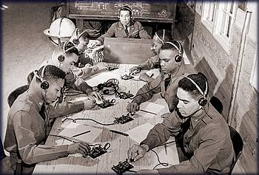
This meant that if a dot lasted for 1 unit and a dash for 3 units then:
Figure 1- US Army Morse Code Operators Learning How It's Done (http://www.qsl.net/ae0q/Army_morse.jpg)

- 1 unit of silence was left between each part of a letter (eg between the dot and the dash for A)

- 3 units of silence were left between each letter

- 7 units of silence were left between each word

  - How many units would HELLO be in total?

Morse Code: - - . . - . - - - - - - . . . - - . - - !!

Sheet 2

On this sheet, the 1:3:7 spacing is used. To remind you, this is where there is 1 space between each dot and dash, 3 between each letter and 7 between each word.

Example 1
. . . 1 space here (new dot / dash)
S

Example 2
. . . - - - . . . 3 spaces here (new letter)
S O S

Example 3
. - - . . . . . - - . . . . . . . - . . - - . . 7 spaces here (new word)
W H A T I S I T ?

- Challenge - Decode the following!

“. - - - . . . . . . - . - . . - - - . . - . - . . . . . - . . . - - . - -

. - - . . . . . - . . - . - . . . - . . - . . . . . . . - . . . - . . . . . . .

- . . . . - . . - - - . - - . - - . . - . - - - . . . - . . - . . . - . . - . - - - - - . . –

. . . . . - . . . - . - - . - - - - . - . . - . . . - -

- . . . . - - - . . - . . . . . . . . - . . . . . - . - - . - - - - - . . -

- . - . . - - . . . . - . . . - . . . - . . . . . . - . - . . . - - .

. . . - - - . . .” Round-the-world yachtsman Sir Robin Knox-Johnston

Morse Code

Sheet 3

Now you should be ready to try encoding some messages!

- Write your age in Morse Code

- Write your name in Morse Code

- Write the name of your favourite film in Morse Code

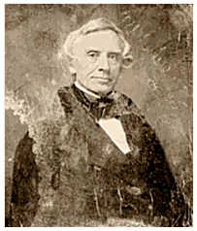
- Now decode a sheet 3 from the previous group.

Age:
Name:
Favourite film:
Figure 2- Samuel Morse 1791 - 1872 (http://lcweb2.loc.gov/ammem/atthtml/mrshome.html)

Morse Code

Sheet 4 (Extension)

- Now decide on your own message, which should contain up to 20 letters. Encode it below (do not write it down in normal letters)

Working with a partner, use the buzzer and take turns to send each other’s message. Then try and decode it! Good luck!

Morse Code

International Morse Code

Letter | Morse |  | Letter | Morse |  | Digit | Morse
A | .- |  | N | -. |  | 0 | -----
B | -... |  | O | --- |  | 1 | .----
C | -.-. |  | P | .--. |  | 2 | ..---
D | -.. |  | Q | --.- |  | 3 | ...--
E | . |  | R | .-. |  | 4 | ....-
F | ..-. |  | S | ... |  | 5 | .....
G | --. |  | T | - |  | 6 | -....
H | .... |  | U | ..- |  | 7 | --...
I | .. |  | V | ...- |  | 8 | ---..
J | .--- |  | W | .-- |  | 9 | ----.
K | -.- |  | X | -..-
L | .-.. |  | Y | -.--
M | -- |  | Z | --..
Punctuation Mark | Morse
Full-stop | .-.-.-
Comma | --..--
Question mark | ..--..
Morse Code- Teachers’ Notes

Curriculum: Problem-Solving
Suggested prior experience: None

Overview:

This sheet introduces Morse Code, gets the students to think about the practical problems associated with such a code and tests their ability to decode messages in Morse. There is information about Morse Code on the CD. (Go to the index and type ‘Morse’)

Equipment Needed:

Sheet 1 and 4 suggest using a buzzer to communicate in Morse Code. This is fantastic fun if you can get hold of a few battery, switch and buzzer circuits. If not then sheet 1 will work purely as a discussion exercise to kick-start the activity and sheet 4 can be done only on paper.

Photocopying needed: Enough copies of front sheet, Morse Code sheet and sheet 1 so everyone in each group can see one.

Every pupil doing the activity will need their own copy of sheets 2,3 and 4

Answers to Sheet 1

HELLO should take up 49 units. There are several ways to the pupils could have done this eg

H . . . . 7 units
Space 3 units
E . 1 unit
Space 3 units
L . - . . 9 units
Space 3 units
L . - . . 9 units
Space 3 units
O - - - 11 units

TOTAL 49 units

Answer to Sheet 2
“At the end of the day when all the fuses blow, provided you have got a few batteries left, you can still send an SOS."
Round-the-world yachtsman Sir Robin Knox-Johnston

Notes on Sheet 3

You will need to fill in a sheet 3 prior to the first group starting so that they can decode it (you are, however, entitled to be creative with the ‘age’ box!). The next group will then decode the first groups’ sheet 3 and so on.

So you want to be a spy??

A simple substitution – The Pigpen Cipher

Sheet 1
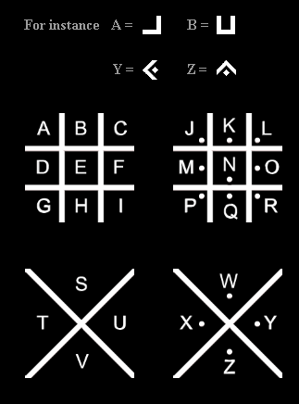

Example:

Y O U

- Work out how the cipher (you can look up cipher in the glossary) works.
- Using the Pigpen cipher, encipher your name.

- Use the Pigpen cipher to decipher the following mathematical words:

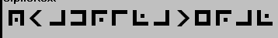

The Pigpen Cipher - Continued

Sheet 2

- Discuss some advantages and disadvantages of the cipher and list below. Can you think of how the cipher might be broken (ie a message deciphered by the enemy)?

- Now encode a secret message of your own and ask a friend to decode it.

A simple transposition - The Railfence Cipher

Sheet 3

- Use the computer or have a look at the ‘Railfence Explained’ sheet to investigate how the cipher works. If using the computer, go to the index and type ‘railfence’. You will need to enter your message into the plaintext box, click on ‘railfence’ and then click on ‘create ciphertext’.

Example 1
The following message has been ‘railfenced’ using 2 lines:
ESRALAYELY
To decipher it, split it in half and write the second half underneath, spaced in between the letters of the first half, as follows:
E S R A L
A Y E L Y
Now you can read the message: ‘EASY REALLY’ !!

- Decipher the following without using the computer, which has been enciphered using 2 lines
AOREOAHUADIEBGNWTAIGETPJUNYFTOSNMLSEISIHSNLSE

The Railfence Cipher - Continued

Sheet 4

- Encipher your own message using 4 lines.

Extension Challenge
- Swap with a friend – can you decipher their message?

- Can you invent your own transposition or substitution cipher?

The Pigpen and Railfence Ciphers – teachers’ notes

Curriculum: problem solving and vocabulary
Suggested prior experience: none

Photocopying Needed: Front Sheet- Enough for group to see
Railfence Explained- Only if no computer
Sheets 1,2,3,4- They will need 1 each

Sheet 1 (Pigpen Cipher)
This is a good activity to introduce the idea of ‘encoding’ or ‘enciphering’ and ‘decoding’ or ‘deciphering’ messages.
If you want to use the CD, go to the index and type ‘Pigpen’. The students can enter messages into the box marked ‘plaintext’. When they click the button marked ‘Encipher Plaintext’ it takes a moment then puts the encrypted text into the box below.
Most children will pick up the code from the diagrams. If they don’t, encourage them to type in the alphabet in groups of 4 letters at a time and encode it.
This can easily be done without a computer as well, since they should pick up the code from Sheet 1.
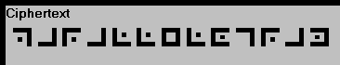 says parallelogram
and
 says quadrilateral

Sheet 2 (Pigpen Cipher)

Things to think about include the fact that the code could be disguised as a picture or border decoration, it is quite time-consuming to do and if the enemy did get hold of a code-book it would be easy to crack the message.

Sheet 3 & 4 (Railfence Cipher)

If not using a computer, it will be necessary to print out some of the ‘Railfence Explained’ sheets instead. The message is:

‘A journey of a thousand miles begins with a single step’

If they are having difficulty, point out that because the number of letters doesn’t exactly divide into 2, the top ‘half’ needs to have 23 letters and the bottom 22. Eg:

A O R E O A H …
J U N Y …

To crack a code that has been ‘railfenced’ with four lines, they will have to split it into four parts.

Railfence Explained!

This cipher works by taking the message and splitting into different lines like this:

Plaintext: Life should be simple!
Railfence (2 lines):
L |  | F |  | S |  | O |  | L |  | B |  | S |  | M |  | L
 | I |  | E |  | H |  | U |  | D |  | E |  | I |  | P |  | E

Then, the ciphertext would be:
LFSOLBSMLIEHOUDEIPE
(you just write down the letters across each row in turn)

If we want to railfence with four lines then it works like this:

Plaintext: So you’re ready to get going?

Railfence (4 lines):
S |  |  |  | U |  |  |  | E |  |  |  | T |  |  |  | T |  |  |  | N
 | O |  |  |  | R |  |  |  | A |  |  |  | O |  |  |  | G |  |  |  | G
 |  | Y |  |  |  | E |  |  |  | D |  |  |  | G |  |  |  | O
 |  |  | O |  |  |  | R |  |  |  | Y |  |  |  | E |  |  |  | I

Then, the ciphertext would be:
SUETTNORAOGGYEDGOORYEI



So you want to be a spy??

Frequencies & Fingerprints

Sheet 1

A substitution cipher replaces each letter with another one using a ‘mixed up’ alphabet as follows:

A | B | C | D | E | F | G | H | I | J | K | L | M | N | O | P | Q | R | S | T | U | V | W | X | Y | Z
Q | A | Z | W | S | X | E | D | C | R | F | V | T | G | B | Y | H | N | U | J | M | I | K | O | L | P

So ‘attack at dawn’ would be enciphered as ‘QJJQZF QJ WQKG’

- Encipher the following message:

Macavity’s a mystery cat, he’s called the hidden paw
For he’s the master criminal who can defy the law
He’s the bafflement of Scotland Yard, the flying squad’s despair
For when they reach the scene of the crime Macavity’s not there!
By T S Elliot

- Decipher this message:

ECIS TS AMJ BGS XCNT UYBJ BG KDCZD JB UJQGW QGW C KCVV TBIS JDS SQNJD (HMBJS XNBT QNZDCTSWSU)

Imagine receiving a coded message from a mystery sender. You know that each letter of the message has been replaced by another letter in the alphabet BUT you don’t know which one. How could you crack the code?

- About 1000 years ago an Arabic scholar called Al-Kindi realised that letters have their own personalities! What do you think this means?

Al-Kindi thought that he could look for these tell-tale ‘fingerprints’ of each letter in the code, and by doing this discover the original message. But, how did he do that? Find out on the next sheet

Frequencies & Fingerprints

Sheet 2

What are the fingerprints of each letter? Here’s the first clue:

Look at this paragraph. What is vitally wrong with it? Actually nothing in it is wrong but you must admit it is most unusual. Don’t just zip through it! With luck you will spot what is particular about it and all words in it. Can you say what it is? Tax your brains and try again. Don’t miss a word or symbol. It isn’t all that difficult.

- Did you work it out? If so, working with a partner, try and have a conversation using only words which don’t have a ‘e’. You could start with ‘what did you do this morning?’

As you have probably found, it is quite hard to have a conversation with no ‘e’s!!

- What does this tell you about the letter ‘e’?

Frequencies & Fingerprints

Sheet 3

It turns out that the most common letter used in English is an ‘e’ , followed by ‘t’. See if you can use that information to decode the following message (use the tally chart below):

LJUF UFLLQEFL QGF VFXZ LFHGFZ SJZ DR DFISE FSHJOFO

DMZ DR DFISE KIOOFS JSF JA ZKF UJLZ MSMLMQP UFZKJOL

MLFO DR ZKF EGFFVL TQL ZJ LKQBF ZKF KFQO JA ZKF

UFLLFSEFG ZQZZJJ ZKF UFLLQEF JS KIL LHQPX QSO ZKFS

LFSO KIU JSHF ZKF KQIG KQO EGJTS DQHV SJZ JSF AJG SFWZ

OQR OFPIBFGR

Ciphertext Letter | Tally | Total | Possible Plaintext Letter

A
B
C
D
E
F
G
H
I
J
K
L |  |  | S
M
N
O
P
Q
R
S
T
U
V
W
X
Y
Z

A | B | C | D | E | F | G | H | I | J | K | L | M | N | O | P | Q | R | S | T | U | V | W | X | Y | Z
 |  |  |  |  |  |  |  |  |  |  | s

Frequencies & Fingerprints

Teachers’ notes

Curriculum: Tally Charts, Problem Solving

Suggested Prior Experience: Tally Charts (don’t need to have done bar charts for this activity, but they are used on the CD-Rom)

Overview

This activity is a basic introduction to frequency analysis. If you can set up a computer for the group to use, then they can go through the ‘cracking the substitution cipher’ section on the CD-Rom (type ‘substitution’ on the index page) and have a go at some of the puzzles.

Sheet 1

T S Elliot’s excerpt should cipher as:
TQZQICJLU Q TLUJSNL ZQJ DSU ZQVVSW JDS DCWWSG YQK XBN DSU JDS TQUJSN ZNCTCGQV KDB ZQG WSXL JDS VQK DSU JDS AQXXVSTSGJ BX UZBJVQGW LQNW JDS XVLCGE UHMQWU WSUYQCN XBN KDSG JDSL NSQZD JDS UZSGS BX JDS ZNCTS TQZQICJLU GBJ JDSNS
The decipherment should read:
Give me but one firm spot on which to stand and I will move the earth (quote from Archimedes)

Sheet 2

Look at this paragraph. What is vitally wrong with it? Actually nothing in it is wrong but you must admit it is most unusual. Don’t just zip through it! With luck you will spot what is particular about it and all words in it. Can you say what it is? Tax your brains and try again. Don’t miss a word or symbol. It isn’t all that difficult. This paragraph has no ‘e’!

Sheet 3

LJUF UFLLQEFL QGF VFXZ LFHGFZ SJZ DR DFISE FSHJOFO DMZ DR DFISE KIOOFS JSF JA ZKF UJLZ MSMLMQP UFZKJOL MLFO DR ZKF EGFFVL TQL ZJ LKQBF ZKF KFQO JA ZKF UFLLFSEFG ZQZZJJ ZKF UFLLQEF JS KIL LHQPX QSO ZKFS LFSO KIU JSHF ZKF KQIG KQO EGJTS DQHV SJZ JSF AJG SFWZ OQR OFPIBFGR

This deciphers as:
Some messages are kept secret not by being encoded, but by being hidden. One of the most unusual methods, used by the Greeks, was to shave the head of the messenger, tattoo the message on his scalp and then send him once the hair had grown back! Not one for next day delivery!

A | B | C | D | E | F | G | H | I | J | K | L | M | N | O | P | Q | R | S | T | U | V | W | X | Y | Z
f | v | z | b | g | e | r | c | i | o | h | s | u | q | d | l | a | y | n | w | m | k | x | p | j | t

They should get e and t by counting the frequencies of different letters and then, with the letter given, be able to deduce the rest.

