Code-makers & Code-breakers



The Strength of Enigma

Author:

Will Mitchell
william.mitchell@ic.ac.uk

The Strength of Enigma…

Stage 1 - The Rotors

On the CD-Rom, go to the index, type ‘building enigma’ and then follow through this section (always click on the red icon to move to the next section).

You will see that the number of keys (that is, different ways that it could be set up) enigma had was greatly increased by using detachable motors. On this sheet, we investigate how that works and adds strength to Enigma.

Firstly we have 3 rotors: Also, 3 possible slots:

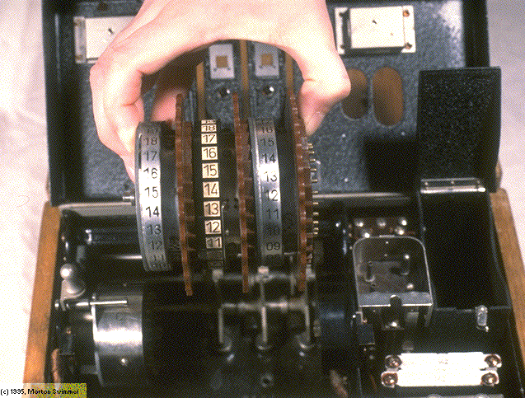
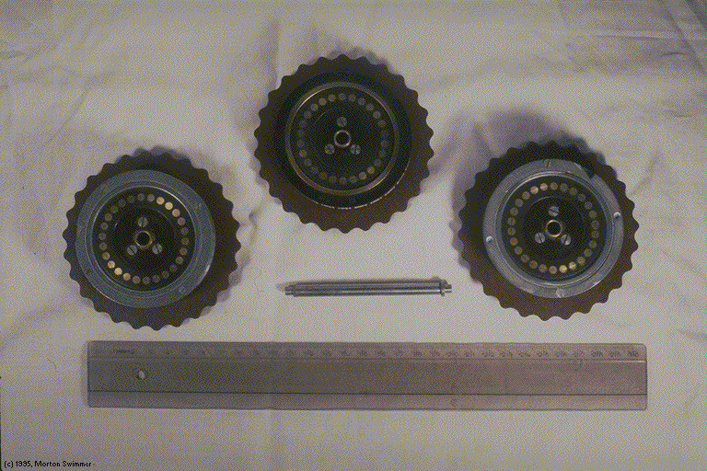

How many ways could these 3 rotors be arranged in the 3 slots? Eg labelling the rotors A,B,C then ACB and CAB would be 2 ways.

The Enigma used by the German Navy had 4 rotors and 4 slots. How many ways could it be set up?

Can you find a general formula for n rotors and n slots?

How many rotors would you have put in? What would be the problems of having large numbers of rotors?

After Scherbuis decided on 3 slots for the standard machine he further increased the number of keys by choosing 3 from 5 possible rotors.

How many ways are there of setting up the 3 rotors now (remember you have 5 to choose from)

HINT: Suppose there are 5 people at the cinema, and they are trying to sit in 3 seats. How many different people could sit in the 1st seat? Once the 1st person has sat down, how many could sit in the second? How many in the 3rd? So, how many different ways are there of the 3 seats being filled?

However, Scherbuis was even more clever with his design. Each motor could be placed in the slot in 26 different ways!

How does this affect the total number of ways to set up the rotors?

Finally:

How many ways are there to set up the rotors in total?

EXTENSION

You will hopefully have seen that the rotor system generates a lot of keys for the Enigma Cipher. However, does this make it secure against enemy decipherment?

How long would it take to for each of these configurations to be checked if you could check 1 per minute?

How many people would need to be employed checking different combinations to get through them in a day?

Is this practical?

The Strength of Enigma…

Stage 2 - The Plugboard

Enigma
had another trick which (so they thought) would ensure that it was
impossible to decipher.

This trick was a plugboard which meant that a plug cable could be inserted between any 2 letters and effectively ‘swap’ them around. For instance if the plug cable connected A to F then when A was typed in it would go through the machine as if it was F and vice versa. (Type ‘plugboard’ into the Index Search on the CD to find the plugboard page)

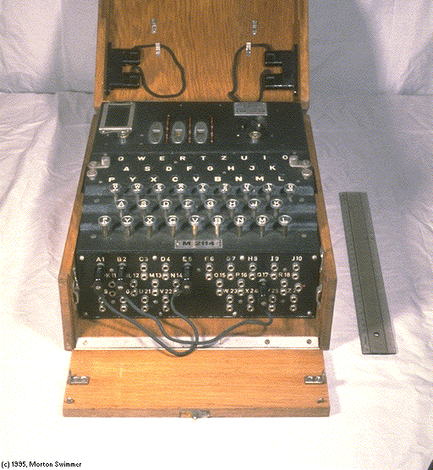

D J
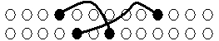

R T

If we have 2 plug cables and 6 letters (ABCDEF), how many ways are there to plug them in? Eg, [A-B,C-D ] or [A-F,B-E] . Be careful not to count the same combinations twice: [A-B,C-D] is the same as [B-A,C-D], [B-A,D-C], [C-D,B-A], etc!

If there are 2 plug cables and the full 26 letters how many ways are there to plug them in? The diagram above shows 1 cable from D to T and another from J to R. There is a hint on the next page.
!
WARNING: You will not be able to write out all the possibilities as there are more than 40,000!

HINT: Think about whether you are counting possibilities twice: If there was 1 cable, the number of ways of plugging it in would be:

( 26 x 25 ) / 2 (number of choices for 1st end of cable)
(number of choices for 2nd end of cable)

since we don’t want to count A to F differently from F to A.

What about if there are 3 plug cables? The German Army did exactly these calculations to determine if Enigma was a safe enough code to use!

A Stage Further…

The general rule, for n cables, turns out to be:

M_{n} = 26x25x24x…x(26-(2n-1)) / (n! x 2^{n})
If you don’t know what this is, ask your teacher!

Can you establish this rule from your result for 3 cables?

If you look at the rule as a function of n, we want to try and maximise the function or in other words find out how many cables will give the most number of configurations for the plugboard. We could just graph the function and find the maximum, but here is another way:

Can you find a term to term rule?

HINT: Try writing out the next term (ie put in n+1 instead of n), and then try to separate out the ‘new’ part of the fraction.

You should have got something in the form:
M_{n+1} = ( a_{n} / b_{n} ) M_{n}
Clearly M_{n+1} will increase when a_{n} / b_{n}> 1 and decrease when < 1.

Determine what the optimum number of plug cables is. What is M_{n} for this n? Hence sketch a graph of M_{n} against n. Do you think this would be a large enough number of configurations to make Enigma safe?

The Strength Of Enigma…

Teachers’ Notes

Target age: Y11 Higher Level (15/16 yr olds)
Curriculum: Problem-solving, Reasoning, Powers, Sequences, Graphs

Overview

This activity introduces the enigma machine cipher to students, and examines how the design of the machine allows it to be set up in millions of different ways, thus making it very secure. Enigma was the cipher that the Germans used during World War Two, it was eventually broken by the code-breaking team at Bletchley Park.

This activity is designed to accompany the CD ‘The Code-Book’, by Simon Singh. If you don’t have the CD, you can order it at http://www.simonsingh.net. It only costs £5, or £2 for educational establishments.

The activity can be done in a computer room, with each pupil individually going through the relevant parts of the CD (as indicated at the start of each sheet). However, it works equally well done with an interactive whiteboard, or even without any computer at all. If you are planning to use it without the CD, you will need to remove the references to the CD at the start of each stage before you print.

There is lots of fantastic information and even video clips about enigma on the CD (to find it go to the index and search for ‘enigma’). The activity works best if you can convey the importance of the Enigma Machine and its historical context so that pupils understand the significance to the Allies of trying to understand Enigma.

Stage 1 – The Rotors

Pupils should go through the section called ‘Building Enigma’ on the CD-Rom. There are several video clips in this section, and if you have the facility to show them through a data-projector to the whole group it would be well worth doing.

Answers:

Q1) 6

Q2) 4! = 24
(you may wish to introduce the idea of n! since it will be needed for the last sheet (if you are going to use it), however the first 2 sheets will work without an understanding of n!)

Q3) n!

Q4) It would make the machine extremely heavy, and hence would not be practical since the Enigma machine had to be reasonably portable.

Q5) 5*4*3 = 60

Q6) The total is now increased by a factor of 26*26*26

Q7) 60*26*26 = 40560

EXTENSION: It would take 676 hours or just over 28 days to check 40560 configurations at 1 per minute. Hence if you employed 29 people, you could get through it in one day, and this is clearly a possibility.

Stage 2 – The Plugboard

This sheet is fairly difficult, and it could be that you want to go through the questions with the whole group after giving them some time to think. It is designed to try and engender an appreciation of the importance of the plugboard to Enigma.

Answers:

Q1) (6*5*4*3) / (2! * 2²) = 45

Q2) (26*25*24*23) / (2! * 2²) = 44850

We divide by 2! because ordering of the plug cables doesn’t matter and divide by 2² because ordering of the ends of the cables doesn’t matter.

Q3) (26*25*24*23*22*21) / (3! * 2³) = 3453450

A Stage Further …

This sheet is designed as an extension sheet and looks at optimising the number of plug cables to give the greatest number of keys.

Q2) The term to term rule is:

M_{n+1} = [((26 – 2n )( 26 – 2n – 1)) / (2(n+1))] * M_{n}

Q3) The optimum number of cables is 11. M₁₁ ≈ 2.06 x 10¹⁴

The graph should look like:

