CODES
First edition
Material to support teacher use of the CD-ROM

In the second edition of these notes, we are planning to include a treasure trail, in which each code gives the key to the next code.

Background reading:
‘The Code Book’ by Simon Singh

Authors:
Sue Johnston-Wilder, Open University
Josephine Burgess, Burgoyne Middle School
with help from
Anita Aggarwal, De Montfort University
Greg Morris, Milton Keynes LEA
Simon Singh, author
Nick Mee, Virtual Image
Tracy Johns,Open University
Alex Wilder, Ralph Butterfield Primary School
and the Maths Club of Burgoyne Middle School

Introduction
The CD-ROM contains more than 20 encryption tools that enable you to encode/encrypt your messages in different ways.

To find these tools quickly, click on the ? icon (top right) to access the contents page. You can use the search engine on the contents page to find a particular topic. For example, type in Pigpen or Enigma and click on Search. Encryption tools are marked with an E.

The activity pages are designed to give you some quick ideas for using the CD-ROM with children aged 9 to 13.

The CD-ROM is designed to run on PC computers using Windows Explorer. For further information about the CD-ROM please email simoncontact@hotmail.com

Activities
A simple substitution – the Pigpen Cipher
The Caesar Wheel
Decoding messages
Scrabble
Letter frequencies
The Babington Plot
The Affine Cipher
A simple substitution – the Pigpen Cipher

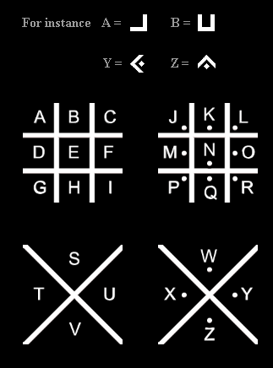

Using the Pigpen encryptor on the CD-ROM, type in your name and encipher it.
Work out how the cipher works.

Use the Pigpen cipher to decipher the following familiar mathematical words:

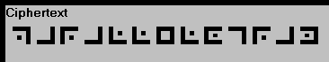
and
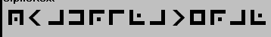

Now encode a secret message of your own and ask a friend to decode it.
The Pigpen Cipher – teachers’ notes
Curriculum: problem solving and vocabulary
Suggested prior experience: none
This is a good activity to introduce the idea of ‘encoding’ or ‘enciphering’ and ‘decoding’ or ‘deciphering’ messages.
The children can enter messages into the box marked ‘plaintext’. When they click the button marked ‘Encipher Plaintext’ it takes a moment then puts the encrypted text into the box below.
Most children will pick up the code from the diagrams. If they don’t, encourage them to type in the alphabet in groups of 4 letters at a time and encode it.

says parallelogram
and
 says quadrilateral

The Caesar Wheel
Make a Caesar Wheel from the template on the CD-ROM.

Working with a partner, encode the name of your school.
Check you both have the same result.

Move the wheel to a new position that your partner doesn’t see.
Now encode your name.
Ask your partner to work out how you positioned the wheel.

Choose a new position of the wheel.
Encode a short secret message for your partner.
The Caesar Wheel

There is a template on the CD-ROM for a Caesar Wheel.
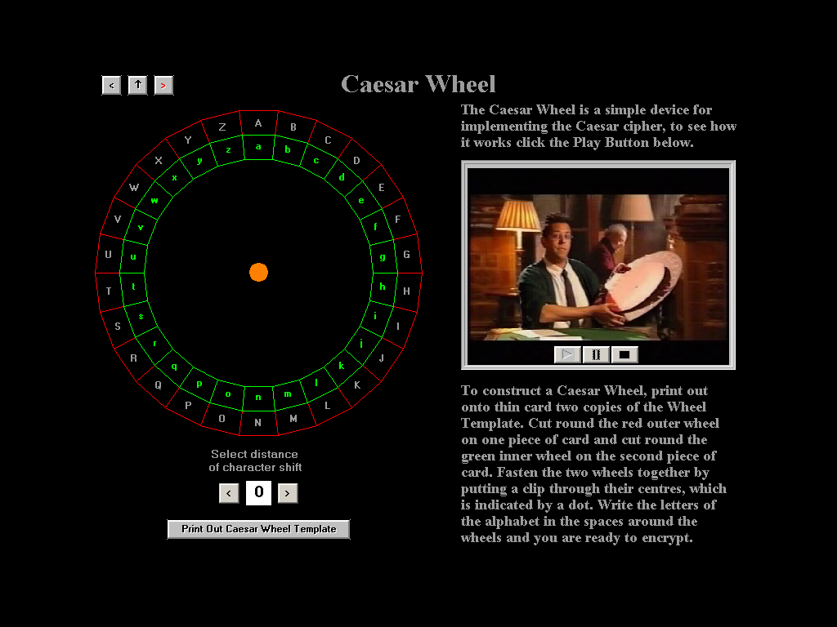

It can be printed out in advance of the lesson.
This activity introduces the notion of a key to a cipher. The cipher is the Caesar Wheel and the key is the number of displacements.
It is an interesting code to decipher in that if you try the wrong key you get rubbish, but when you try the right one the message suddenly makes sense.

Decoding messages

Using the Caesar Cipher, try to decode the following message:
ZKHQ BRX KDYH GHFRGHG WKLV ZRUN RXW WZHQWB VHYHQ WLPHV QLQH DQG WHOO BRXU WHDFKHU
You could try
- Trial and error
- Focusing on just one word
- Another way

Try this one
HSLE OZ JZF NLWW L OTYZDLFC HTES ZYP PJP
L OZJZFESTYVSPDLHFD

Now use the Caesar Shift encryption tool on the CD-ROM to encode a message of your own.
Print out both the message and the encryption.
Cover up the message and see if your friend can work it out.

Decoding messages – teachers’ notes
Curriculum: pre-functions
Suggested prior experience: none
The first message says:
‘When you have decoded this work out twenty seven
times nine and tell your teacher’
The second message says:
‘What do you call a dinosaur with one eye
A doyouthinkhesawus’

When the children use the Caesar Shift encryption tool, they can choose the distance of the character shift.
They type the message into the Plaintext box.
They can either encrypt the message
- a letter at a time (Letter Encrypt)
- the whole message at once (Fast Encrypt)
The Print Ciphertext button offers an option to print Plaintext, Ciphertext or both.
Scrabble

Construct a graph of the frequency of scrabble letters in a set.
Construct a graph of the tile scores.
Comment on the similarities and differences.

Scrabble – teachers’ notes
A graph of the frequency of scrabble letters in a set, not including blanks.
A graph of the scrabble scores.
If the children have difficulty describing the pattern, they could construct the graph of 1/score and compare that with the frequency graph instead.
A graph of 1/score.
Letter Frequencies

Choose a page of your reading book.
Count a hundred letters.
Make a frequency table.
Put the results of the whole class into a spreadsheet.
Calculate the mean frequency for each letter, rounded to the nearest whole number.
Which is the most common letter used in your sample?
Which are the next 4 most common letters?
Which letters occur most rarely?
Compare your results with the scrabble frequencies.
Comment on any differences you find.

Letter Frequencies – teachers’ notes
Curriculum: data handling and graphs
Suggested prior experience: frequency tables and graphs
The CD-ROM has materials about the early use of letter frequency analysis, in Baghdad.
Once the children have met the idea of frequency analysis they can use it to decode messages such as the one in the next activity.
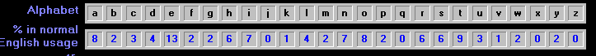
Frequency of letters in English writing

The Babington Plot
The following note has been coded using the cipher actually used by Mary Queen of Scots.
Can you crack it?

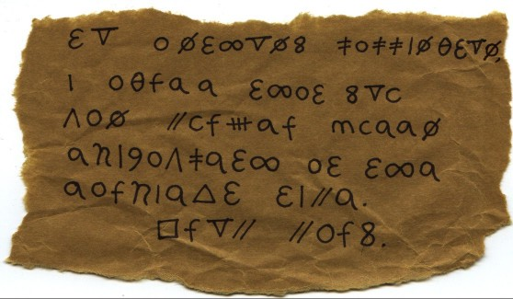

Carry out an analysis of the frequency of each character

De-code the message

Frequency table
Symbol | Tally | Frequency
Δ
Ø
O
8
C
f
M
9
q
 | Total | 81

Frequency table - answers
Symbol | Tally | Frequency
 |  | 5
Δ |  | 1
Ø |  | 6
O |  | 9
8 |  | 3
C |  | 3
 |  | 4
 |  | 4
 |  | 2
 |  | 5
f |  | 6
 |  | 4
m |  | 1
9 |  | 1
q |  | 11
 |  | 2
 |  | 10
 |  | 1
 |  | 1
 |  | 2
 | Total | 81

The Babington Plot – teachers’ notes
Curriculum: Tudors and Using data interpretively
Suggested prior experience: graphing frequency of characters
The text says
To Anthony Babington, I agree that you can murder Queen Elizabeth at the earliest time. From Mary.
Hints to give pupils as needed.
- What are the most common symbols in the coded message? Perhaps they match the most common letters in English, which are E, T, A and N.

- Can you guess any parts of the message? Who might it be to and who might it be from?

- Focus on any 1-letter words. What words have only 1 letter?

- Focus on any 3-lettter words. What are the common 3-letter words in English?

- If you know the story of Mary, who might she talk about in the message?

It will not take long to count the frequencies in this extract.
Letter frequencies fit those that you might expect for common letters.

Extension idea:
Invite the pupils to read the page about the role of Phellippes on the Codes CD-ROM, then to set up a role play.
Multiplicative and Affine Ciphers
Curriculum: functions, common factors, modular arithmetic
Suggested prior experience: The Caesar Wheel
A Caesar shift of 5 can be thought of as labelling every letter 0-25, then encrypting by adding 5 (mod 26), then translating the new number back into a letter.
Is it possible to multiply rather than add? The diagram shows what happens when you multiply by 2. This doesn’t produce a useful code, as you can not tell whether 24 is M or Z.
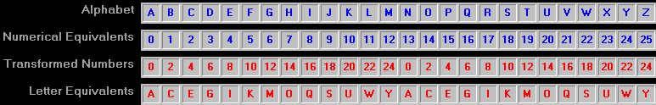
You can use 3 to produce a code. Try it and see.
(You can use the Affine Ciphers tool on the CD-ROM.)
People who use codes call 3 a key.
See whether 4 is a key. What about 5?
Can you find all the possible keys?
What do you notice about the numbers that make keys?

Extension
Can you multiply and add?
How many different keys are there?

Multiplicative and Affine Ciphers – teachers’ notes
Curriculum: functions, common factors, modular arithmetic
Suggested prior experience: The Caesar Wheel
The Affine Cipher tool allows children to explore multiplicative ciphers as well as Caesar ciphers.
The possible keys are
3 5 7 (at this point the children may think these are prime numbers)
9 11 15 (what is going on here?)
17 19 21 23 25
The prime factors of 26 are 2 and 13. So any multiples of 2 or 13 will not work as possible keys.

The numbers that work as keys are numbers that are coprime with 26.
That is, they don’t have any prime factors in common with 26.

You can combine multiplying and adding to make an affine cipher, provided that you use a multiplier that is coprime with 26.
Multiplying by 27 has the same effect as multiplying by 1, by 29 as by 3 etc.
Therefore there is a limited number of distinct keys.

