Checklist for Recorded Interview/Presentation
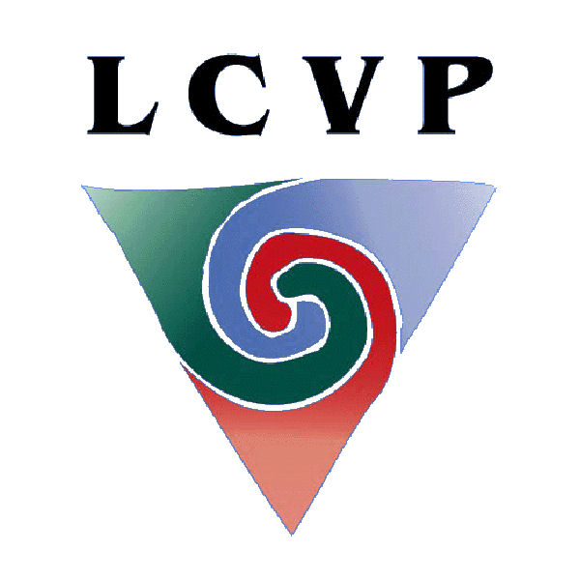
Ensure you can tick each statement before you complete your Recorded Interview. If any statement cannot be ticked, make the necessary changes.

Have you checked your time – a minimum of three and a maximum of five minutes?

Does your Recorded Interview relate to LCVP activities that you engaged in during
the course of the two year programme?

Have you commenced by stating your Leaving Certificate number?

Is your Leaving Certificate number displayed at all times?

Have you researched your questions and sample answers?

Are you making eye contact with the Interviewer?

Did you express your ideas in a logical sequence?

Did you express your opinions clearly?

Have you mentioned the skills you gained through the Link Modules activities?

Have you used action words when describing events, i.e. I planned, we evaluated, etc?

Have you used hand gestures where appropriate?

Have you explained Technical terms?

Is your uniform neat and are you dressed appropriately?

Is the interview area appropriate?

Does your Recorded Interview represent a variety of all LCVP activities?



If you are content with your recording, submit it as part of your Portfolio.
Photocopy the sequence sheet and submit it with your Portfolio, highlighting your Leaving Certificate number.
Remember, you submit your best work for assessment.

