Macgillycuddy’s Reeks - Unit of Learning - Notes
Name: ________________________________________
With your teacher’s help, create a mind map of topics you will explore in this chapter.

Section 1 | Formation of Fold Mountains

Fold Mountains form where plates collide. This can be oceanic-continental boundary or a continental-continental boundary. We have already looked at what happens when an oceanic and a continental plate collide.

Continental-Continental
The ridge-push process at opposite ends of two continental plates pushes them towards each other, aided by convection currents in the mantle. As both plates are continental plates, no subduction takes place. Instead the edges of both plates are folded upwards. The rocks lying on top of these plates buckle into arch shapes, which are called mountains. The top arch of a mountain is known as an anticline, and the valley, or downfold, between each mountain is known as a syncline. As this process continues over millions of years, the mountains continue to grow.

This happened with the Himalayan Mountain range, where we can find Mt. Everest. Here, the Indian plate collided with the Eurasian plate, and formed huge mountains. The Himalayas continue to grow to this day.

01. Construct and label a diagram of fold mountains forming where two continental plates collide.

02. Name the two processes that occur to form fold mountains.

03. What is the name given to the plate boundary where two plates are colliding?

04. What happens to the rocks lying on top of two continental plates that are pushed together?
05. What shape are the mountains that form?

06. Describe the difference between the anticline and the syncline.

07. Going online or using an atlas, mark in different fold mountain ranges. State whether they are an example of an oceanic-continental or a continental-continental boundary.

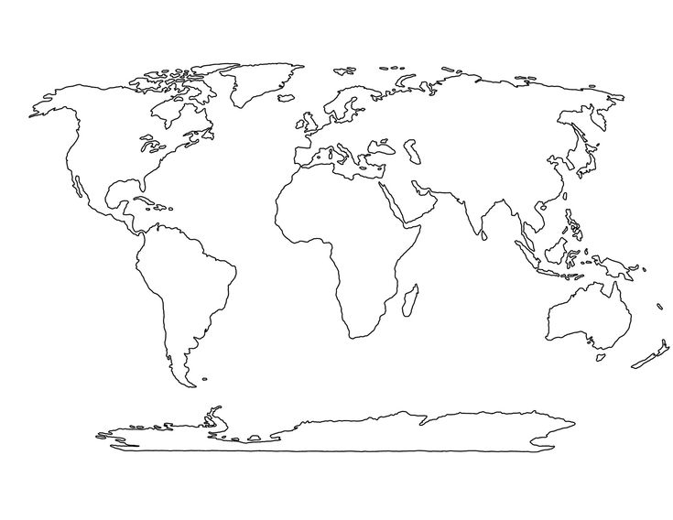

Section 2 | Orogeny – Periods of Fold Mountain Forming

In Earth’s history, there have been 3 main periods of fold mountain forming. Periods of fold mountain forming are called orogeny. These are:

Orogeny / Period | How long ago? | Example
Caledonian | 400 million yrs ago | Dublin - Wicklow Mts
Armorican | 250 million yrs ago | Macgillycuddy’s Reeks
Alpine | 35 million yrs ago | The Alps

01. List the 3 periods of fold mountain orogeny.

02. Which orogeny happened first?

03. How many million years ago did the Macgillycuddy’s Reeks form?

04. Using the information above, complete this fill in the blank exercise.
The Dublin-Wicklow Mountains were formed __________ million years ago during the Caledonian

______________. By contrast, the Macgillycuddy’s Reeks in Co. Kerry were formed during the

______________ orogeny which occurred 250 million years ago.
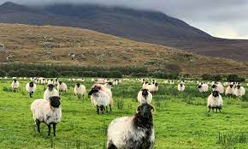

Section 3 | Sheep Farming on Fold Mountains

Sheep Farming
In Ireland, mountains are used for sheep farming. This is because the mountain landscape is not suitable for other types of commercial agriculture. Sheep farming is an example of a Primary Economic Activity, meaning it takes resources from the earth.

As the slope is steep, the land is not suitable for other types of farming. Sheep are small livestock which makes it easy for them to climb the mountains.

Sheep have adapted to the high altitudes of mountains. They grow strong and thick wool to endure the cold weather of mountains.

Podzol soils are common on mountains. These soils are infertile and suitable only for growing grasses. Podzols form under coniferous forests, which keep their leaves all year round. This results in them being acidic and lacking in nutrients. Leaching occurs when rainwater washes nutrients away from the A horizon. They collect together to form a impermeable layer between the A and B horizons which is called a hard pan.

Sheep farming on mountains allows farmers to earn an income from poor land.

01. Define each of the key words below.
Commercial farming
Primary Economic Activity
slope
adapted
Altitude
Podzol
infertile
coniferous
Leaching
hardpan

02. What type of farming would you expect to find on mountains?

03. In 3 sentences, explain how sheep farming on mountains can make a farmer money.

04. Why are sheep suited to the slope of a mountain?

05. Why are sheep suited to the high altitudes of mountains?

06. Why is sheep farming more suitable for the soil type on a mountain?

07. With your teacher's help, draw and label a profile of Podzol soil?
Section 4 | Soil Creep

Soil on mountains are prone to soil creep. This is the slow movement of soil downslope. It occurs due to gravity and the wetting and drying of soil.

Soil Creep happens so slowly we cannot see it happening, but we can the effects of soil creep. They include:
- Titled telegraph poles.
- Tree trunks tilting and curving.
- Bulging of walls.
- Terracettes, small grassy ridges, on a slope.

- Is soil creep a slow or fast form of mass movement?

- Name two factors in the occurrence of soil creep.

- Describe two effects of soil creep.

- Draw and label a diagram of a slope affected by soil creep.

Section 5 | Rocks in the Macgillycuddy Reeks: Sandstone

Sandstone is the most common rock in the Macgillycuddy’s Reeks. It is an example of a Sedimentary rock, meaning it forms from sediments (small particles).

- Rocks on land are weathered. They break down into small particles called sediments.
- Natural forces such as wind, water and ice erode the sediments and transport them into lakes and seas.
- Overtime, as more sediments build-up on the sea floor, the weight of the ocean pushing down compacts and cements them to form layers of rock, called strata.
- These strata build-up over time and form sandstone rocks.

- What is another name for small particles of rock?

- What natural forces erode the sediments?

- What is a layer of rock called?

- In your own words, describe how sandstone is formed, and with your teachers help, draw and label a diagram of its formation.

Section 6 | Weathering of Rocks on Fold Mountains

Weathering on mountains happens mainly due to freeze-thaw action. This is an example of a mechanical weathering process. It occurs in mountains where rainfall is present and a change in temperature occurs.

Freeze-thaw action
- Rainwater seeps into cracks in rocks on a mountain.
- At night time, temperatures drop which freezes the water. This causes it to expand by 10%. This widens the cracks.
- During the day temperatures rise and the water thaws out. More rain water fills the cracks.
- This process is repeated until the cracks become too wide and parts of the rock break off.
- It falls down the slope and piles up. This pile of rock is known as scree.

With your teacher’s help, construct and label a diagram to show the process of freeze-thaw action.

Section 7 | Recreational Tourism in the Macgillycuddy’s Reeks

Mountains like Mcgillicuddy’s Reeks are popular destinations for recreational tourists. These are tourists who are interested in outdoor activities like hiking. The Kerry Way is a popular tourist destination for walkers and hikers.

Environmental Impacts of Recreational Tourism
- Destruction of habitats: As tourists walk and hike across mountains, they can step on, and destroy, some plant species. Some plant species go into decline and may become extinct in that area. This hurts animals and insects who may rely on that plant for food and shelter.

- Litter: Tourists throw their litter on the group. Animals can ingest items such as plastics. This can cause them to get seriously ill and die. This can lead to a reduction in the population of that animal in the area.

Development of Transport Links
Increased tourism in the Macgillycddy’s Reeks has led to the development of transport links in the area. Several local roads have been built and are maintained to allow access within the mountain range, particularly to the Kerry Way. This gives tourists easy access to tourist sites.
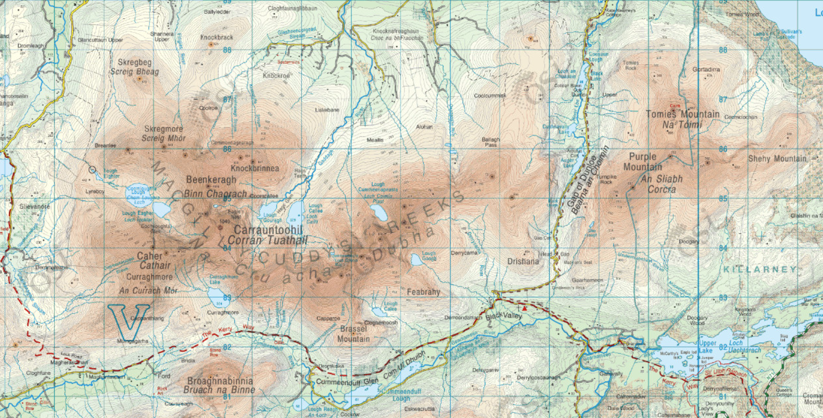
01.What is a recreational tourist?

02. Describe one environmental impact of tourism in the Macgillycuddy’s Reeks.

03. Why have transport links developed in the area?

04. Log onto maps.scoilnet.ie and locate a spot height in the Macgillycuddy Reeks. Give the height in metres and give a 4-figure grid reference for its location.
Height:
Grid Reference:

