Macgillycuddy’s Reeks Unit of Learning - Assessment
The photo below shows a sheep farm on the Macgillycuddy’s Reeks in Co. Kerry. Examine the photograph and answer the questions that follow.
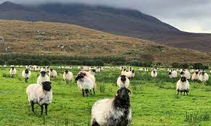

- Sheep farming is an example of which type of economic activity?
primary | secondary | tertiary

- Explain two reasons why sheep farming is the dominant type of farming on mountains.

- Define the term coniferous tree.

- Would you expect soils developing under a coniferous plantation to be fertile or infertile?
- Name an example of an infertile soil you have studied, and describe one process that impacts its fertility.
Soil Name:
Process:
Description:

- Soil is influenced by its parent rock. Name one rock that is found in the Macgillycuddy’s Reeks and explain how it formed.
Rock Name:
Explanation of formation:

- Explain one way in which the rock named by you in part (f) can be weathered by mechanical weathering.

- Mountains are a prime location of mass movement. Name an example of a slow mass movement you have studied, and list two factors that contributed to it.
Type of mass movement:
Example:
Factor 1:
Factor 2:

- Mountains like the Macgillycuddy’s Reeks are popular destinations for recreational tourists. Define the term recreational tourism.

- Explain two environmental impacts of recreational tourism.

- Explain how tourism has led to the development of transport links in an example you have studied.
- What challenge would a mountain pose to the development of transport links?

- Explain the formation of fold mountains, similar to those of the Macgillycuddy’s Reeks. Draw and label a diagram to assist your explanation.

