John Daly’s Mixed Farm Unit of Learning
Name: _______________________________
With your teacher’s help, create a mind map of the topics you will explore in this chapter.

Section 1 | What is a Mixed Farm?

John Daly is from Trim in Co. Meath. There, he runs a mixed farm with his family. A mixed farm is one that has both livestock and tillage (crops). On John’s farm, he has suckler cows, which means they are reared for beef production, and he grows barley and maize, two grain crops.
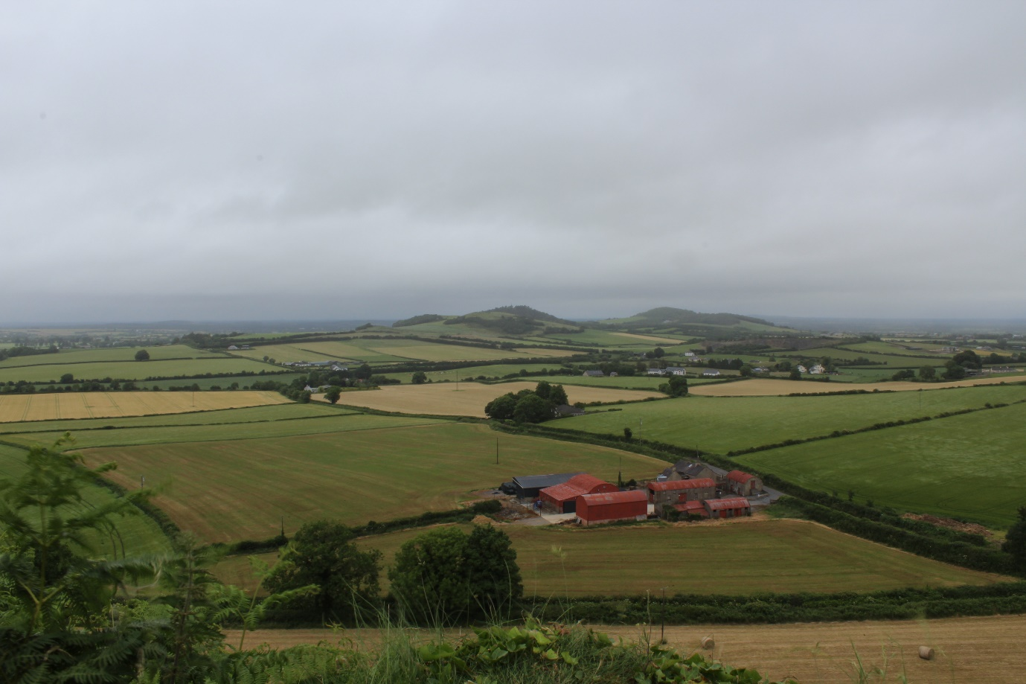
Many of John’s neighbours are also farmers, however they all have different types of farms. Here’s a summary of the different types of farms near John:
Pasture Farming | Raising only livestock, mainly cattle or sheep, to produce beef, dairy and lamb.
Tillage Farming | Growing and harvesting of crops.
Equine Farming | Rearing horses for racing, showjumping, or meat production.
Pig Farming | Raising pigs for meat production
Poultry Farming | Raising chickens, ducks or other birds for meat or egg production.

- Where is John’s farm located?

- What is a mixed farm?

- Describe the difference between a pasture farm and a tillage farm.

The aerial photo above shows John’s farmhouse and some of his farm buildings.
- Locate John’s farmhouse on the aerial photo.

- Which angle is the aerial photo above taken at?
vertical | oblique

- Which season do you think the above aerial photo was taken? Justify your answer.
Season:
Justify:

Section 2 | Location of John’s Farm
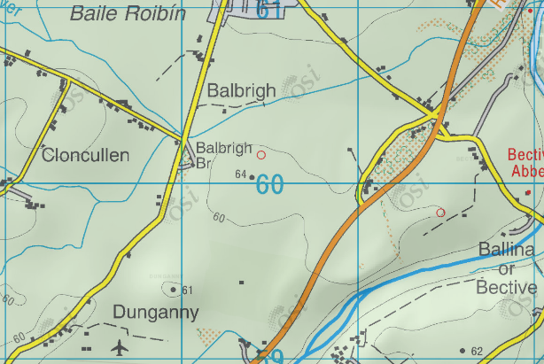
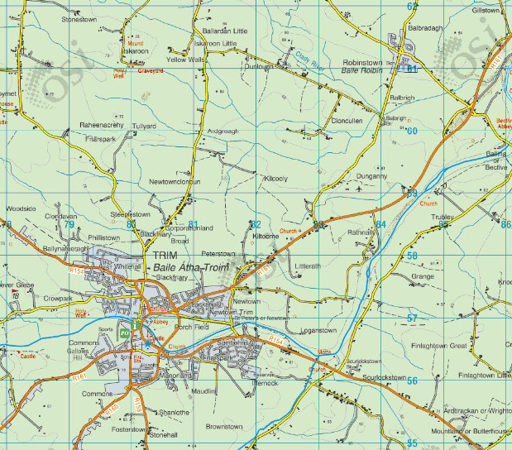
John’s farm is marked by a red ‘X’ on the O.S. Map extracts.
John first established his farm in 2005. At that time, he surveyed many locations for the ideal place for his farm. He took into consideration several physical factors and factors.

Physical Factors
Physical Factors are those that relate to the physical landscape in an area. In John’s case, he examined 3 key physical factors:
Climate: Trim is in Ireland, which has a Cool Temperate Oceanic Climate. This means that, while it doesn’t have very warm summers, winter temperatures are not too low. This allows John to have a long growing season. As Trim is located away from the Atlantic Ocean, the area receives less rainfall than the West of Ireland. The average annual rainfall for Trim is 750mm. This reduces the likelihood of waterlogged soil due to heavy rainfall.
Soil Quality: John’s farm is located on Brown Earth soil. Brown Earth soil is naturally fertile and is ideal for crop and grass growing. In addition, the soil contains high levels of alluvial material, which was deposited by the river Clady during a previous flood.
Topography: The area that John chose for his farm is relatively flat land. We can see this by the widely spaced contour lines on the O.S. Map extracts. The light green shading also indicates that there are no steep slopes in the area. Flat land is better for farming as it makes it easier for large machines to drive. Tillage farming involves a lot of large machinery and so flat land is necessary.
Drainage: John’s farm is located near the Boyne River. This means that excess water has a natural waterway to flow towards, reducing the risk of flooding. Trim is also located over limestone bedrock. As limestone is a permeable rock, water is easily drained down into ground water reservoirs.

Human Factors
Human Factors are those that relate to man-made structures, like roads and electricity wires. Here are some of the human factors John considered:
Transport Links: As John needed to travel with large machinery, good roads were needed. As can be seen on the O.S. Map extracts, the R161, which is a Regional Road, runs right by his farm. This allows him to transport raw materials and goods easily and affordably.
Services: As John runs a modern farming enterprise, it was necessary to have access to services like water, electricity, and broadband. As John’s farm is located along a main road, his farm can easily access these services without the need to pay to install new pipes and wires.
Proximity to Markets: As John sells his outputs like grain and beef, he needed to be close to his markets. The towns of Trim and Navan are close by and provide a market of 45,000 customers. In addition, John’s farm is only 40 minutes from Dublin Port. This gives him access to a large European market of 500 million people.
- In what year did John set-up his farm?

- Explain how Ireland’s climate is beneficial to John’s farm.

- Why is flat land better for John’s farm?

- Describe how the Boyne river aids the drainage on John’s farm.

- What colour is used to indicate a regional road on O.S. Maps?

- Name 3 services John needs for his farm.
- What size market does access to the European Union give John?

Section 3 | John’s Farm as an Enterprise

Most modern farms are enterprises, and John’s is no different. This means they are geared towards profit making. Within each farm is a system, which is made up of inputs, processes, and outputs. For example, on John’s farm an input would be barley seeds. A process would be sowing those seeds, then harvesting them once they are grown. And the output would be barley grains.
Below are some more inputs, processes, and outputs on John’s farm:
Inputs | Processes | Outputs
Barley Seeds  Maize Seeds  Grass Seeds  Machinery | Ploughing  Sowing  Harvesting | Barley Grains  Maize Grains  Silage  Straw bales
Cows  Feed | Feeding  Vaccinating | Finished animal / beef.  Calves
Labour
Money

- Define the term enterprise.

- Compare how inputs for growing barley, and raising cattle would be different on John’s farm.

- Explain what Labour is, and why it is essential on John’s farm.

- Can you think of two more processes that might take place on John’s farm?

Section 4 | Brown Earth Soils on John’s Farm

Brown Earth soils are naturally fertile, due to several factors during its development. Brown Earth soils are the most common around Trim on Co. Meath, where John’s farm is located. They form under deciduous forests. As these are trees that lose their leaves in winter, they provide the soil with a lot of organic matter (comes from plants or animals). This organic matter gets broken down by microorganisms to form humus. Humus is a fertile black jelly like substance. Due to this high level of humus, Brown Earth soils are very fertile. In addition, the black humus gives the soil its dark brown colour. Ireland’s mild climate encourages insect activity. As a result, it has a lot of earthworms that mix the soil, and because of this there is no clear divide between the A and B horizons.
Brown Earth soils are ideal for tillage and livestock farming, like John’s farm. The main reasons for this are:
- Fertility: Brown Earth soils are known for their high fertility levels. They contain high levels of humus which makes them ideal for crop growth. This reduces the need to buy chemical fertilisers. This makes Brown Earth more cost effective and environmentally friendly for farmers.

- Versatility: These soils have a balanced texture. This texture allows for good water retention while preventing waterlogging, making them suitable for both tillage and livestock farming.

- Long Growing Seasons: Brown earth soils, when combined with favorable climate conditions, often provide a longer growing season. This extended period allows farmers to cultivate multiple crops or have extended grazing periods for livestock, increasing overall productivity.

- Explain why Brown Earth soils are naturally fertile.

- In the space below, create a flow chart for the formation of Brown Earth soils.

- Describe one reason why Brown Earths are suitable soil for growing crops.
Section 5 |  | Sustainable Use of Soil on John’s Farm

Farming practices can have a significant impact on soil structure and fertility. These impacts can be both positive and negative, depending on how the farming is managed. Here's some examples of how farming can affect soil structure and fertility:
- Large machinery driving over soil regularly causes compaction, reducing the space for water and air.
- Spreading chemical fertilisers can improve soil fertility in the short term, but over time it lowers the soil pH, making it more acidic.
- Leaving fields ploughed for long periods of time increases soil erosion by wind, as loose soil is easily blown away.

John is committed to sustainable farming practices which aim to protect the soil on his land. Some of the sustainable practices John implements on his farm include:
- Ploughing the land before growing crops to aerate the soil.
- Crop rotation (planting different crops each year) to help the soil build-up its nutrients.
- Planting hedges or trees around fields to help prevent wind erosion of soil.

- List 3 farming practices that can damage soil.

- How does chemical fertiliser affect soil?

- John grows barley, maize, and grass on his farm. He divides his land into 4 sections. This allow him to leave 1 section barren (without any crops) each year. Create a crop rotation plan for John that he can use over the next 4 years.
Section 1  Year 1: _____________________________  Year 2: _____________________________  Year 3: _____________________________  Year 4: _____________________________ | Section 2  Year 1: _____________________________  Year 2: _____________________________  Year 3: _____________________________  Year 4: _____________________________
Section 3  Year 1: _____________________________  Year 2: _____________________________  Year 3: _____________________________  Year 4: _____________________________ | Section 4  Year 1: _____________________________  Year 2: _____________________________  Year 3: _____________________________  Year 4: _____________________________

Section 6 | Globalisation and John’s Farm

On his farm, John produces three types of food: barley, maize, and beef. Globalisation has opened opportunities for John to sell his produce in international markets. Globalisation is the increasing interconnection between countries, economies, and cultures across the world.
John’s farm benefits from this as his beef gets exported to countries such as the UK and Italy. This helps him secure a higher price for his produce and ensures he makes a good profit.

- Define the term globalisation.

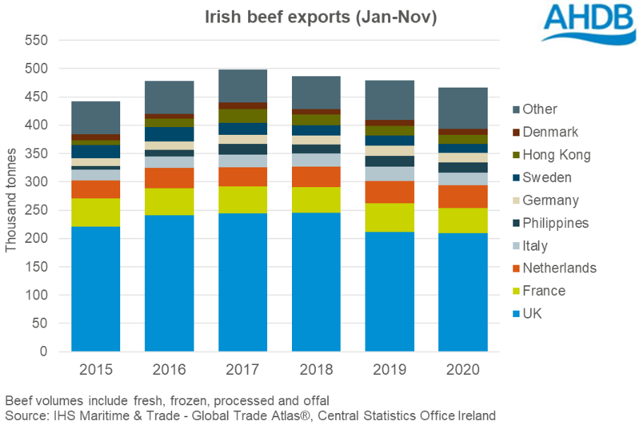
- How does globalisation benefit John’s farm?

The graph above shows Irish beef exports for the years 2015-2020 and the country beef was exported to. Analyse the graph above and answer the questions below.

- Which country did Irish beef get exported to most for the years 2015-2020?

- In which year was the most amount of beef exported?

- Suggest one reason why the total number of beef exported in 2020 was lower than in 2019.

