John Daly’s Farm Unit of Learning - Assessment
Question 1
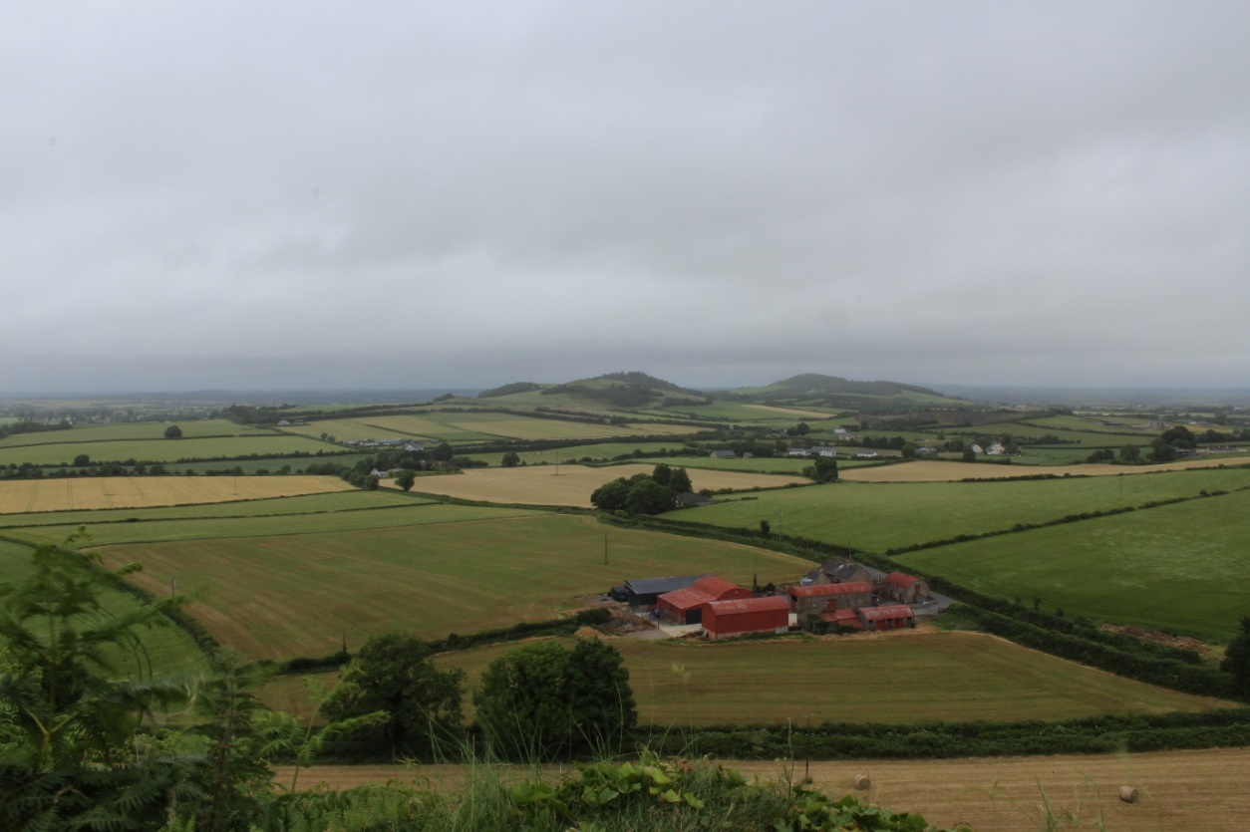
The photo below shows John Daly’s mixed farm in Trim, Co. Meath. He grows barley and maize along with raising a suckler herd. Examine the photograph and answer the questions that follow.

- Tillage farming is an example of which type of economic activity?
primary | secondary | tertiary

- Define the term mixed farm.

- List two processes that would take place on John’s mixed farm.
1.
2.

- What soil type is most common in the area where John’s farm is located?

Brown Earth q Podzol q Gley q
- Explain how the soil type you chose in part (d) is formed.

- Explain two reasons why the soil you chose in part (d) is suitable for a mixed farm.
Reason 1:
Reason 2:

- John ensures that he practices sustainable exploitation of soil. Define the term sustainable, and describe one sustainable practice John might undertake on his farm.
Sustainable:
Sustainable Practice:
- Match each farm type below with the correct definition.
1 | Poultry Farm |  | A | Raising only livestock for meat or fairy production. |  | 1 | D
2 | Tillage Farm |  | B | Rearing horses. |  | 2
3 | Pasture Farm |  | C | Growing and harvesting of crops. |  | 3
4 | Equine Farm |  | D | Raising chickens, ducks or other birds for meat or egg production. |  | 4

Question 2
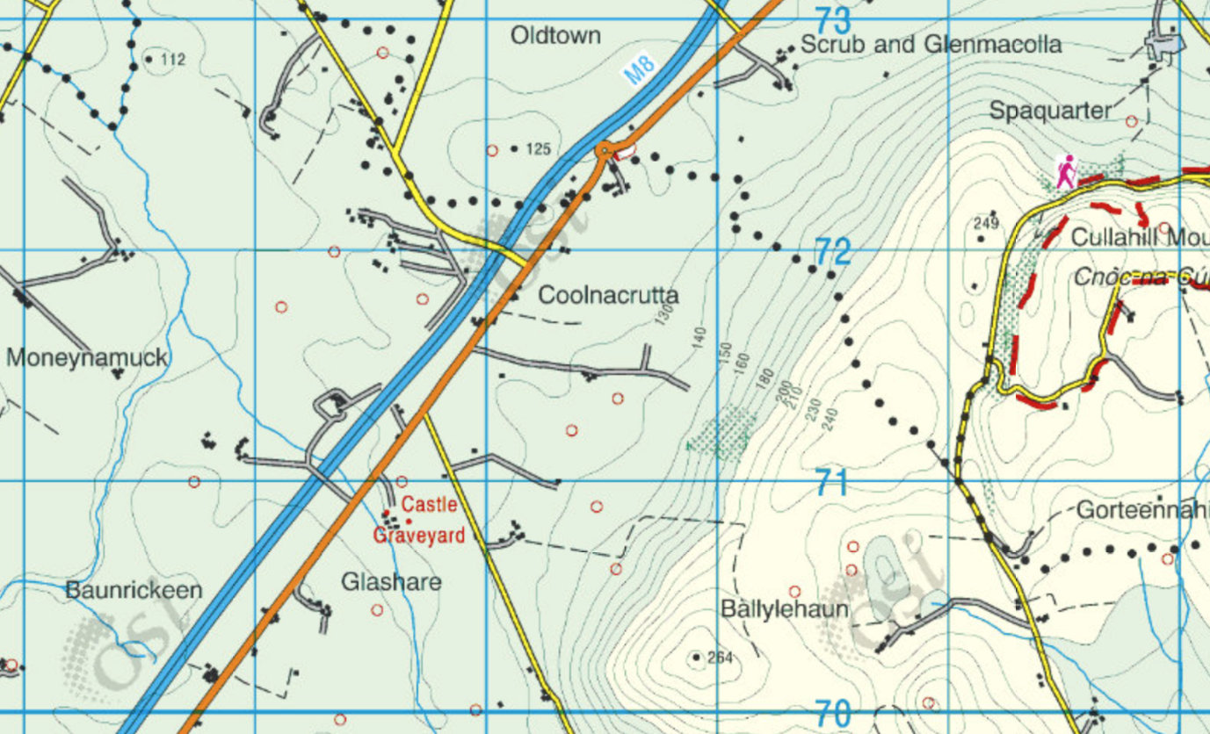
John’s friend Sarah is looking to establish a tillage farm in her local area near Urlingford in Co. Kilkenny. Two sites have come up for sale in the area, Site A and Site B.
A
B

- Advise Sarah which site is best suited to a farm in terms of physical factors. Refer to the O.S. Map in your answer.
Reason 1:
Reason 2:

- The M8 motorway is close by both sites. This motorway is a direct route to Dublin City, including the airport and the port. Explain why being close to the motorway would benefit Sarah’s farm.

- List two inputs that Sarah would likely have on her tillage farm if she were to grow soybeans and corn.
1.
2.

- Explain two reasons why Ireland’s climate is beneficial to Sarah’s farm.

